Sensation and Perception
______________________________________________

- Define key terms

- Describe the relationship between the physical world and its psychological representation (i.e., sensation).

- Discuss how we use psychological representations to identify objects (i.e., perception).
  - template theory
  - feature theory
  - prototype theory
  - Gestalt psychology

- Distinguish between top-down and bottom-up processing.

- Outline Gibson's 'Direct Perception' approach.

Sensation and Perception
______________________________________________

Sensation – receiving physical stimulation and translating it

Perception – sensory information

Key Questions:
    - How do we encode information? How is a physical object in the world ( ) turned into a psychological object ( ) in our mind/brain?

    - What is the nature of the psychological representations of physical objects?

    - How do we use this information to identify objects?

Distal vs. Proximal Stimuli
______________________________________________

Sense | Distal Stimulus | Proximal Stimulus | Our Perception
Vision |  | Pattern of neural activity | Color
Audition |  | Pattern of neural activity | Music
Taste |  | Pattern of neural activity | Chocolate
Smell |  | Pattern of neural activity | Frying Bacon
Touch |  | Pattern of neural activity | Squeeze

Important Questions:
- Can you think of any other senses?
- Does food have taste? Does light have color?
- Perception vs. imagery
- Source memory
How do we go from Proximal to Distal?
______________________________________________

In vision, Photoreceptors do the work
Retina: a movie screen in the back of your eye.

 | Rods |  | Cones
How Many? | Population of U.S. |  | Population of NY
What do they react to? | movement |  | Color
When do they work best? | Night |  | Day
Where are they? | periphery of retina |  | center of retina
What are they specialized for? | sensitivity |  | acuity
Why the difference? | Many rods connected to same ganglion cell | One cone per ganglion cell
How do they work? | Light bleaches a chemical (photopigment) which by some mysterious process stimulates a nerve impulse.
Color vision
________________________________________________

Different types of cones

Red light | =========> | Red cone activity ⇑
Blue light | =========> | Blue cone activity ⇑

Cones work in teams:
- red-green
- blue-yellow
Red light | =========> | Red cone activity
Red light | =========> | Green cone activity

Evidence:
- Color afterimages

______________________________________________

Two questions:
- Why don’t we see the color fade if our photoreceptors get washed out?
- Why doesn’t this happen all of the time?

Eye Movements influence visual cognition
______________________________________________

Your eyes don’t just sit there!!!
- integrate information over saccades

Why do our eyes move?
- Nervous system is keyed to and/or

Evidence that system is keyed to changes
________________________________________________

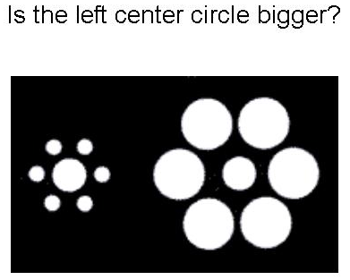
Evidence of enhancing boundaries: Lateral Inhibition
________________________________________________

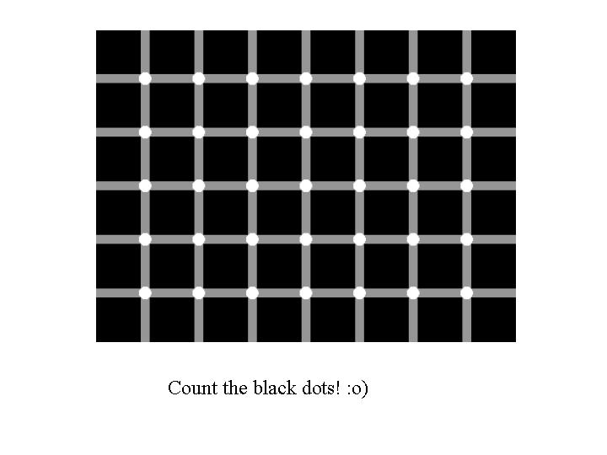

More evidence that perception enhances boundaries
______________________________________________





Change / Repetition Blindness
________________________________________________

- Repetition blindness
- Change blindness
  - moviemistakes.com

Change Detection CogLab
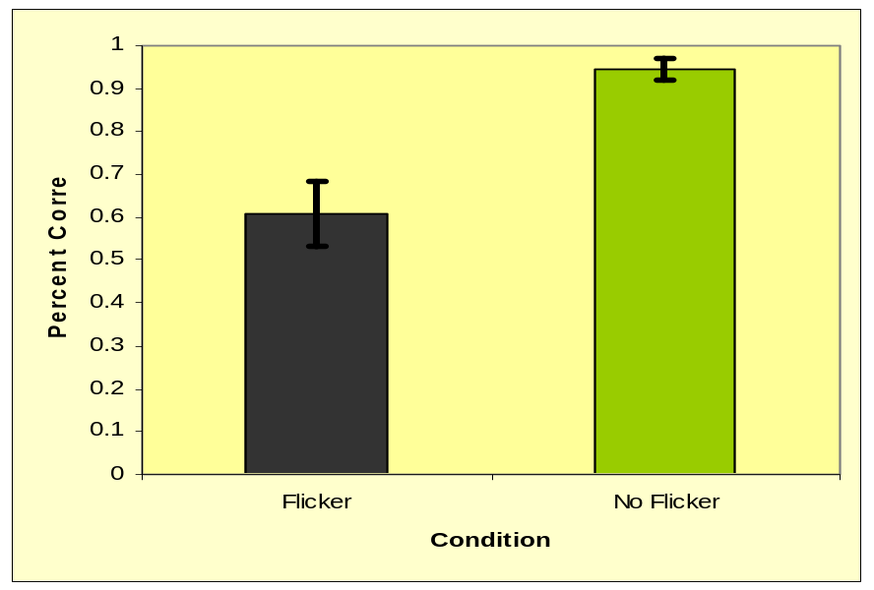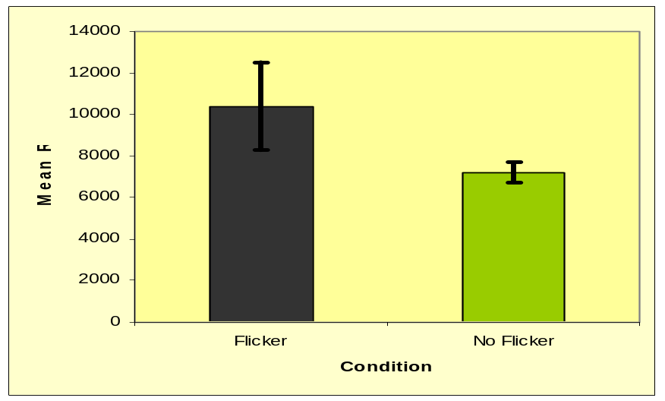
Simons & Levin (1998)
________________________________________________

Theoretical Question:

Empirical Question:

Background Literature:
People have trouble detecting changes in ‘flicker’ paradigm and ‘actor’ paradigm
- Is CB a function of limited attention?
  - Central vs. peripheral information
  - Predictability by naïve subjects

Do ‘actor’ paradigms provide enough evidence to suggest that focused attention is not enough to eliminate change blindness?
- Use of ‘cuts’ to simulate eye movements
- Passive viewing vs. active engagement
- Focused attention?

Simons & Levin (1998)
________________________________________________

Experiment 1:
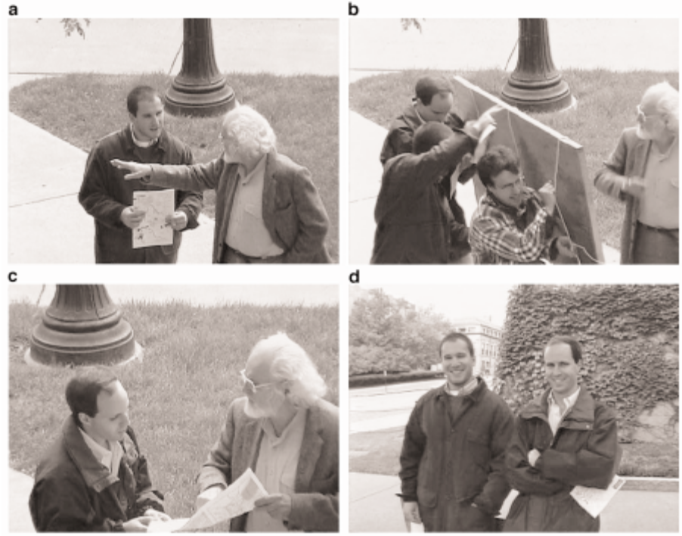

- Results:

    - Age difference
      - Cognitive vs. social explanation

Simons & Levin (1998)
________________________________________________

Experiment 2: construction workers
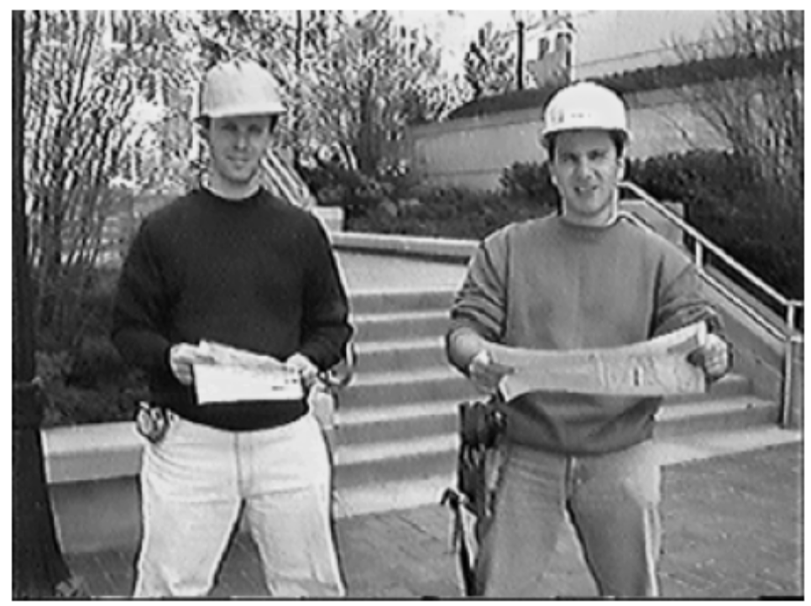

Results:
    - Same or different as E1?
    - Quote at end of p. 647

Discussion:
- Objections to the results/conclusions?
- Social demands: encourage or discourage report?
- Locus of attention
- Insufficient attention?
        - Nice to meet you, uh, uh, uh, dude!
Simons & Levin (1998)
________________________________________________

More discussion:

- How do we establish that an example of change blindness is worthy of theoretical attention?

- What do the results of Simons and Levin (1998) suggest about in-group/out-group effects?

- Which experimental phenomenon do you find more compelling/interesting: Change Blindness CogLab or Simons and Levin (1998)? Why?

- How would you characterize moment-to-moment representations of the visual world? Do we retain little information from saccade to saccade? If so, how do we navigate our worlds as effortlessly as we do?

- What kinds of changes would be recognized in this paradigm (see pg. 648)? What would that imply?
How do we recognize objects in the environment?
______________________________________________

Why is object recognition important?
EX: Vermicious Knid
________________________________________________
Template Matching – Our brains store a template of every object we have ever encountered
EX: Photograph at the airport.

Problems:

Feature models of Object Identification
________________________________________________

Recognition by Components (Biederman)
- Break an image down into its constituent components, called
- Look for edges and concave surfaces
- Identify geons and their interconnections
- Compare with stored representation

How does this address problems with template model?
- Flexibility
- Space
- Speed

Biederman’s RBC Model
______________________________________________

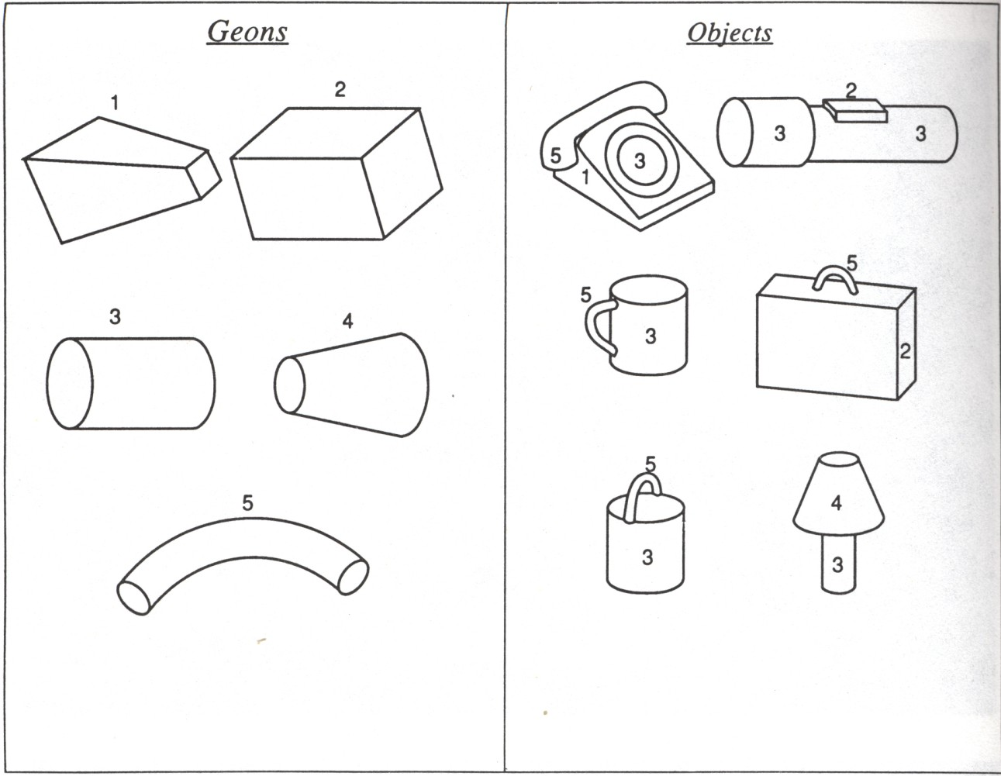

Evidence supporting RBC: Hubel and Wiesel
________________________________________________

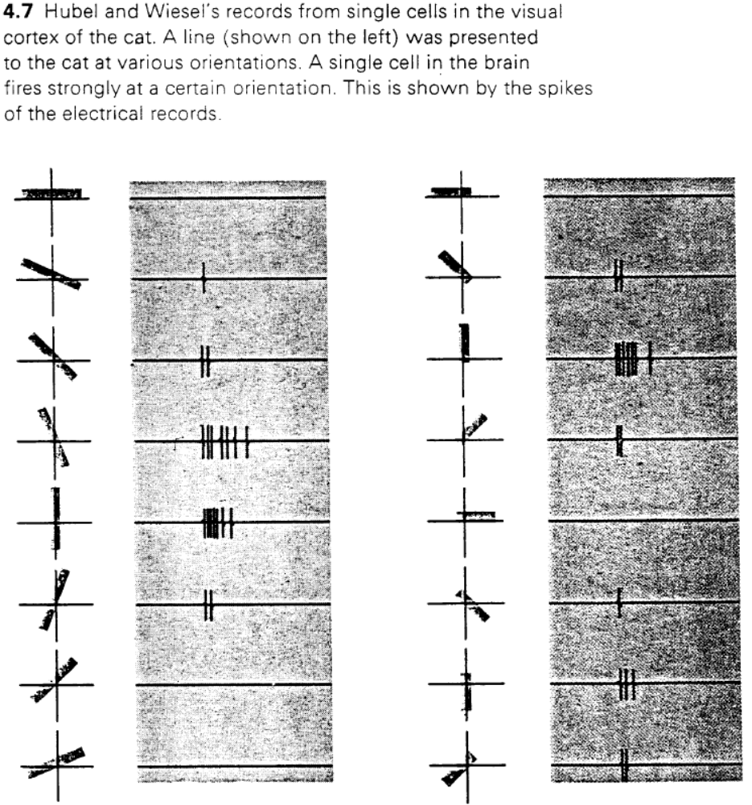
More Evidence Supporting RBC model
______________________________________________

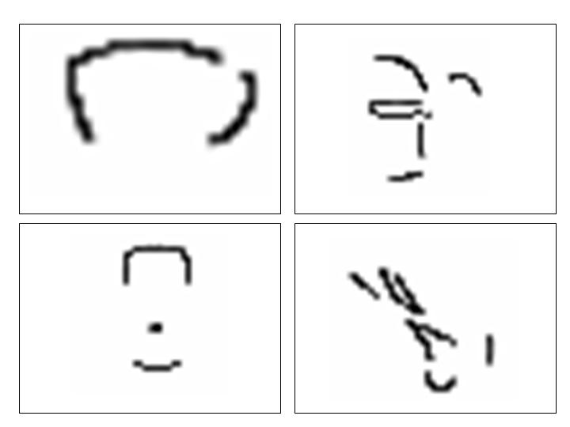
More Evidence Supporting RBC model
______________________________________________

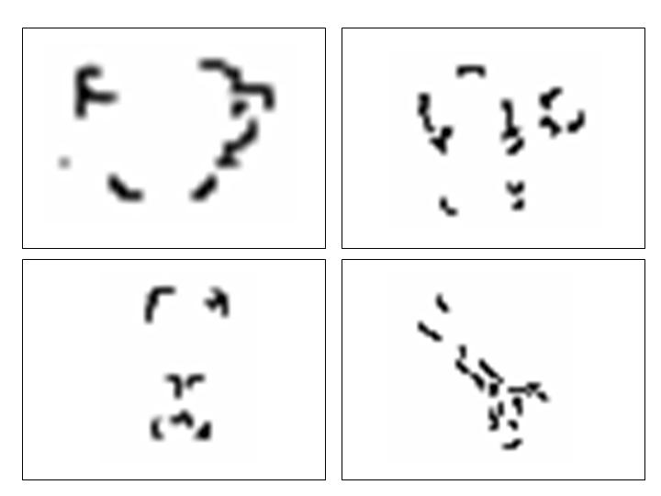
More Evidence Supporting RBC model
______________________________________________

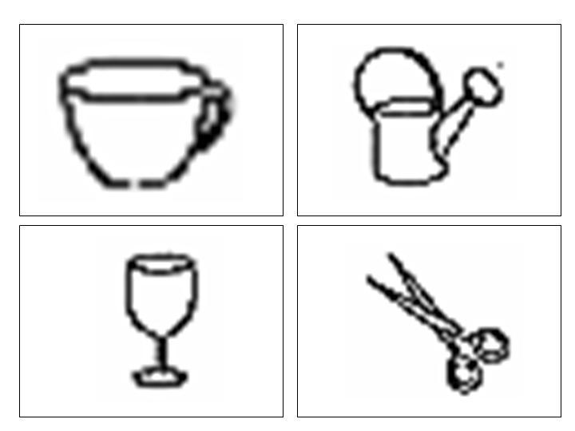
Prototype Theory
________________________________________________

GuidingPrinciple – Categories are organized around a “prototype” or . Items are related by

- Bird

- Dogs

- Colors

Evidence:
- People are faster to verify “Robin is a bird” than “Ostrich is a bird”.
- People remember "good" exemplars better than "bad" exemplars (but more false alarms, as well)

Rebuttal:
- Robins have more bird features than ostriches.

Re-rebuttal:
- Works for "colors"
- Prototype need not be a real object.

Agnosias
______________________________________________

Agnosia -
- unrelated to problems with low-level S&P
- integration

Interesting syndromes -

- Semantic dementia –
    - Natural vs. man-made objects
    - Familiar vs. novel objects

- Prosopagnosia –

- Emotional agnosia – unable to recognize the emotion expressed by faces / speech

Top-Down vs. Bottom-up Processing or
Conceptual Processing vs. Data-driven
______________________________________________

Top-Down: we use conceptual information to interpret the

Bottom-Up: we use the physical properties of the stimulus

Dominant view: much of perception is Top-Down.

______________________________________________

Evidence for Top-Down processing:
a) Ambiguous Figures
b) Size and Shape Constancy
c) Word-Superiority Effect
d) context effects (i.e., face identification)

Evidence for Bottom-Up processing:
a) unexpected object identification

What do you see?
________________________________________________

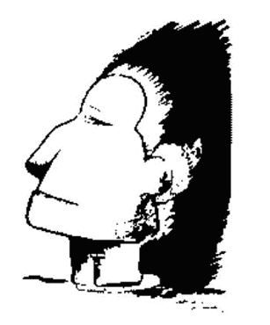

Size Constancy and Illusory Contours
________________________________________________
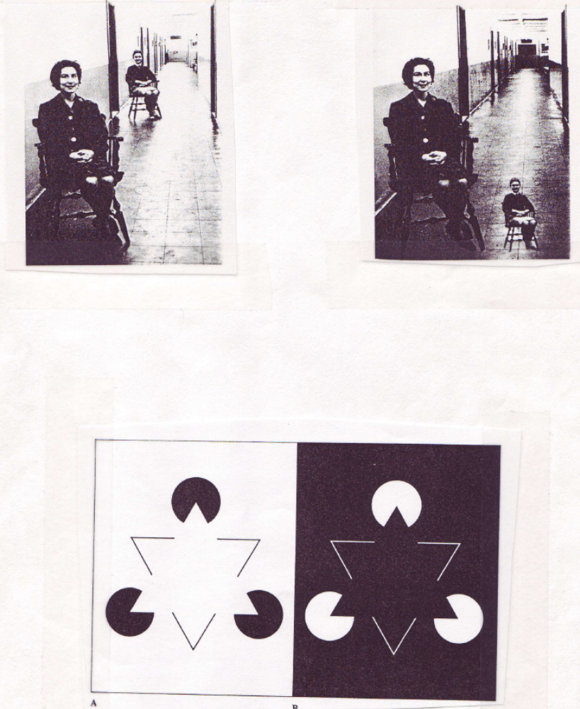
Kohoutek (c) 1985 – REM

______________________________________________

Who will stand alone?

She carried ribbons, she wore them out
Courage built a bridge, jealous tore it down
At least its something you've left behind
Like Kohoutek, you were gone

We sat in the garden, we stood on the porch
I won't deny myself, we never talked

She wore bangles, she wore bells
On her toes and she jumped like a fish
Like a flyin' friend, you were gone
Like Kohoutek, can't forget that

Fever built a bridge, reason tore it down
If I am one to follow... who will stand alone?

Gestalt Psychology
______________________________________________

Law of Prägnanz
- When in doubt, adopt the simplest possible interpretation



Will the perception of the white triangle remain if I remove:
- The black ‘circles’?
- The gray triangles?

Gestaltism: How do we know what is simple?
______________________________________________
- Figure-Ground
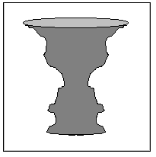
- Proximity
x x x x x
x x x x x
x x x x x
x x x x x

- Similarity
x x x x
o o o o
x x x x
o o o o
- Continuity

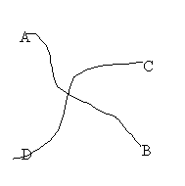
More Gestalt Principles
______________________________________________

- Closure

- Symmetry

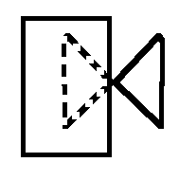
- Problems: Neckar Cube
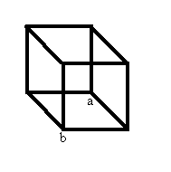

Alternative View: Gibson's Direct Perception
______________________________________________

Affordances
- recognize objects based on

- Species-specific

Invariants
- Some things about the environment
  - These things allow us to interpret the world.

Depth Perception: Making myself Huge
______________________________________________

How would you interpret the situation from the perspective of …

- …the dominant view?

- …Direct perception?

Monocular and binocular depth cues
______________________________________________

Monocular cues
- Texture gradients
- Relative size
- Muller-Lyer Illusion
- Interposition
- Linear perspective (Ponzo Illusion)
- Motion Parallax

Binocular Cues
- Binocular convergence
- Binocular disparity (stereopsis)
  - 3rd Eye books

Depth Illusions
___________________________________________

Müller-Lyer Illusion
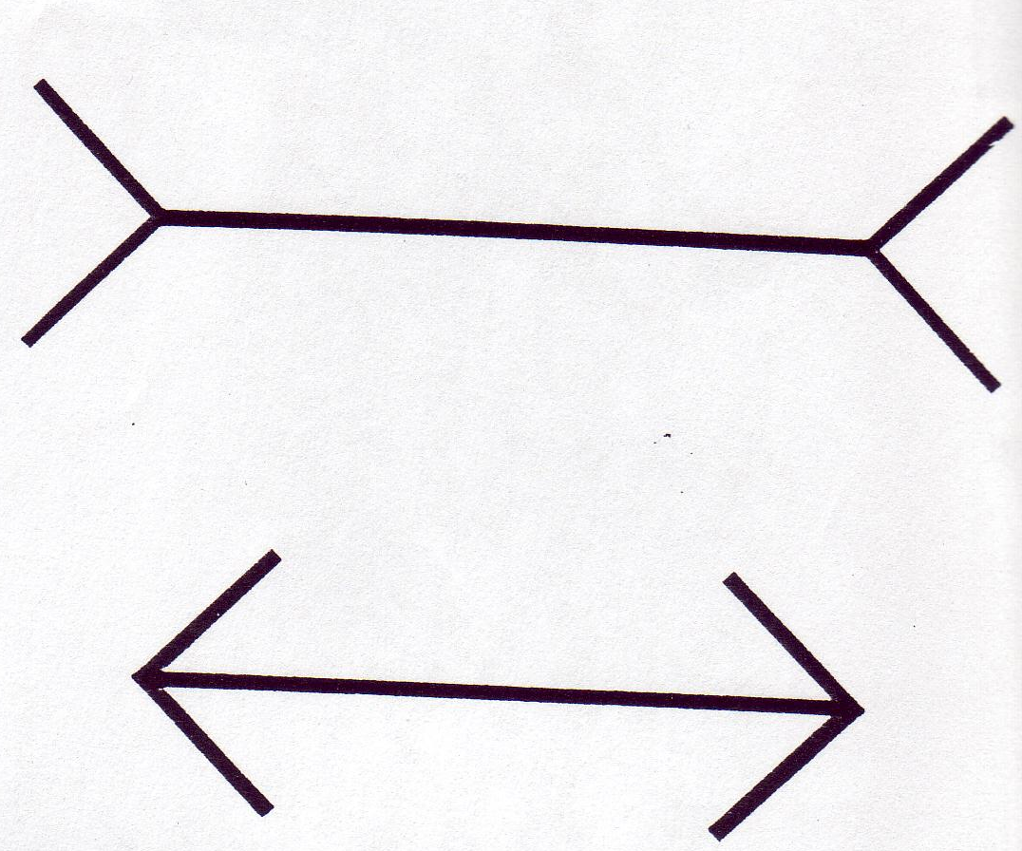

Ponzo Illusion
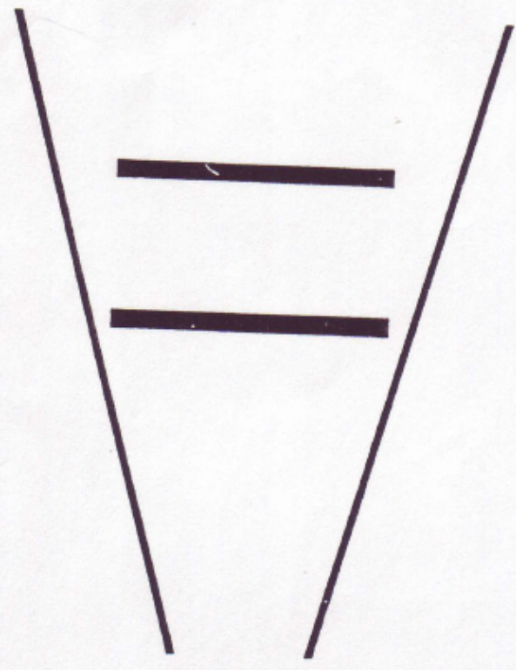
Kozlowski & Cutting (1977):
Identifying Gender from Point-Light Displays
______________________________________________

Introduction:
- Theoretical question
- Empirical question

Methods and Results:
E1: Is identification possible?
- ID was relatively easy (one outlier)
E2: Is static display sufficient?
- ID was difficult with static displays
E3: What did viewers use: armswing vs. speed?
- Armswing:
  - Why is it important that armswing mattered more than speed?
E4: What did viewers use: lower vs. upper joints?
- Upper joints were more informative
E5: Necessary vs. sufficient
- No joint was necessary; no joint was sufficient
  - Why is this result important?

Aside:
- Significantly above chance
Kozlowski & Cutting (1977): Theoretical Implications
________________________________________________
Discussion
- Why did I have you read this article?

- Any particular model of perception?

- Conscious vs. unconscious processes

- What are some different ways that the experimenters used failure to illuminate cognitive processes?

- Selected walkers with a ‘normal’ gate. Did this bias the results?

- Twice mentioned no feedback, why was this so important to them?

- Ecological validity? Who cares we never see point-light displays in our everyday environment?
________________________________________________

Problems with Direct perception view:
- Affordances really specified by the environment?
- Circularity:
  - What makes a bird a bird?
  - How do we recognize a bird?
The Matrix: Science or Science Fiction
______________________________________________

Possible IF we figure out:

Penfield
- stimulated patients brains and got responses
  - Movement of an arm or leg
  - Tingling burning sensation
  - In theory, sense of smell, taste, etc.
- BUT the subjects knew that "he did it"

What about implanting memories/skills?
- Memories we can do (sort of) today.
- Skills a little bit harder because there's another piece.

