The Spillover Effects of Participation in Development Projects:
Evidence from Honduras and Guatemala

By Daniel Altschuler
Oxford University

daniel.altschuler@sant.ox.ac.uk

and

Javier Corrales
Amherst College

jcorrales@amherst.edu

December 15, 2009

With the financial support from the Ford Foundation, the Tinker Foundation, and Amherst College

Abstract

Political scientists and development scholars wonder whether civic participation can have spillover effects, that is, whether civic participation in one domain of public life can lead to more participation in other domains. Based on a survey of participants in community-managed schools (CMS) throughout all of rural Honduras and in the department of Alta Verapáz, Guatemala, a predominantly Q'eqchí Mayan area, we find evidence that such spillover effects do occur. No doubt, context-based factors such as poverty, patronage dynamics, and low state support hinder participation and, by extension, spillover effects. But our surveys—rare in studies of development due to their broad coverage—indicate that these obstacles are not insurmountable. Once initiated, participation can lead to more participation. Not only do some participants acquire skills necessary to participate in other group activities, but some actually apply such skills to other civic organizations and even join new organizations. We also find evidence of increased trust in peers and teachers, signifying that changes in attitudes, not just behaviors, are also possible. All this suggests that the supply of participation can be stimulated: participatory development programs can yield limited but nonetheless new forms of civic engagement, even where one least expects it.

I. Introduction

We present descriptive statistics from a survey of participants in community-managed schools (CMS) in Honduras and Guatemala. CMS are a prototype of participatory development projects in which parents take on the duty of administering primary schools. With the financial support of the Ford Foundation, the Tinker Foundation and Amherst College, we designed and applied a survey across participating parents in these CMSs to gauge whether their participation in these schools yielded greater civic and political engagement elsewhere in society, what we call “spillover effects”. Among studies of participatory development, ours is one of the most comprehensive surveys of participants on record.

Various studies have examined similar questions, with mixed results. Some studies report positive spillover effects. For instance, Baiocchi (2001), Avritzer (2001), and Souza (2001) find that Brazilian participatory budgeting (PB) enhances political learning, deliberation, oversight and mobilization, and saves communities from elite capture. Heller et al. (2007) have also shown how Kerala’s People’s Campaign for Decentralised Planning engenders democratic ethos and associational life. Similarly, Barron et al. (2006) find that participation in Indonesia’s Kecamatan Development Program promotes conflict avoidance and resolution.

Other studies, on the other hand, report less positive outcomes. For instance, Nylen (2002) concludes that PB in Belo Horizonte and Betim has far less impact on the civic and political behavior of previously-disengaged participants, suggesting that certain participatory initiatives fail to shift dynamics of participation and intra-community power relationships. Grindle (2007) finds that groups stop participating once their demands are met. Even Souza (2001) and Heller et al. (2007) find that participatory programs can fall prey to patronage politics and co-optation by local officials.

Many of these conclusions are based on relatively few cases, anecdotal evidence, or statistical analysis using data from relatively few locales. Our study marks an important departure because it analyzes data that covers all of rural Honduras and the entire Guatemalan department of Alta Verapáz, which has the greatest share of the CMS (roughly 20 percent) in the country. We also undertake a cross-country comparison. To our knowledge, no such national and cross-country survey of participatory development programs has been done before.

Furthermore, whereas many surveys limit themselves to urban and semi-urban regions, ours explicitly targeted truly remote communities. Both rural Honduras and Alta Verapáz, Guatemala, are arguably the poorest areas in each country, and possibly among the poorest in the Americas. They are examples of “brown areas” (O’Donnell 1993): geographic zones where the state’s reach is minimal. Political scientists have long noted that “brown areas” suffer from democratic deficits, but few, if any, have explored scientifically the spillover impacts of participatory development in such zones. Ours is one of the first to do so.

II. What are Community-Managed Schools?

CMSs represent one of the most innovative education experiments in Latin America since the 1990s. They are efforts by the state to expand primary education coverage by inviting parents to form, and more importantly, to manage local primary schools (Di Gropello 2006).

In Guatemala and Honduras in particular, CMS emerged as a direct response to the serious education deficits prevailing in rural areas. In Honduras and Guatemala, 25 and 40 percent of rural school-age children, respectively, lacked primary education access in the late 1990s. Literacy rates were similarly dire in both areas (PREAL 2002; PREAL 2002a). Prior to CMS, most remote communities in rural Honduras and Alta Verapáz, Guatemala, lacked even primary schools.

To address these education deficits, Guatemalan and Honduran state officials essentially emulated their neighbor, El Salvador, which pioneered a version of CMS in the early 1990s. With World Bank support and technical advice from policy experts abroad, Honduras and Guatemala established their own CMS, called PROHECO and PRONADE, respectively. These programs expanded rapidly. By the mid 2000s, PROHECO and PRONADE covered roughly 8 percent and 20 percent, respectively, of each country’s rural primary education (PREAL 2005; PREAL 2008).

CMS are distinctive in that they introduce parent oversight of teachers, in contrast to traditional public schools, which leave teachers accountable to a faceless bureaucracy. While opponents—especially teachers’ unions—denounce CMS as a form of privatization, CMS are not private schools, but rather state-funded schools. The difference is that parent councils, rather than state officials, are responsible for school administration, including hiring and firing teachers, paying salaries based on teacher attendance, overseeing school lunches, and purchasing materials for the schools. CMSs were created to run in parallel with, and to fill the gaps left by, traditional public rural schools.

PRONADE and PROHECO were created with two goals in mind: first, to create schools using a less expensive model of school administration and, second, to fortify civic democracy by fostering participation. The programs were thus conceived as mechanisms for addressing both development and democratic deficits—all through parental participation.

Our research focuses mostly on assessing the program’s second objective. We developed a survey designed to assess how much these programs stimulate participation beyond the school councils.

III. Survey Design and Methodological Problems

We surveyed members of parent councils at 285 schools across Honduras (n=1252 parents surveyed) and 150 schools in Alta Verapáz, Guatemala (n=819 parents surveyed).

To measure the impact of school participation on civic and political behavior, we would have preferred to compare our treatment groups (participating parents in CMS communities) with a control group (either parents in otherwise comparable communities or randomly selected non-participating parents within the same communities). Given the lack of a clear sampling frame to identify comparable communities and the difficulty of identifying non-participating groups, we opted for a second-best approach—to ask parents about their social relations before and after the start of their participation in CMSs. Given that the reforms were well underway by the time we conceived of our study, we lacked baseline data. Instead, we relied on carefully-constructed and -piloted retrospective assessments to establish how the subject had changed (behaviorally and attitudinally) since he or she started participating in the school council.

Of course, assessment of the causal impacts of state actions on the rise of civil society is complicated by many factors, including the likelihood that state policies respond to conditions in the communities. For example, the state might intervene in villages with greater rather than less civic involvement. Nonetheless, this type of endogeneity problem is less relevant in our study, given that both governments explicitly targeted the most marginalized rural communities.

Still, in the absence of randomly assigned experiments, the estimation of causal effects of a specific initiative relies upon the identification of valid comparison groups. Parental activities in the participating villages prior to the intervention provide our most promising, albeit imperfect, baseline. Before/after comparisons thus form our study’s core.

Our study does offer one methodological advantage relative to other studies of participation—participation in school management appears to be driven by a different process than participation in other aspects of civic life. Most participatory programs elsewhere are predominantly populated by participants who are already civic or have a proclivity to become engaged and thus volunteer for these programs. CMSs, on the other hand, attract parents for different reasons. Specifically, the incentive to participate appears to have more to do with the subject’s private need (to ensure the education of their children) rather than an inherent desire to be civic. Many participants do not have a rich history of prior engagement. Roughly 30 percent of surveyed parents had never participated in a prior organization, roughly 30 percent had participated in one prior organization, roughly 20 percent had participated in two organizations, and another 20 percent had participated in more than two organizations. Thus, it is more likely that involvement in school management is an experience that affects skills, behaviors, and attitudes valuable to civic participation among individuals with little prior participatory experience. Ours is thus a better pool for studying whether the seed of participation can bear fruit.

IV. Dependent variables

We were primarily interested in capturing changes in participants’ civic and political behavior after their participation in school councils. Does participation in the school council lead to more participation in other domains of civic life?

Table 1 summarizes the key data that we collected to capture changes in parents’ civic and political behavior since joining the school council: 1) number of parents who gain skills for participating in civic organizations and apply them in other organizations, 2) parents who increase participation outside the school council, 3) school councils form alliances with other organizations, 4) parents who increase trust in others, and 5) parents who increase the frequency in which they engage in certain types of political behavior.

Table 1: Dependent Variables of Interest

Category | Measurement
Gaining Skills Related to Participating in Civic Organizations | - Gaining skills such as organizing meetings and making a budget  - Applying such skills to another organization
Building Civic Networks | - Greater overall active participation in community affairs (data only available for Guatemala sample)  - Participating actively in more organizations  - Becoming a leader of other organizations after joining the school council  - Creating another organization after joining the school council  - Councils forming alliances with other civic organizations
Political Behavior (Non-electoral) | - Change in frequency of organizing meetings  - Change in frequency of petitioning or visiting government offices
Trust | - Change in trust in community members, parents, and teachers

V. Obstacles to Spillovers

Consistent with the theoretical literature, our study corroborated acute obstacles to civic and political engagement in most CMS communities: geographical remoteness, material resource scarcity, low levels of education, and human insecurity. Furthermore, in Alta Verapáz, Guatemala—one of the departments hardest hit by the armed conflict and genocide in the 1960s-1980s—levels of trust and political engagement (especially propensity to vote) were low.

To gauge individual/household socio-economic levels—perhaps the most serious impediment to civic and political engagement—we asked respondents to report whether their households possessed any of the following assets: 1) refrigerator, 2) stove, 3) television, 4) radio/sound system, 5) landline telephone, 6) cellular telephone, 7) car, 8) bicycle, 9) computer, 10) internet, 11) cattle, 12) horses/mules, and 13) chickens. We then created a simple additive index, with ownership of each type of asset adding a value of one (see Chart 1 below). We found widespread material poverty in both samples, especially in Alta Verapáz. Respondents’ mean number of assets was just over three in Honduras and two in Alta Verapáz. Chickens, radios, and cellular phones were the most commonly held assets in both samples. Virtually no one surveyed in either country owned costly items such as cars or computers.

To gauge community socio-economic levels, we recorded whether the visited communities had any of the following local services: 1) potable water, 2) electricity, 3) sewage system, 4) latrines, access to public transportation, 5) postal service, 6) public library, 7) police, and 8) nursery.

Chart 2 shows the comparative distribution of local services in both samples. As with the data on assets, data on local services convey high levels of deprivation. Virtually none of our sampled communities had a postal service, police, or a public library. Many, though, had latrines and potable water. Also, as with assets, we find more services for the Honduran sample, though only the differences in the first two services displayed below are statistically-significant.

Chart 1
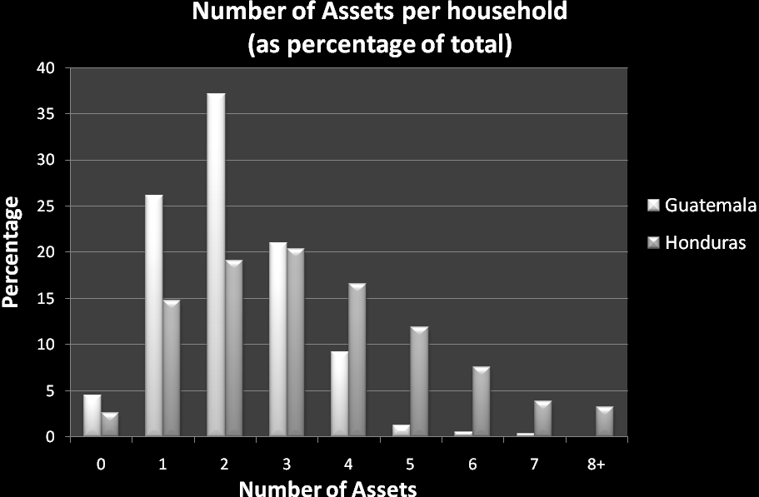

Chart 2

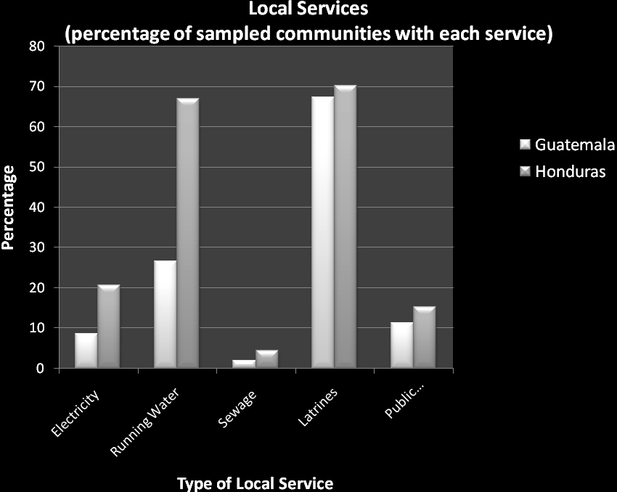

Literacy and education levels were also low, especially in Alta Verapáz: 16 percent of Honduran respondents and 43 percent of Guatemalan respondents self-identify as illiterate. The mean years of schooling was just under four in Honduras and under three in Guatemala (Chart 3).
Chart 3

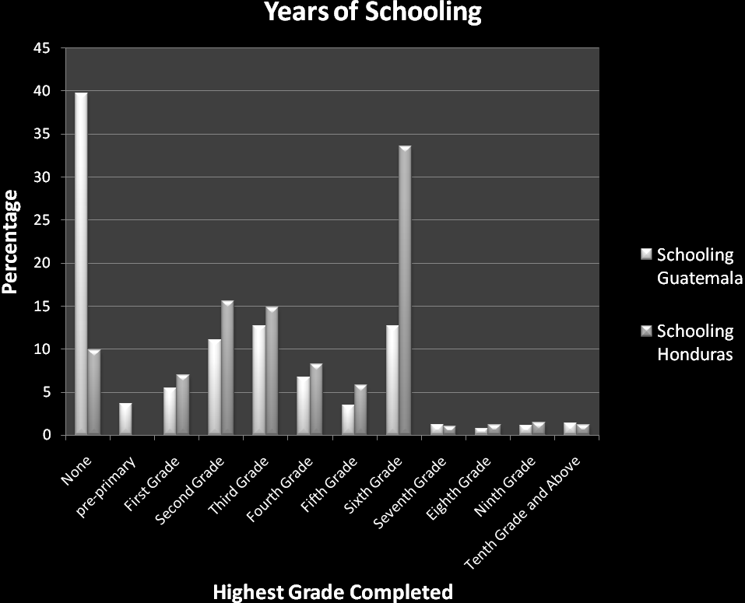

In addition, multiple pilots and subsequent qualitative research revealed that participants face high transportation costs: distances are far, roads are in disrepair or nonexistent, and vehicles are scarce (see Altschuler 2008). These transportation costs further hinder collective action, making it harder, for instance, for parents to come together to create other organizations or form networks with other communities. Furthermore, we expected political behavior such as voting to be resistant to change in the short term given that CMS programs did not seek to impact such behavior.

Finally, there are significant program-related obstacles to participation spillovers (Altschuler 2008):

- Insufficient project resources, as manifested by insufficient training for parent council members and a high turnover rate of local project administrators (“promoters”);
- CMS’ administrative focus: in both countries, the programs’ aim was creating a functional administrative unit, not generating greater civic and political participation among parents;
- Weak Decentralization—very limited role for the municipalities and minimal supervision from departmental and district level; and
- Patronage/Clientelism: in Honduras, CMS staff members are mostly political appointees who are expected to promote the agenda of the ruling party, including hiring teachers based on party affiliation. In Guatemala, selection of technical assistance organizations sometimes fell along party lines.

Given these obstacles at the individual level (low schooling), household level (asset scarcity), community level (local services shortage, geographical remoteness), and program level (CMSs’ institutional deficiencies), we were confident that we were testing our hypotheses in “least likely” environments. These are very poor and isolated communities inhabited by people with rudimentary supplies of physical and human capital, participating in poorly-run development programs and facing serious communication barriers. By most theoretical accounts, the probability of finding vibrant civic life emanating from these cases is low.

VI. Evidence of Rising Civic Life

Despite all these obstacles, our survey produced evidence of increased civic and political engagement among some participating parents. Naturally, we did not expect to find evidence of rising civic and political engagement among all participants, not even a majority. In addition, we hypothesized that more onerous types of new participation, such as forming alliances with members of other organizations and communities, would occur less frequently than less onerous types. These two expectations were confirmed. Spillover effects occur among a minority of participants, and the incidence of spillovers varies according to type of activity. We begin by presenting data from the least onerous to the most onerous form of spillover effect.

1. Learning skills

The most prevalent spillover outcome was the acquisition of new skills—how to make a budget, to organize and conduct a meeting, to propose and manage a project, and to contact the government. This set of skills is important because it attests to individuals’ capacity to participate effectively in community organizations and interact with other actors.

Seventy-seven percent of Guatemalan respondents and 53 percent of Honduran respondents reported learning at least one skill (Chart 4). In addition, 34 percent of Guatemalan respondents and 26 percent of Honduran respondents reported applying learned skills to participation in other organizations (see Chart 5).

Chart 4

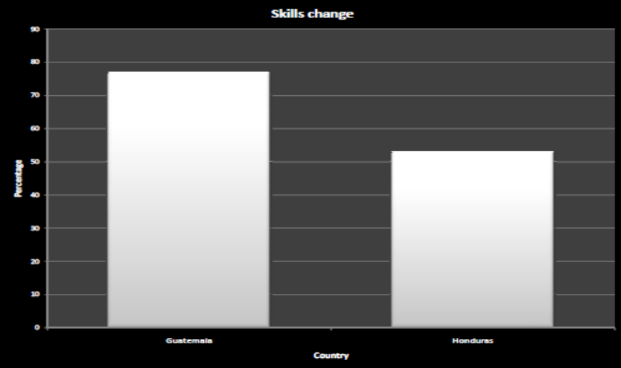

Chart 5

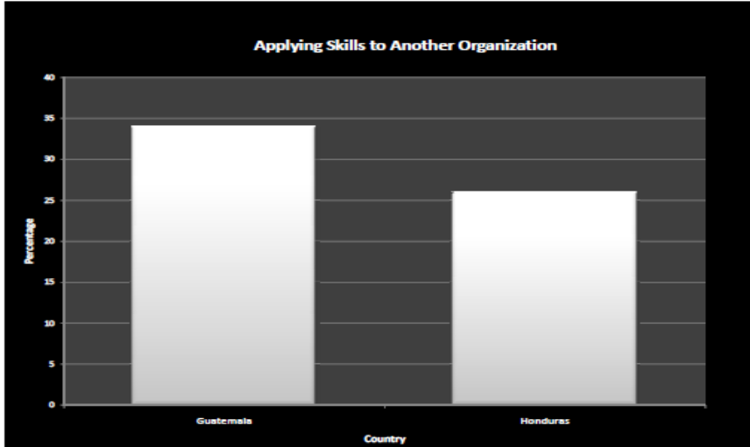

2. Joining, Leading, and Founding Other Organizations

The evidence on behalf of joining other organizations is more complicated to assess. On the positive side, over 25 percent of respondents in both countries reported actively participating in at least one more non-school-related group than they did before joining the school council. In addition, roughly 15 percent have become active in their community governance group since joining the school council. Nonetheless, roughly similar numbers of respondents reported declines in their overall group participation and governance organization participation (see Chart 6). In addition, there were more negative responses than positive responses for various group types in both countries. The findings were more positive for Guatemala than in Honduras. Furthermore, in Guatemala, we identified a general increase (reported by 70 percent of respondents) in active participation in other organizations after joining the school council.

The key difficulty in identifying the effect on participation in other organizations is the lack of a valid comparison group that could provide a counterfactual estimate of how participation would have evolved in the absence of the parent councils. Consequently we look deeper into the patterns of participation by a number of factors including the timing of parent council involvement. One possible explanation for the incidence of declining civic participation among some respondents may be the time and resource burden—namely, the possibility that the time and energy required of participants in school councils leaves less time and energy to participate in other organizations. If this is the case, one would expect present council members to show less positive changes than past members. Chart 7 bears this out for Guatemala—approximately 10 percent more former council than current members report an increase in participation in other organizations, and this difference is statistically-significant at the .01 level. Put differently, nearly twice as many former council members show increases rather than decreases, while the difference between positive changes and negative changes for current members is smaller than the difference for the overall sample. This provides evidence that the time and resource burden of parent council involvement reduce civic participation in other spheres.

Chart 6
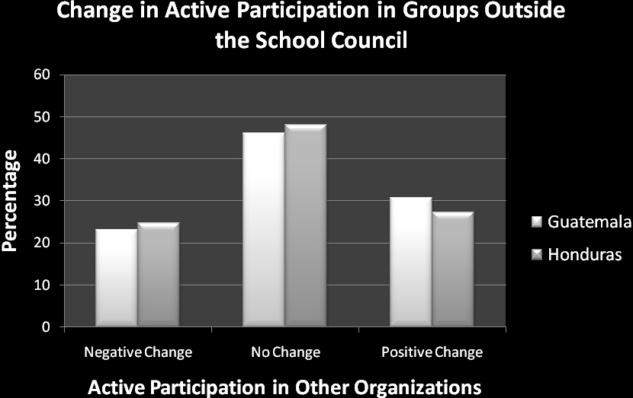

Chart 7
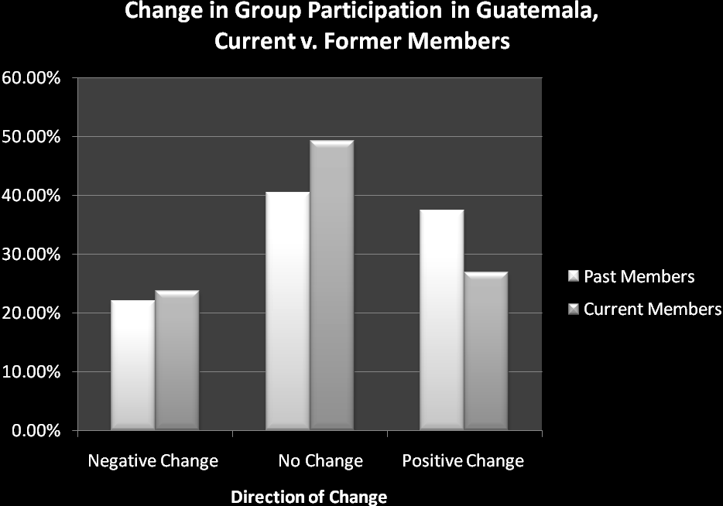

We also asked about the type of new participation in other organizations. Did parents become ordinary members of other organizations, or did they assume leadership positions rather than mere membership without added responsibilities? Consistent with our hypothesis, the incidence of more taxing forms of civic and political behavior was lower than the incidence of less taxing activities. For instance, when we asked parents whether they were currently leaders of other organizations, 58 percent in Honduras reported that they were (for Guatemala, the data for this question are incomplete). Nonetheless, only 17 percent of all respondents reported becoming leaders in other organizations after joining the school councils (see Table 2). Most respondents reporting leadership positions elsewhere assumed those positions either before or in the same year they joined the school council. Thus, most contemporaneous leadership roles in other organizations cannot be attributed to participation in the school councils.

Furthermore, among Honduran respondents who had never previously participated actively in another organization (30 percent of the entire Honduran sample), only 9 percent reported becoming leaders of another organization after joining the school council. This suggests that, while school councils may involve substantial numbers of new participants in a community’s organizational life, these structures rarely transform people with no leadership experience into new leaders. Consistent with Nylen’s (2002) analysis of Brazilian participatory budgeting, school council leaders with prior organizational experience appear more likely to increase or sustain their previous levels of engagement outside the school council.

Founding a new organization after joining the school council and forging alliances with other organizations—two of the most burdensome forms of spillover effects—occurred even less frequently. Roughly five percent of respondents in each country reported creating another organization, and roughly ten percent reported an inter-organizational alliance. Neither difference was statistically-significant (see Table 3).

Incidence of demand-making on the state is also low. Individuals report a median of one proposal to local government on behalf of the school in the past two years and the same figure for proposals on behalf of the community (see Table 3). Given both the lack of explicit state promotion of demand-making and the low probability of successful response from the state in these areas, these low numbers are not surprising.

3. Political activity

We also obtained data on changes in political behavior. Essentially, we found minimal net changes along both electoral and non-electoral dimensions. For two non-electoral measures that we gauged—organizing meetings in the community and visiting or petitioning government—we found a country difference. In the Guatemalan surveys, more respondents reported decreasing rather than increasing frequency, whereas the inverse was true among our Honduran respondents. We suspect that this cross-country difference was partly due to program design: CMS in Guatemala placed a greater administrative burden (both time and resources) on parents than it did in Honduras. It likely also reflected differences in other determining factors of political participation between the two countries.

Regarding electoral political participation, results showed few positive changes. If anything, parents in both countries reported declining interest in politics and declining frequency of voting. Given the generally apolitical nature of CMS in these countries, entrenched political abstentionism in Guatemala, and strong party alignments in Honduras, we neither expected nor found parental involvement yielding major changes in political participation.

Chart 8
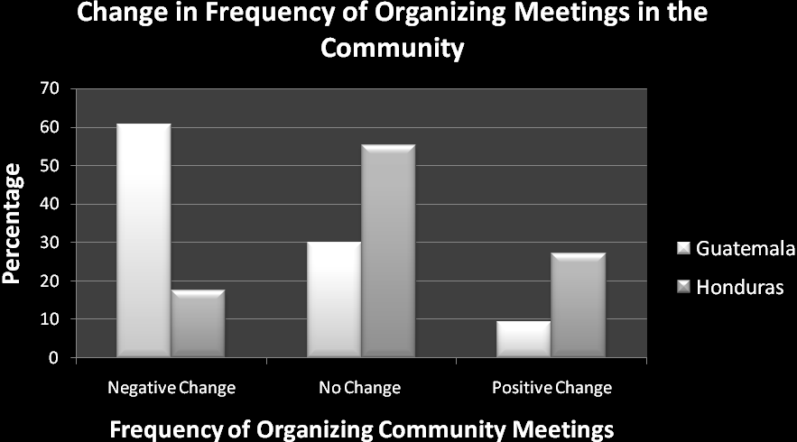

Chart 9
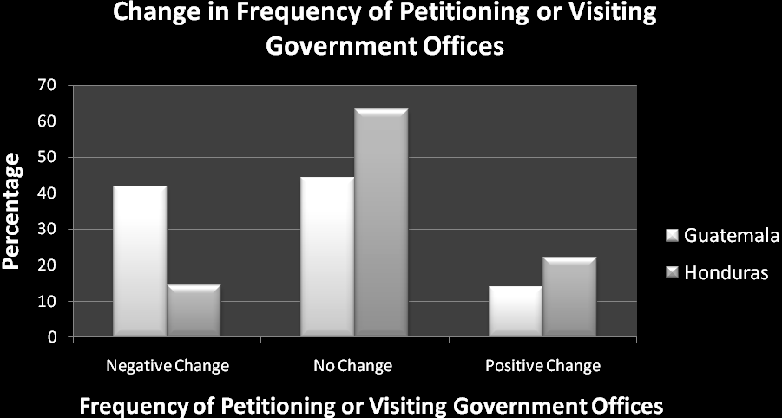

VII. Recap: Changes in Behavioral Outcomes

Thus far, we have reported changes in behavior. As hypothesized, the relative frequency of spillovers to parental participation differs by type of behavior: the more burdensome, the more infrequent the new type of participation. The most widespread spillover effect was acquisition of skills. Substantially fewer respondents in both countries reported substantial changes in building civic organizations and networks and changing political behavior.

Diagram 1 depicts this relationship between type of new participation and frequency. It ranks different types of civic and political engagement from the most onerous or taxing on a given individual (at the top) to the least onerous or taxing (at the bottom). The triangle in the background captures the likely frequency: incidence of engagement declines as one moves up the list of spillover effects. The pyramid figure captures an inverse relationship between frequency and impact—the most onerous and potentially significant changes occur least frequently.

Diagram 1: Relative Likelihood of Behavioral Spillovers to Participation

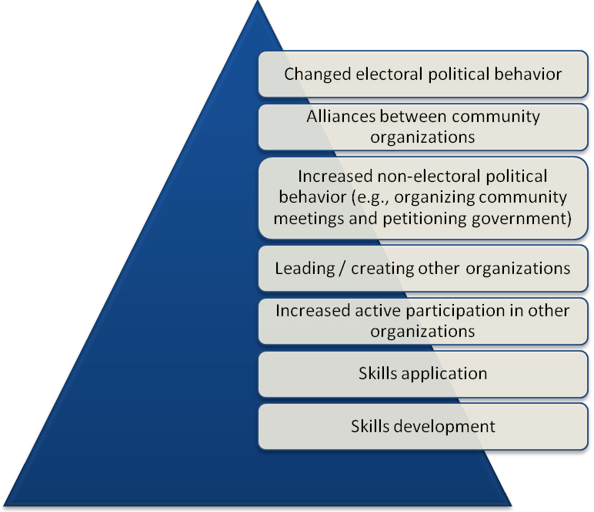

VIII: Changes in Attitudinal Outcomes: The Rise of Trust

Perhaps the most surprising outcome of our surveys had to do with trust. Our survey collected data not just on the behavioral outcomes, but also on an attitudinal outcome, namely whether participants experienced gains in the degree to which they trust others, In Guatemala, over 40 percent of respondents reported increasing trust in other community members, teachers, and other parents. The figures were lower but still marginally positive for Honduras (see Charts 10, 11, and 12).

The dramatic expansion in trust in Guatemala surprised us for at least two reasons. First, Alta Verapáz, Guatemala has a history of violence and exclusion, which tends to yield high levels of mistrust among community members (e.g., Remijnse 2003; Hurtado 2007; McIlwaine and Moser 2001). Second, many scholars agree that moving from mistrust to trust is difficult, certainly more difficult than moving from trust to mistrust. Re-building trust is an extremely rare and difficult challenge in human interaction.

We did not include trust in Diagram 1 because of potential incommensurability with the behavioral outcomes listed in the diagram. Yet, arguably, trust could be placed near the top of the pyramid, given the difficulty of achieving it. If so, the emergence of trust from CMSs would constitute one of our most unexpected findings, contradicting our hypothesis that the more onerous forms of spillovers effects occur least frequently.

Our surveys suggest three possible hypotheses that could explain the expansion of trust in a setting normally considered by scholars as deprived of trusting relationships. One is that indigenous Guatemalans are no longer as politically passive and mistrusting as in the past. This may be the reason why, as some scholars suggest, political mobilization in rural Guatemala has risen in the past two decades. The second hypothesis is that trust within communities (what some deem “bonding social capital”) may be on the rise, while trust between communities (“bridging social capital”) remains lacking (Woolcock 1998; Grootaert et al. 2002). The third hypothesis is that participation in CMSs (or in general) might have a strong impact in breaking barriers to trust and political engagement.

One way or another, there is substantial evidence of rising trust among communities with CMS in Alta Verapáz, Guatemala. If, as some theories indicate, rising trust is the seed of stronger civic life in the medium term, then this discovery bodes well for the future of participation in those communities.

Chart 10
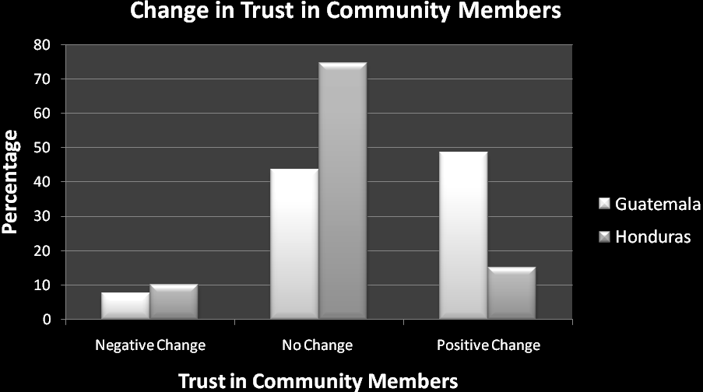

Chart 11
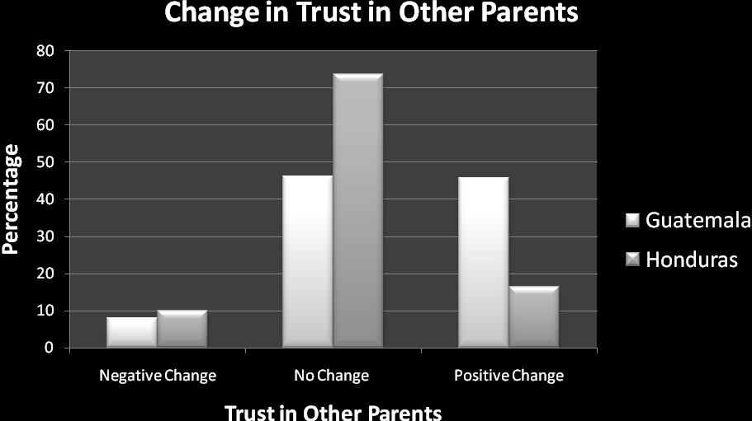
Chart 12
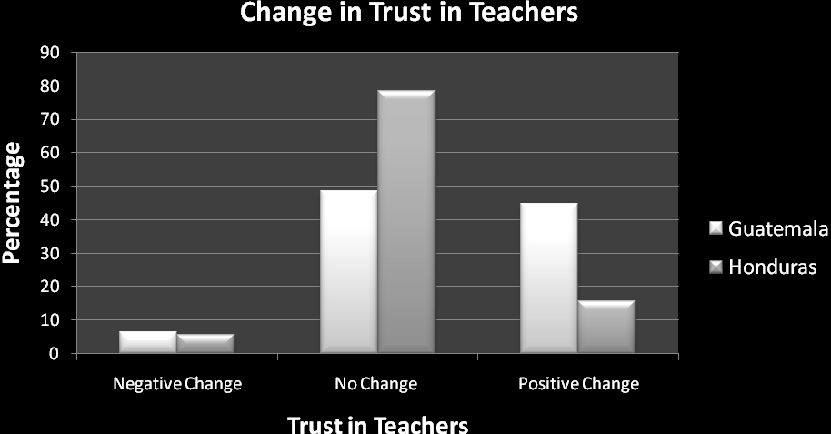

IX. Gender: Do CMSs Change or Reflect Gender Roles?

Finally, gender participation differs between our two samples. In the Guatemala sample, only 4.5 percent of our respondents were women, which is consistent with the finding that at least 81 percent of school councils had no active female participants. This contrasts with Honduras, where 39 percent of respondents were female, with only 13 percent of councils reporting male-only membership.

Provisionally, we believe the lower female participation in Alta Verapáz reflects the more pervasive machismo/patriarchy in Q’eqchí communities (see, for instance, García 2006). In this sense, one could judge CMS in Guatemala as a participatory program that has little short-term impact on gender roles in its host communities—CMS there simply reflect or reinforce, rather than alter, prevailing levels of patriarchy.

For Honduras, two broad hypotheses could explain the higher levels of female participation relative to Guatemala. One is that rural communities in Honduras are simply less patriarchal, and that, as in Guatemala, CMSs reflect (rather than change) prevailing gender relations within their home communities. The other hypothesis is that CMS in Honduras actually provide more opportunities for women participation than is typically the case in Honduras’ rural society. If the latter, then CMS could be considered to have an impact in changing gender roles and maybe even empower women.

Further qualitative fieldwork and quantitative analysis should help us determine which hypothesis is correct. We will also assess whether the frequency and type of spillovers from participation differ for male and female participants.

X. Conclusion and Future Research

Overall, results for spillovers in both countries are generally similar. A non-trivial minority in both countries reported becoming more engaged in other forms of participation after joining school councils. These spillover effects occur despite daunting obstacles for participation at the individual, household and community levels.

We also find, not surprisingly, that less onerous forms of participation such as acquiring and applying skills learned or joining other organizations are more frequent than more onerous activities such as demand-making to government, creating new organizations, or forming ties with other groups. Frequencies of this latter type of engagement are equally low for both countries.

There are also important cross-country differences that are difficult to explain through quantitative data. Regarding both skills and trust, for instance, the greater gains reported in Guatemala partly reflect the lower baseline (see Table 3). In addition, the Honduran data set had a slightly more constricted scale (four valid data points, as opposed to five in Guatemala) for several key questions, such as trust. Finally, the only variables for which the Honduran sample revealed more positive changes were the non-electoral political behavior questions. This may simply reflect the higher baseline levels for these variables in the Guatemalan sample (see Table 3). Meanwhile, the higher proportion of parents reporting joining another leadership group in Honduras may not be valid given the lack of temporal specificity for the Guatemala sample (see above).

Table 2: Frequency of Positive Changes (unless otherwise specified)
Dependent Variables | Guatemala (percent) | Honduras (percent)
Learning
Skills Change | 77*** | 53
Skills Application in Other Organization | 34*** | 26
Participation in Civic Organizations
Becoming an Active Participant in Another Organization After Joining School Council | 31* (23 decreased) | 27 (25 decreased)
Increasing Active Participation Outside the School Council After Joining | 70
Being a Member of Another Leadership Group | 33 (no data to give temporal specificity) | 58 (17 percent for after joining school council)
Creating a New Organization After Joining School Council | 3 | 4
Alliances with Other Organizations | 10 | 11
Trust
Trust in Members of the Community | 48.7*** | 15.2
Trust in Teachers | 44.9*** | 15.8
Trust in Other Parents | 45.8*** | 16.4
Political Behavior
(negative changes in parentheses)
Frequency of Organizing Meetings | 9.31*** (60.8 decreased) | 27.2 (17.4 decreased)
Petition or Visit Government Office | 14.1*** (41.8 decreased) | 22.2 (14.5 decreased)

The baseline levels of trust and political behavior bear further mention. In rural Guatemala, as noted above, trust has been notoriously low, and our surveys reflected this. Baseline levels of political behavior, however, were higher among Guatemalan survey respondents than among the Honduran sample. The major exception to the trend of higher baseline political participation is voting. For Honduras, voting rates dwarf the figures for Guatemala. This cross-country variation remains consistent with the high levels of abstentionism in Guatemala (particularly in rural indigenous areas) and more vibrant party life in Honduras.

The near complete inversion with past involvement in protesting—Guatemalan figures dwarf Honduran figures—is also consistent with each country's particular political history. Since independence, Guatemala has experienced contentious (sometimes violent) encounters between rural communities and the state, certainly far more than in rural Honduras.

Table 3: Baseline Data
(percentage of respondents reporting high—i.e., 4 or 5 on a 5-point scale—levels before joining the school council)
Trust | Guatemala (percent) | Honduras (percent)
Trust in Other Community Members | 57.7*** | 69.7
Trust in Teachers | 65*** | 75.9
Trust in Other Parents | 59.8*** | 66.7
Trust in Local Politicians | 40.7*** | 10.8
Political Behavior  (Reported Frequency) | Guatemala (percent) | Honduras (percent)
Organizing Meetings | 53.8*** | 40.4
Petitioning or Visiting Government | 50.6*** | 30
Protesting | 87.8*** | 7.3
Voting | 8.4*** | 89.4
Attending Political Meetings | 42.5*** | 30

Our research demonstrates that participation can have spillover effects. Participating in one domain of civic life can awaken the desire and capacity to participate in other realms, even among individuals with scarce history of participation, and in communities were participation is costly. However, this is not an automatic outcome. Not all participants, in fact, only a minority, report spillover effects. While this minority is not trivial in size, it does suggest that further research is necessary to specify the determinants of these behavioral and attitudinal changes, both within and between countries.

In particular, multivariate regression analysis will assess the relative weight of three key possible explanations—socio-economic level, initial levels of civic participation, and state support. We will also explore whether the form that participation takes place within schools (e.g., degrees of democratic decision-making within school councils) has any effects on spillover incidence. Finally, we will assess the time- and resource-burden factors, namely, the extent to which participation in the school council may crowd out participation in other groups in the short term.

In short, now we know that participation is not always a dead-end affair, but rather can be the start of new forms of civic engagement for some individuals. Our task will now shift toward identifying the factors that might explain such a fork in the road.

References

Altschuler, Daniel. 2008. Developing Parents’ Political Capabilities? The Dynamics of
Parental Participation in Honduras’ PROHECO Schools. Masters Thesis. Oxford
University, Department of International Development. Oxford, UK.
Avritzer, Leonardo. 2002. Democracy and the public space in Latin America. Princeton, N.J.; Oxford: Princeton University Press.
Baiocchi, Gianpaolo. 2001. Participation, activism, and politics: The Porto Alegre experiment and deliberative democratic theory. Politics & Society, 29 (1): 43-72.
Barron, Patrick, Rachael Diprose, and Michael Woolcock. 2006. Local conflict and community development in Indonesia: Assessing the impact of the Kecamatan Development Program. World Bank, 10.
Corrales, Javier. 2006. Does parental participation in schools empower or strain civil society? The case of community-managed schools in Central America. Social Policy & Administration, 40 (4): 450-70.
Di Gropello, Emanuela. 2006. A comparative analysis of school-based management in Central America. World Bank working paper. Vol. 72. Washington, DC: World Bank.
García, David. 2006. “Casos de estudio sobre los mecanismos de resolución de conflictos en las comunidades rurales de Chisec, Alta Verapáz.” University of Oxford – FLACSO.
Grootaert, Christiaan, and Thierry Van Bastelaer, eds. 2002. Understanding and measuring social capital: A multidisciplinary tool for practitioners. Directions in development (Washington, D.C.). Washington, D.C.: World Bank.
Heller, Patrick, K. N. Harilal, and Shubham Chaudhuri. 2007. Building local democracy: Evaluating the impact of decentralization in Kerala, India. World Development, 35 (4): 626-48.
Hurtado Paz y Paz, Laura. 2008. Dinámicas agrarias y reproducción campesina en la globalización: El caso de Alta Verapaz, 1970-2007. Guatemala: F&G Editores.
McIlwaine, Cathy and Caroline O.N. Moser. 2001. “Violence and Social Capital in Urban Poor Communities: Perspectives from Colombia and Guatemala”. Journal of International Development, 13: 965-984.
Nylen, William. 2002. Testing the empowerment thesis: The participatory budget in Belo Horizonte and Betim. Comparative Politics, 34 (2): 127-140.

O'Donnell, Guillermo A. 1993. On the state, democratization and some conceptual problems (A Latin American View with Glances at Some Post-Communist Countries). Working Paper #192.
PREAL. 2008. Educación: un desafío de urgencia nacional. Guatemala 2008. Washington, DC: PREAL.
———. 2005. Educación: El futuro es hoy: Informe de progreso educativo: Honduras. Washington, DC: PREAL.
———. 2002. Informe de progreso educativo de Guatemala. Washington, DC: PREAL.
———. 2002a. Informe de progreso educativo de Honduras. Washington, DC: PREAL.
Remijnse, Simone. 2003. Memories of violence: Civil patrols and the legacy of conflict in Joyabaj, Guatemala. Thela Latin America series. Amsterdam; London: Rozenberg; Global.
Seligson, Mitchell. 2004. Can social capital be constructed? Decentralization and social capital formation in Latin America.
Souza, Celina. 2001. Participatory budgeting in Brazilian cities: Limits and possibilities in building democratic institutions. Environment and Urbanization, 13 (1): 159-84.
Woolcock, Michael. 1998. Social capital and economic development: Toward a theoretical synthesis and policy framework. Theory and Society, 27 (2): 151-208.

For consideration of spillover effects with a Central American example, see Seligson 2004.
We constructed our sample by randomly selecting clusters of eight schools in each country.
Except where otherwise noted, all differences between country means and proportions are statistically-significant at a .05 significance level. Most are significant at the .01, as well. See Table 2 for more detail.
The skills we capture bear some resemblance to the ‘civic skills’ explored by Brady, Verba, and Schlotzman (1995), who define civic skills as “those communications and organizational capacities that are so essential to political activity.”
The lower figure in Honduras is likely due to the greater frequency of parent training in Guatemala and the greater proportion of Honduran respondents who had maximum baseline skills levels for the five skills in question.
One could argue that certain respondents' responses that they learned skills—without a follow-up question or activity to demonstrate these new skills—may generate some false positives. The datasets provide few ways to conduct this check, but we will further explore this issue in qualitative research.
Data for this question was not available in Honduras.
We could not perform this test for the Honduran data set, as we were not able to survey a sufficient number of previous council members. Our survey teams reported that many of the communities visited had either very few or no former members, often because of low council turnover.
The data reveal significant variation within schools in reported number of proposals, suggesting differing levels of involvement and information among council members. We will follow-up on this in subsequent qualitative fieldwork.
The number may be higher, as we lack data for approximately 10 percent of the schools in our sample.
*** indicates statistical significance of .001 in the difference between country sample means or proportions. ** indicates statistical significance of .01. * indicates statistical significance of .05.

