I. Introduction

The rapid globalization of financial markets has allowed for the addition of foreign assets to investors’ equity portfolios. Data suggests, however, that investors have failed to take full advantage of foreign markets, instead preferring to hold primarily domestic assets (French, 1991; Lewis, 1999). According to modern portfolio theory, this home bias implies that investor portfolios are inefficient. A large body of literature therefore seeks to explain why rational investors do not further diversify internationally, giving a multitude of debated explanations. In this paper, I attempt to further the arguments that investors are acting rationally due to higher amounts of risk associated with foreign markets. In particular, I attempt to use deviations in purchasing power parity (PPP) to explain high levels of domestic investment.
Since the home bias effect implies inefficient investor portfolios, when considered globally it also implies inefficiencies in the allocation of capital in world markets. Global equity investments allow firms to receive the capital they need to become more profitable. Equity prices reflect firm profitability. As a firm expands its capital, the marginal rate of profitability from investment decreases, and therefore the risk/reward ratio of additional investment also decreases. This suggests that efficient world capital markets would allow capital to flow to those firms that need it most, and therefore could yield the largest returns. The home bias effect, by implying inefficient global capital markets, results in equity investment that does not accurately target firms with the most profitability potential.
The home bias effect is an interesting topic because it suggests investors could decrease risk in their equity portfolios without decreasing expected returns. While it is impossible to eliminate risk altogether from such portfolios, a rational investor will attempt to hold the most efficient portfolio possible, one with the minimum amount of risk for a given expected return. While the current body of literature offers several hypotheses pertaining to why domestic assets are over emphasized, it is limited in that there is little agreement as to which hypothesis is correct. This paper offers support to one of those hypotheses.
My paper establishes a theoretical investment world that mirrors the types of investment choices actually available. I then generate efficient investment curves that reflect possible risk and returns on efficient portfolios, both adjusting for PPP deviations and assuming no additional PPP-related risk. Upon comparing the two types of portfolios, I find that once PPP deviations are accounted for, the level of domestic investment in an efficient portfolio increases, albeit not to the levels actually observed. This finding is based upon an increase in the share of the domestic asset in PPP-adjusted portfolios relative to portfolios that assume no PPP risk. I also attempt to discover whether or not investors are diversifying their portfolios based on expected future performance, or are instead attempting to hedge solely against those times of large domestic market movements.
My paper is organized in this manner. The next section provides a brief introduction to portfolio theory and a survey of the current literature pertaining to the home bias effect. Section III describes in more detail the issues this paper attempts to address. Section IV gives a description of how the model generates efficiency envelopes, and how these curves are used to discover the role of PPP deviations in the home bias effect. Section V gives the results from the efficiency curve comparisons and analyzes those results. Section VI concludes.

II. Literature Review

Introduction

This section outlines much of the previous work done relating to the home bias effect. It summarizes the relevant portfolio theory, and then defines the home bias effect. By doing this, the costs associated with home bias are made evident. Finally, this section explores some of the potential causes of home bias given in the existing body of literature; the effects of PPP deviations are the main focus of this paper.

Portfolio Theory

The rational equity investor attempts to maximize expected return for a given level of portfolio risk, i.e. the variance of the portfolio. The variance of the portfolio is determined by the variances of all the assets within the portfolio plus their covariance terms (Bodie, 1998; Cecchetti, 2006). The fact that the effects of asset variance on the overall portfolio variance change with diversification is an important mathematical distinction. If all assets are held in equal proportions, a term that is (1/n) squared, where n is the number of assets, weights asset variance in the portfolio. This means as n, the number of assets, approaches infinity, the variance of the portfolio depends less and less upon the variance of the individual assets (Cecchetti, 2006). The covariance term, however, does not approach zero as the number of assets approach infinity (Bodie, 1998). Ultimately, the covariance of assets within the portfolio is all that affect the variance of the portfolio itself. In such a case, all the idiosyncratic risk of the portfolio has been eliminated, and there are no further gains to be made from diversification.

Home Bias Effect

Since portfolio diversification results in the reduction of idiosyncratic risk, a rational investor will attempt to hold many assets. In the case of an equity portfolio, these assets can include international stocks. While the economies of the various countries around the world are correlated, the correlation is not as strong as the industries within a single economy (Levy, 1970). As a result, a decrease in the portfolio risk is possible by increasing foreign investment.
Assuming investors are rational, they should maintain a substantial percentage of their equity portfolios abroad. Yet studies show that this is not the case (Lewis 1999, French 1991). Investors typically hold the vast majority of their portfolios in domestic assets. This in essence is the home bias puzzle; if investors could reduce the idiosyncratic risk by investing greater proportions of their portfolios abroad, why are they not doing so (Lewis, 1999; Solnik, Karolyi, & Stulz, 2003)?

Costs of Home Bias

The home bias puzzle suggests that investors’ portfolios are not efficient. An efficient portfolio is defined as one that yields the maximum expected returns for a given risk level, or, inversely, one that has the minimum amount of risk for a given expected return (Bodie, 1998). An easy way of measuring portfolio efficiency is through the construction of an efficiency locus, which plots the expected returns and variances of all available efficient portfolios. Each point on the locus represents the efficient risk/return ratios for portfolios of diversified assets (Bodie, 1998; Levy, 1970).
The efficiency locus is a graphical representation of the risk/return tradeoff for various efficient portfolios of risky assets. A rational investor will hold a portfolio that both is on the locus and whose risk/return tradeoff is equal to his marginal rate of substitution between risk and return. Relative risk aversion (RRA) is defined as how much additional expected return an individual requires for a given amount of additional risk and determines the slope of investors’ indifference curves (Woglom, 2003). The general relationship is RRA equals twice the slope of its respective indifference curve (Woglom, 2003).

Figure 2.1
A
B

E(r)
σ²
Eff Locus
C

Above is a graphical representation of an efficiency locus for risky assets and a set of indifference curves. The indifference curves A and B both have the same level of relative risk aversion, but a different level of expected utility. Curve C has a lower level of risk aversion than A and B. An investor with a relative risk aversion corresponding to indifference curve B would be indifferent to any portfolio located on the curve. An investor with an indifference curve of A would also be indifferent to any portfolio on his curve, but would require a larger expected return for a given risk level than an investor with a utility level corresponding to indifference curve B. An investor with a relative risk aversion corresponding to indifference curve C would prefer to hold an efficient portfolio with a larger amount of risk and a larger amount of expected return than an investor with indifference curve B. Current research suggests that the average investor’s RRA is much greater than one, and probably greater than 2; therefore, the assumption that the average investor’s indifference curve has a slope of 1 is valid (Friend, 1975).
The most important characteristic of these indifference curves is that, since relative risk aversion does not change with the level of wealth, two individuals with different levels of wealth would have the same slopes for their indifference curves (Friend, 1975). As a result, for a given level of relative risk aversion and a given efficiency locus of risky assets, there is a single possible point of tangency. This point is the utility maximizing efficient portfolio for the investor with that particular level of RRA (Friend, 1975; Woglom, 2003). As an example, estimating relative risk aversion to be 2 on the diagram above, the point of tangency of indifference curve B with the efficiency locus is the utility maximizing efficient portfolio.
All portfolios that fall within the locus are inefficient (Bodie, 1998; Levy, 1970). In the case of the international equity portfolio, by investing disproportionately in domestic assets, investors fail to spread risk efficiently, causing their portfolios to be inefficient (Lewis, 1999). If a world efficiency locus is created by treating various countries markets as individual assets, portfolios that fall within that locus would be examples of the costs of home bias. The difference in variance between the locus and the portfolio with the same expected return would be the extra risk created by home bias. An example of this cost of home bias is shown in Appendix B.

Potential Causes of Home Bias

If potential gains can be made from reducing the idiosyncratic risk associated with home bias, it appears that rational investors must be subjected to some additional costs in investing abroad. Yet while formal institutional barriers to investment, such as taxes and varying degrees of liquidity in markets, used to exist, these barriers have been greatly reduced or altogether disappeared (French, 1991; Kho, Stulz, & Warnock, 2006). The additional cost of foreign investment, therefore, can be assumed to be an increase in risk of foreign assets instead of an increase in transaction costs.
Because of this, one of the most basic arguments for the existence of home bias is that investors are in fact not acting rationally. The reason for this irrationality may be that investors perceive risk in the unfamiliar; they view foreign investments as more risky simply because domestic investment opportunities may be more recognizable (Cai & Warnock, 2006; French, 1991). Investors may have more optimism for domestic markets simply because of feelings unsupported by return data (French, 1991; Suh, 2005).
An interesting test of this is a study where households are given the chance to make one of two investments with the exact same probability distribution for return and variance, but one investment is more familiar to the household. More often than not, the investor chooses the more familiar investment, even given the knowledge that the two choices are statistically equal (Tversky, 1991).
Conversely, assuming investors are acting rationally, asymmetry in information is potentially responsible for an increase in costs of foreign investment. If investors do not have the same type of access to information about firms abroad as they do for domestic firms, then they are less likely to invest abroad, as foreign assets may be seen as riskier. Empirical testing shows a negative correlation between information asymmetry and expected returns (Bellalah & Aboura, 2006). These reduced expected returns could be viewed as a byproduct of increased perceived risk; further studies have shown that the perceived risk is greater in equity markets than debt markets (Gehrig, 1993). Therefore, the lower expected returns/increased risk that are associated with information asymmetry may explain home bias in equity investments, as imperfect information could be seen as an additional cost of foreign investment (Bellalah & Aboura, 2006).
Perhaps the most debated explanation for the home bias effect is that it is a result of investors hedging against deviations in purchasing power parity (Adler, 1983; Lewis, 1999). PPP deviations cause exchange rate fluctuations that affect domestic currency real returns and thereby increase risk in foreign holdings (Adler, 1983; Bodie, 1998; Bohn, 1996; Lewis, 1999). If a foreign currency suffers a real depreciation relative to a domestic currency, then securities valued in the foreign currency have less value to the domestic investor; this is the source of PPP-related risk. This exchange rate risk changes both the variance and the expected return of a foreign asset - the return on risk free assets varies directly with the PPP deviations (Bodie, 1998). It is also important to note that empirical findings suggest that while the law of one price holds in the long run, in the short run PPP deviations not only exist but tend to persist (Adler, 1983). Since PPP deviations are not extreme short-term phenomena, investors must factor their effects into investment decisions.
There are, however, ways to reduce risk from PPP deviations. For example, investors making short-run decisions can hedge against PPP deviations with future contracts (Bodie, 1998). This means that they can agree upon a fixed exchange rate for the future. An example is an American investor buying a Japanese bond that pays a certain amount in yen, while simultaneously purchasing a future contract buying dollars for yen. No matter what happens to the dollar/yen exchange rate, the bond payment is guaranteed.
Some empirical findings suggest that in fact PPP deviations do not change investor behavior (Cooper, 1994). If the risk from PPP deviations can be minimized through certain types of hedges, as shown above, its share in the cause of home bias should be minimal. Hedges, however, are costly, and may be unfamiliar to many investors. Because of this, the extent to which PPP deviations cause home bias is contested.

III. The Issue

Introduction

This section explains the main issue this paper seeks to address, and how the theory of efficient portfolios will address it. It proposes that PPP deviations are causing higher rates of domestic investment by adding risk to foreign assets, and that this phenomenon can be observed in PPP-adjusted efficient portfolios. Lastly, it states the hypothesis that PPP-adjusted efficient portfolios will have higher proportions of domestic assets than non-PPP-adjusted efficient portfolios.

Theory

The main issue this paper seeks to address is whether or not PPP deviations are responsible for the home bias effect in global equity investments.
In order to address this issue, I make a critical assumption. I assume that investors are rational and want to hold efficient portfolios. Because of this assumption, I attempt to find a reason that efficient portfolios emphasize domestic asset holdings in the real world. The explanation I am proposing is that PPP deviations are creating additional risk in foreign markets. Since PPP deviations tend to persist, an investor would account for additional risk associated with such deviations with respect to foreign investments by increasing the proportion of domestic assets in his portfolio.
My study creates a representation of international investment opportunities, and then tests whether or not PPP deviations are causing increased shares of domestic assets in efficient portfolios. To represent the world capital market, I select a group of countries and economic markets that are representative of the types of markets typically utilized by the average investor, i.e. large developed nations, smaller developed nations, and emerging markets. By selecting markets that encapsulate the diversity of available investment opportunities, I approximate the global capital market available to the modern investor. Stock market index returns are used to estimate the returns of each of these individual markets.
By using exchange rate data, I am able to adjust each market’s return data for PPP deviations. This is further explained in the next section. Efficient portfolios that account for PPP deviations are then created. If these portfolios show an increase in domestic asset holdings when compared to an efficient portfolio that is not adjusted for PPP deviations, then the theory that PPP deviations are causing the home bias effect will be supported. The home bias effect would then be a result of rational investment behavior – of investors attempting to hold an efficient portfolio.

Hypothesis

PPP deviations are at least partially responsible for the home bias effect. Once market return data is adjusted for PPP deviations, efficient portfolios will have a higher proportion of domestic assets relative to non-PPP-adjusted efficient portfolios.

IV. The Model

Introduction

This section describes how I generated envelope curves of efficient portfolios and how those envelopes can be used to discover whether or not purchasing power parity deviations are responsible for the home bias effect. By identifying efficient portfolios that have been adjusted for PPP deviations, and comparing them to a portfolio that has not been adjusted, PPP deviations can be found as a partial source for home bias.
A small group of countries and a market has been selected in order to represent possible international investment decisions. Stock market index data was collected and used to estimate monthly annualized returns. This data in turn was used to find efficiency envelopes for each market after adjusting for PPP deviations.

The Data

In order to approximate possible investment choices, a grouping of stock indexes has been selected to represent a potential world capital market. The grouping consists of indexes for four nations and the emerging markets; The United States, Great Britain, and Japan all represent large, developed economies, while Australia is representative of a smaller developed economy. These economies are described by their major stock market indexes: the S&P 500, the FTSE 100, the Nikkei 225, and the Australian All Ordinances (AORD), respectively. The Morgan Stanley Emerging Markets Index (MSCI EM) is used to approximate investment opportunities in the emerging markets. Each index is treated as a single asset so that a five asset portfolio can approximate the possibilities for international diversification.
Stock market indexes give stock return data in terms of price. Investors, however, care about the returns on their investments. To convert the stock price data into return data, a logarithmic function is used.

R = [Log(P_{t}) - Log(P_{t-1})]¹²⁰⁰

This function estimates the percent returns between two time periods, P_{t} and P_{t-1}. Since the data set gives price data monthly, these periods are months. By including the exponent 1200, the function estimates the returns in terms of annual percentages. It multiplies the returns by 12 to convert monthly return data into continuously compounded annual return data, and by 100 to give returns in percentages.
To try and capture the effects of PPP deviations, each stock market has been adjusted so that it reflects the returns of an investor for each of the respective currencies. In order to do this, the stock index prices are converted into that country’s domestic currency. This domestic currency allows the total portfolio to represent efficient investment behavior for an investor from that country.

Description of Model

An efficient portfolio is one that can have no possible higher level of expected return for a given amount of risk. As discussed in the literature review, one way of making a portfolio more efficient, of reducing the risk associated with a given expected return, is to further diversify the portfolio. By allowing relative asset shares of a portfolio to fluctuate, the model minimizes the variance of the portfolio; this estimates the efficient amount of diversification. Since each asset in the model represents a different global market, the model estimates the efficient amount of international diversification. It does this by estimating the portfolio share of each market on the efficiency locus for a given expected return.
The set of portfolio estimates takes the form of an envelope curve of risk and return, which plots a point for each efficient portfolio with a given expected return and a corresponding minimum variance. The positively sloped portion of this envelope, including the inflection point, is the efficiency locus for risky assets, and plots only those portfolios that are efficient.
I calculate the envelope by minimizing variance for a given expected return. The variance of an efficient portfolio is determined by the variance/covariance matrix for each of the assets, which in this case is derived from their historical return data. In the case of the five asset international portfolio, the total portfolio variance is a summation of each asset share squared multiplied by its own variance and twice the asset shares of each unique pair of assets multiplied by their covariance. This is represented by the equation:

₅ ₅
σ² = ∑ ∑ s_{i}* s_{j} * σ_{ij}
^{i=1 j=1}

In this equation, σ_{ii} = σ²_{i} = the variance of asset i. The benefits from international diversification are clear; as the number of international assets increases, the total portfolio’s variance decreases, since each asset’s own variance is weighted by its portfolio share squared. Ultimately, as the number of assets approaches infinity, only the covariance of the assets affects total portfolio variance. The expected return of an efficient portfolio is the average of the expected returns for each asset, weighted by their portfolio share. The expected returns of the assets are estimated to be an average of the historical returns for the analysis period.
Not only does the model calculate the share of each asset in a portfolio, but by adding the restriction that the asset share is greater than or equal to zero, the possibility of short selling an asset can be eliminated. Short selling a risky asset is represented by a negative portfolio share. Limiting asset portfolio shares to be non-negative, therefore, restricts the possibility of short selling.
Unrestricted short sales are an assumption in many existing empirical analyses. This creates a problem, however. Ross states that in the real world, shorting a risky asset is generally penalized (Ross, 1977). Estimating efficient portfolios without some sort of restriction on short sales fails to account for this “penalty rate.” As a result, assuming an investor can freely short or long risky assets is unrealistic (Black, 1972).
Allowing the shorting of risky assets causes an efficient portfolio to have an equal or smaller variance than an efficient portfolio that does not allow short selling; by shorting a diverse selection of its stocks, an individual investor can approximate shorting a foreign market. Yet because of the penalty rate and possible unfamiliarity with shorting, I assume investors do not short sell. Because disallowing short sales increases portfolio variance, the envelope curve of non-short sell portfolios falls inside of the envelope curve that allows short selling.
Deriving envelope curves that allow short selling and that disallow short selling is a different process. For an envelope that allows short selling, the whole envelope can be found by identifying two efficient portfolios, using each as an asset in a two asset portfolio, and varying their share weight in order to generate an efficient portfolio for an infinite number of expected returns (Sharpe, 1970). This method does not work for an envelope that forbids short selling. In order to calculate such an envelope, one must calculate each point individually by using the same minimization process used to determine the original two efficient portfolios along the short sell envelope, but adding in the restriction that share prices cannot fall below zero. The diagram on the following page is an example of these efficiency envelopes. It maps the efficiency locus for the five asset international portfolio, from the period of November 1987 to December 2007, allowing for both short selling and no short selling. In this particular example, the markets are unadjusted for PPP deviations, so the percentage returns are measured in terms of each market’s home currency. Expected returns are measured in percentages on the dependent axis, and risk is measured by portfolio variance on the independent axis.

Figure 4.1
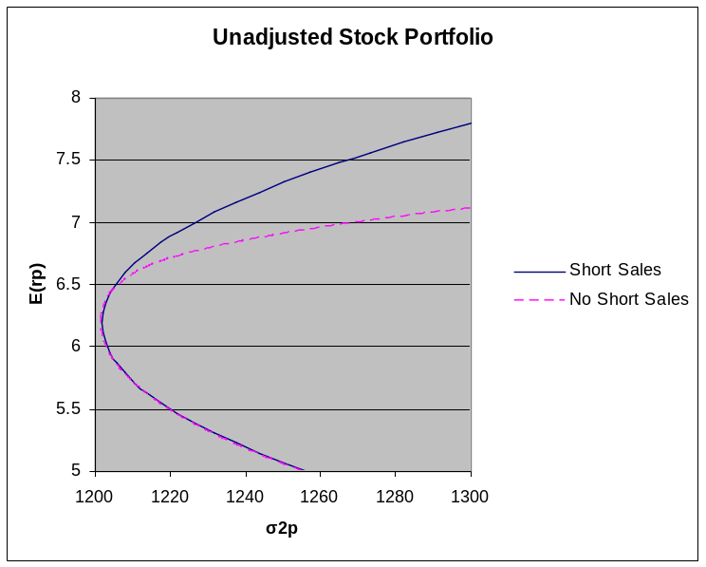

Sources: Stock return data from yahoo.com/finance and mscibarra.com ; Inflation data from IFS Online
(imfstatistics.org)

Application of Model

Since the majority of international investment occurs in the markets of the US, the UK, Japan and a limited number of other highly developed large economies, the portfolio includes the assets which are most utilized in actual international portfolios. Additionally, the inclusion of Australia allows the portfolio to encapsulate those economies that are less traditionally utilized in international portfolios, but that are less risky than developing economies. The inclusion of the Emerging Market Index allows the portfolio to include an asset that represents investment choices in lesser developed nations. Due to the diversity of investment opportunities represented by the five indexes, I hope to approximate the actual opportunities that are provided by international diversification.
By using foreign exchange data to convert the returns into a single currency, the efficiency envelope is adjusted to reflect the perspective of a domestic investor. All the portfolios along this curve are efficient only for the investor who uses that currency. Since the curve reflects efficiency for a domestic investor, and is adjusted for PPP deviations, I will hereafter refer to it as the domestic currency adjusted locus. This is because PPP deviations cause the expected return of a market to vary when estimated for different international investors. The difference in returns on foreign investments between currencies is a result of this PPP-deviation adjustment.
Using this logic, an efficient portfolio that has not been adjusted for PPP deviations can be estimated. This is done by leaving each asset’s return data in terms of its own respective domestic currency. By creating such a portfolio, I can compare those portfolios that account for PPP deviations to a control portfolio.
The domestic currency adjusted locus derived by the model estimates the share of the domestic asset in an efficient portfolio for a given expected return. By comparing such figures with portfolio shares in an efficient portfolio that has not been adjusted for PPP deviations, the effects of PPP deviations on rational investing can be observed. If the domestic holdings in a domestic currency adjusted portfolio are greater than in a non-PPP-adjusted portfolio, this would suggest that investors would rationally hold a higher ratio of domestic assets in their portfolio as a response to PPP deviations. If such difference is substantial, this would suggest that some home bias may be a rational investor response to PPP risk.
For example, by looking at all markets in US dollars, one can analyze the returns a US investor would experience. Optimizing that portfolio would yield efficient shares in a US portfolio. In that portfolio, the S&P 500 asset would be considered the domestic asset; the domestic asset of each country is its own stock market. By comparing such a portfolio to one that is not adjusted for exchange rate differences, one can draw inferences as to the effects PPP deviations have on rational investing by looking at the relative portfolio shares of the domestic asset in the two portfolios.

V. Results

Introduction

The following sections detail the results of the stock data analysis. The first test uses multiple points of comparison between the various portfolios, including common expected returns and assuming common relative risk aversion for the typical investor. The hypothesis that PPP deviations cause a rational investor to increase the portfolio share of his domestic asset is not fully supported; there is no case in which every country significantly emphasizes its own asset in relation to those of other countries. Though the hypothesis is not fully supported, this test does not claim to fully explain home bias, and possible reasons for some of the incongruent results have been proposed. As a result, the overall hypothesis that PPP deviations partially explain the home bias effect receives some support.
The second test isolates a time period of relative stability in the Japanese market in order to approximate the returns and variances an investor may expect in the future. The total twenty year analysis period includes a significant crash in the Japanese market, resulting in low predicted investment in Japan. Since investors are concerned with the future, past observations such as recessions may be discounted. The second test finds that, after adjusting Japan’s return data, investment is increased in Japan and the domestic currency adjusted portfolios show an increase in domestic investment relative to the no PPP-risk portfolio, with one exception.
The third test attempts to explain home bias assuming investors diversify primarily in order to avoid major market shocks. The hypothesis is that since international markets tend to move together in times of large movement, foreign assets are not as good of hedges as previously concluded. By only including data from months where real returns were more than one standard deviation from the mean, the data set is altered to reflect only those periods of large market movements, when the annualized return is more than one standard deviation from the mean. The results do not support the hypothesis; in fact, international diversification in emerging markets is more beneficial in times of substantial domestic fluctuation.

The First Test

For the first test, the entire set of stock data is taken into account, so the model uses the entire period of November 1987 to November 2007 to calculate expected returns and variances.
To generate a point of comparison, the portfolios for each nation are selected with a common expected return of 6.85%. This return was chosen because each market had an efficient portfolio with an expected return of 6.85%. As a result of taking 6.85% as a given expected return, the portfolios generated are all on the efficiency locus for their respective markets, since a higher expected return is not possible with an equal lower variance.
As stated previously, to measure the increase in demand for domestic assets as a result of PPP deviations, a no PPP-risk portfolio is included in the data analysis. The portfolio lacks risk associated with PPP deviations as measured by exchange rate changes. Inflation on each asset is subtracted using CPI data from the assets respective countries, with the exception of the emerging market index, which uses US inflation to match its US dollar returns.
As can be inferred from my hypothesis, my expected results are increases in each nation’s domestic asset share when measured as a percentage of the total domestic currency adjusted portfolio, relative to that asset’s share in a non-PPP-adjusted efficient portfolio. This result would be interpreted as consistent with an increase in risk associated with foreign assets relative to domestic assets once the stock data is adjusted for exchange rates.

Analysis (full results reported in Appendix A)

Table 5.1
Nation | Portfolio σ | % Dom Asset PPP-risk adj | % Dom Asset no PPP-risk adj | Change
Australia | 46.95 | 37.33% | 29.17% | 8.15%
US | 36.80 | 48.16% | 44.38% | 3.77%
Japan | 48.21 | 16.53% | 0.00% | 16.53%
UK | 55.34 | 9.58% | 0.00% | 9.58%
Sources: Stock return data from yahoo.com/finance and mscibarra.com ; Historical exchange rate data from The Federal Reserve Bank of St. Louis; Inflation data from IFS Online (imfstatistics.org)

The above table is a condensed summary of the test results. All the results are rounded to the nearest tenth of a percentage point. The two most important categories are % Dom Asset PPP-risk adj and Change. % Dom Asset PPP-risk adj is the percentage of domestic asset in the overall domestic currency adjusted portfolio; for example, in order to achieve 6.85% returns in an efficient manner, Australia must invest 37.33% of its total portfolio in domestic assets. The Change column describes the change in domestic investment behavior from the no-PPP risk portfolio. This column shows the increase in domestic investing as a result of PPP deviations.
Looking at the % Dom Asset no PPP-risk adj data, it is clear that substantial gains can be made by increasing international diversification. As an example, when one does not adjust for exchange rate risk the model estimates that the US should only hold 44.38% of its total portfolio in US assets. This is in stark contrast to the data presented by French and Poterba (1991), who estimate actual US domestic equity holdings to be approximately 94% in 1989. Once adjusted for PPP deviations, the results generally show a lesser amount of potential gains from diversification, but still allow for substantial risk reduction. This is reflected in the domestic shares still falling short of observed levels, even after the increase.
In this table, there are two interesting cases. The most interesting is Japan. According the Change column, PPP deviations are more responsible for home bias in Japan than in any other country tested. This result could be deceiving, however, due to Japan’s share in the no PPP-risk portfolio. As can be seen in the table, Japan has a 0% share in the no PPP-risk efficient portfolio. This is due to the dismal performance of Japan’s stock market during the analysis period, as shown graphically in Appendix C. For instance, in December of 1989, the Nikkei 225 was at ¥38916; in April of 2003, it had fallen to ¥7831.42. This decline is best represented by the average annual real return of -2.21%.
The reason this result could be deceiving is that while the results reflect the data available for the Nikkei during the analysis period, investors looking forward may discount the figures generated from the data. The large decline in Japanese stocks was due to a market correction that is not indicative of the future performance of the Nikkei. As a result, -2.21% is probably not the current expected return of the Nikkei 225. While historical data is used to estimate expected returns and variances, investors will realize that the performance of the Nikkei in the analysis period is probably atypical, and will consider figures such as -2.21% annual expected returns as an inaccurate prediction of future behavior.
The second interesting case is that of the UK. Relative to the other countries, the UK had small real returns during the analysis period, with an annual average of 3.47%. While this figure does not suggest poor performance on par with Japan, it does help explain the UK’s 0% portfolio share in the no PPP-risk portfolio. Perhaps more difficult to explain is the UK’s relative share in its PPP-adjusted portfolio. In the case of PPP-adjusted portfolios, UK investors maintain a smaller proportion of domestic assets than even Japanese investors. We will look at a possible explanation later.
By showing the potential gains from increasing international diversification after adjusting for currency, the results support the hypothesis that PPP deviations are somewhat responsible for home bias. However, the results also seem to suggest that PPP deviations are causing different levels of domestic investment in efficient portfolios in most of the countries. For example, the efficient level of domestic investment in a PPP-adjusted portfolio with a given expected return of 6.85% for the US is 48.16%, while it is only 9.85% in the UK.
This result could be due to the point of comparison used. By using a common expected return, each portfolio estimated implies that the typical investor in different countries has a different degree of relative risk aversion. The literature review discussed how relative risk aversion is a measure of investor indifference to risk/reward combinations; the slope of a tangent line to the envelope is equal to RRA/2. By taking a given expected return of 6.85%, the efficient portfolio generated for each country is associated with an investor indifference curve tangent to the envelope at the point of that portfolio. Since these indifference curves have different slopes across the countries, the efficient portfolios all are associated with differing levels of relative risk aversion. As stated earlier, the relative risk aversion levels all the countries are positive, but the differences in RRA at a 6.85% given return may be causing skewed results.
In order to address this issue, a new point of comparison can be drawn. Instead of comparing portfolios on the basis of expected returns, they can be compared by using a common measure of relative risk aversion. Since the relative risk aversion for individuals is estimated to be approximately 2, each country will be compared at the point where the slope of the tangent line to its efficiency locus is 1 (Friend, 1975).

Table 5.2
Nation | E(r) | Portfolio σ | % Dom Asset PPP-adj | % Dom Asset no PPP | Change
Australia | 5.63% | 37.34 | 57.97% | 37.13% | 20.83%
US | 7.17% | 36.93 | 50.98% | 49.71% | 1.27%
Japan | 6.55% | 47.85 | 19.04% | 0.00% | 19.04%
UK | 4.90% | 42.14 | 59.11% | 19.94% | 39.17%
Sources: Stock return data from yahoo.com/finance and mscibarra.com ; Historical exchange rate data from The Federal Reserve Bank of St. Louis; Inflation data from IFS Online (imfstatistics.org)

As before, the Change column is determined by finding the difference between the portfolio share of each domestic asset and the portfolio share of that asset in the no risk portfolio of the same expected return. This allows the Change data to describe the difference in efficient domestic holdings and the same asset in an efficient portfolio when PPP-risk is removed.
The two most important differences in this set of results when compared to the previous set are 1) an increase in most country’s Change column and 2) the level of domestic investment in the domestic currency adjusted efficient portfolios for Australia, the US, and the UK. The results show an increase in the Change column for all countries except the US relative to the calculations done with a constant expected return. The decrease in US Change can be easily explained, however, by the increase in the US asset share in the no PPP-risk portfolio. In this portfolio, the US maintains a near 50% share, which leaves less room for increase (post domestic currency adjustment) than the other markets. The non-US results suggest that home bias is better explained by PPP deviations when holding portfolios with an RRA near 2. Since the average investor has a relative risk aversion of 2, the evidence for PPP deviations as at least a partial cause of home bias is especially strong.
Also, once adjusted for PPP deviations, the efficient portfolios for Australia, the US, and the UK all hold over 50% of their assets domestically. While this is not the case for Japan, its figures can again be low due to dramatic decline in the Nikkei previously discussed. This test suggests that PPP deviations are causing the rational investor to hold over half of his portfolio in domestic assets. If this is the case across countries, PPP deviations are a significant factor in home bias.
The UK example is perhaps the strongest evidence for PPP deviations as a source of home bias, with a 39.17% increase in domestic asset share once PPP deviations are accounted for. The UK is also the best support for using a common relative risk aversion over a common expected return as a point of comparison. While the UK maintained 0% portfolio share in the no PPP-risk portfolio with a given expected return of 6.85%, its portfolio share in the no PPP-risk portfolio with a given expected return of 4.905% (which corresponds to the expected return of an efficient portfolio for a UK investor with a RRA of 2) is nearly 20%. Using a common measure of relative risk aversion allows portfolios to be generated that more accurately estimate the actual risk/return preferences of investors across markets.

The Second Test

The second test attempts to reduce the error associated with historical returns not being indicative of future performance. Since the data represents only twenty years of stock returns, it could include an uneven distribution of booms and recessions. An example of this is the real returns of Japanese stocks calculated in yen. Over the period being analyzed, the average annual return is approximately -2.21%. This figure seems highly unlikely to be representative of future performance. It could be explained if the data set started at the peak of a Japanese economic boom, and then included the resulting market correction, or conversely if the set included a recession but ended before the resulting correction.
To correct for this potential error, the data set for Japan has been broken down into a five year subset from July of 1992 to July of 1997. During this period, the Nikkei 225 experienced relative stability. This also can be seen graphically in Appendix C. The rest of the market data is left unchanged; the first test shows the 20 year analysis period to estimate positive average annual expected returns for Australia, the US, the UK, and the emerging markets.
By selecting a period without uncorrected large market variations for Japan, a period that has low variances and reasonable returns relative to the twenty year set, I hope to approximate more realistic investor expectations for future market performance. Such a five-year period would be representative of longer term market data, since in the long run market corrections should prevent skewed average annual return and variance data.
Looking at the results from the first test, an annual expected real return of between 3% and 7% seems a reasonable range. After adjusting Japan’s return data, the average annual expected return for each market is approximately within this range. The expected results are an increase in the domestic holdings in the domestic currency adjusted portfolios relative to the no PPP-risk portfolio, and a positive portfolio share in the no PPP-risk portfolio for each asset.

Analysis

Table 5.3
 | E(r) | Portfolio σ | % Dom Asset PPP-adj | % Dom Asset no-PPP | Change
Australia | 5.02% | 34.67 | 44.60% | 36.64% | 7.96%
US | 6.59% | 30.95 | 40.04% | 46.93% | -6.90%
Japan | 7.04% | 42.07 | 29.48% | 14.25% | 15.23%
UK | 5.35% | 44.73 | 46.37% | 6.03% | 40.35%
Sources: Stock return data from yahoo.com/finance and mscibarra.com ; Historical exchange rate data from The Federal Reserve Bank of St. Louis; Inflation data from IFS Online (imfstatistics.org)

Above is a condensed summary of the results. The domestic currency adjusted portfolios in the table all have a relative risk aversion of 2.
The no PPP-risk portfolio with a corresponding expected return to each domestic currency adjusted portfolio with an RRA of 2 has a non-zero share in each respective domestic asset. This result was expected. By adjusting Japan’s stock return data to reflect more likely future performance, Japan’s desirability increased.
The Change column for the US shows that, after adjusting for PPP deviations, US investors actually hold less of their domestic asset. This result is in stark contrast to the hypothesis proposed in the issue section. One possible explanation is related to the US’s relatively large share in the no PPP-risk portfolio. This would suggest that there are diminishing returns to increasing levels of domestic investment, even when PPP deviations are accounted for, which would support the argument that PPP deviations are not wholly responsible for home bias.
The most interesting result, however, is the decrease in domestic holdings in the domestic currency adjusted portfolios relative to the first test (with the exception of Japan). This could be a result of truncating Japan’s historical stock data. While this data adjustment yielded a more reasonable expected return for Japan’s future performance, it also decreased the level of correlation with the other markets. Japan therefore is a far more attractive investment than in the first test, and is pulling investment away from the domestic markets. The Change column, with the exception of the US, shows this effect to not outweigh the increases in domestic investment as a result of PPP deviations.

The Third Test

The third test attempts to establish the relevance of the first two tests. Home bias is additional portfolio risk associated with the failure to adequately diversify internationally. This additional risk is based upon the idea that the covariance between a foreign and a domestic asset is lower than the covariance between two domestic assets. As previously discussed, as a portfolio becomes further diversified, the covariance of the assets has greater effect on portfolio variance.
The question then becomes: what are investors hedging against by internationally diversifying their portfolios? An investor may be most concerned with reducing risk to minimize the chance of suffering a large financial loss. An adequately diversified domestic portfolio would suffer such losses in times of domestic market recessions. During a major market decline, the domestic portfolio would experience losses since, when diversified, it represents the domestic market as a whole. Investor choices to diversify internationally may therefore be attempts to hedge against large domestic decline.
If investors are attempting to protect themselves from periods of extreme domestic market movements, then the covariance between domestic and foreign assets is only relevant during these periods. Assuming domestic assets were perfectly stable, they would have little risk, and diversification of this risk may not be important. International diversification lessens portfolio risk because losses in domestic markets can be partially offset by lesser foreign losses or even positive foreign gains.
If the covariance of domestic and foreign assets spikes during times of large market movements, there would be less incentive to internationally diversify an equity portfolio. This is because foreign markets would be experiencing the same type of activity, whether positive or negative, as domestic markets. In this case, investors may not view international diversification as beneficial relative to the case where covariances with foreign markets do not increase during times of large movements. If this is the case, home bias may be the result of investors only attempting to hedge against large market movements.
In order to test the hypothesis that home bias is caused by investors placing the most value on the benefits of diversification during times of marked economic fluctuation, the same type of testing previously used will be applied to a data set that measures returns only during times of large movements. As a simplified case, severe fluctuation in market returns will be estimated from the perspective of a US investor. In order to isolate times of domestic market movements, the only data points considered are those in which the S&P 500 annualized real returns are more than one standard deviation from the mean. This yields 62 data points, as compared to the 240 observations of the entire data set.

Tables 5.4
 | USD | Entire | Data | Set
 | Aus | US | Japan | UK | EM
Aus | 1 | 0.4108 | 0.3891 | 0.4239 | 0.4684
US | 0.4108 | 1 | 0.3538 | 0.6398 | 0.5451
Japan | 0.3891 | 0.3538 | 1 | 0.359 | 0.3078
UK | 0.4239 | 0.6398 | 0.359 | 1 | 0.4808
EM | 0.4684 | 0.5451 | 0.3078 | 0.4808 | 1

 | USD | 1 Std | Dev
 | Aus | US | Japan | UK | EM
Aus | 1 | 0.5387 | 0.6199 | 0.5687 | 0.1303
US | 0.5387 | 1 | 0.5396 | 0.8523 | -0.1417
Japan | 0.6199 | 0.5396 | 1 | 0.4906 | 0.0963
UK | 0.5687 | 0.8523 | 0.4906 | 1 | -0.0468
EM | 0.1303 | -0.1417 | 0.0963 | -0.0468 | 1
Sources: Stock return data from yahoo.com/finance and mscibarra.com ; Historical exchange rate data from The Federal Reserve Bank of St. Louis; Inflation data from IFS Online (imfstatistics.org)

The tables above present the correlation coefficients for the five markets when calculated for both the entire 20 year data set and a set that accounts for only time of large market movements, adjusted for PPP deviations for the US investor. This table is evidence that the correlation between foreign and domestic markets is in fact higher during times of large domestic movements than when measured from an entire continuous time period, with one important exception. The covariance between the US and the Emerging Market Index actually shrinks to the point where the two are negatively correlated when calculated from only those periods of large US market movements. A US investor would therefore emphasize the emerging markets in his portfolio if he were attempting to diversify away risk during times of domestic recession.
My expected results are a large positive change in the percentage of domestic and emerging market assets held by the US investor when considering only times of market movements instead of considering the return data as a whole. This would mean that home bias would not be a result of investors hedging against PPP-deviation risk, but instead that most foreign assets are simply not as beneficial to hold during times when most needed.

Analysis

Table 5.5
 | E(r) | % Aus | % US | % Japan | % UK | % EM
UStotal | 7.17% | 16.15% | 50.98% | 0.00% | 8.04% | 24.84%
USdeviation | 3.28% | 33.05% | 8.53% | 0.00% | 30.05% | 28.37%
Change |  | 16.90% | -42.45% | 0.00% | 22.01% | 3.53%
Sources: Stock return data from yahoo.com/finance and mscibarra.com ; Historical exchange rate data from The Federal Reserve Bank of St. Louis; Inflation data from IFS Online (imfstatistics.org)

The above table shows the efficient portfolio composition for two different US investor portfolios. The row USdeviation describes an efficient portfolio for US investors with an RRA of 2, taking into account only those months where the S&P500 deviated more than one standard deviation from its mean estimated real return. The row UStotal describes a portfolio with the minimum variance possible for a US investor with an expected real return of 3.28%, taking into account the returns for every month over the 20 year period. The Change column shows the difference in each country’s relative portfolio share when US investors consider only those times of large domestic market fluctuation. It does this by subtracting asset shares in the US domestic currency adjusted full data portfolio from asset shares in the US domestic currency adjusted portfolio that measures large market fluctuations.
This test uses a common degree of relative risk aversion as a comparison point. While this method was shown to be superior in the first test, the differences in the variances and expected returns of the assets in the two portfolios being compared in this test cause a common investor level of RRA to correspond to extremely dissimilar expected returns for the portfolios. This is important to note when analyzing the results.
The hypothesis stated that, during times of large domestic deviation, the demand for US assets would be greater than when the data was considered in totality. This would have resulted in a positive number in %US Change cell. In fact, the actual result is a large negative number. If a US investor was assembling his portfolio based on the best mixture to hedge against large risks, he would hold a much smaller percentage of domestic assets relative to if he were attempting to minimize risk at all times.
Also predicted was a large increase in demand for the emerging market asset during times of large US market movements. This would have resulted in a large positive number in the %EM Change cell. While there is an increase in demand for the emerging market asset, it is not nearly as large as the Australian or British asset. As expected, if a US investor were attempting to hedge against risk during times of large market movements, he would diversify by holding more emerging market assets in his portfolio, but the amount of this increase is unexpectedly small.
The results do raise some questions. Since the US market’s covariance with Australia and the UK’s respective markets increases during times of large US movements, why would a US investor further diversify in those markets if he were hedging against US recession? And why did the demand for US assets fall when predicted to rise?
These problems can be explained by the properties of the portfolios being generated. While covariance is the only determinate of risk in a portfolio with an infinite amount of assets, the portfolio above has only five assets. Therefore, the variance of each asset still affects overall portfolio risk. Also, the assets all have different expected returns. This also affects the proportions of assets an investor will hold in his portfolio. Other problems stem from overall portfolio efficiency; the two portfolios being compared are different to the point that there is no expected return that corresponds with an efficient portfolio in both cases.

VI. Conclusion

This paper attempted to confirm purchasing power parity deviations as a cause of the home bias effect in global equity investments. By creating and comparing efficient portfolios that both allowed and disallowed additional risk from PPP deviations, I was able to identify trends of increased domestic investment as a rational reaction to PPP deviations.
The testing found, with a few notable exceptions, that levels of efficient domestic investment did in fact increase as a result of PPP deviations. In the first and second test, explanations for the exceptions to this trend were put forth. In the third test, a new potential explanation for US home bias was given, but was unable to provide clear conclusions because of unpredicted results.
This paper shows that deviations in purchasing power deviations are causing additional risk in foreign assets, and that investors are reacting to that risk by investing higher proportions of their portfolios domestically. By doing this, I support the argument that PPP deviations are responsible, at least partially, for the home bias effect.
By showing PPP deviations to be a cause of the home bias effect, my results imply that investors are not acting entirely irrationally. This implies that there are in fact barriers to international capital flows. Because of barriers to capital flow, returns on equity investments do not accurately reflect the profitability of firms; instead, they reflect both firm profitability and the additional costs of international investment. The larger implication of my results, therefore, is that global capital allocation is not efficient.
The results from the testing also present important issues not entirely related to the arguments of this paper, but potentially addressable with further research based on the existing model. The issue is foreign investment in emerging markets. Appendix A shows the full results for the testing, and a trend for large amounts of investment in emerging markets is evident in all of the tests for each domestic currency adjusted portfolio. This finding is in stark contrast with French and Poterba’s (1991) empirical observation that the emerging markets comprise a small proportion of international investment.
The question this poses is, in addition to holding inefficient portfolios, are investors in large developed economies such as the US hindering development in the emerging markets by failing to include them as a significant share in their international portfolios? This issue is important because it deals with the income gap problem across countries discussed by economists such as Wallerstein (1974). By failing to hold efficient portfolios, investors may be contributing to the perpetuation of poverty in the emerging markets.
The ill effects of small amounts of foreign investment for the development of emerging economies are discussed by Anyanwu (2006) in relation to African development. In his paper, Anyanwu suggests that increased foreign investment could boost the development of Africa, and that increasing economic stability is making Africa a safer investment opportunity. The same logic could be applied to the rest of the emerging markets. By holding efficient portfolios, investors could reduce their own risk while simultaneously reducing poverty in lesser developed countries.
My paper showed PPP deviations to be partially responsible for home bias, but it also showed that foreign investment in emerging markets to be a rational investment behavior. This result is a topic for further study.

Appendix A

This appendix gives the full results for each of the tests.

Test 1

E(r) = 6.85%

Nation | E(r) | Portfolio σ² | % Aus | % US | % Japan | % UK | % EM | % Dom Asset PPP adj | % No Adj | Change
Australia | 6.85% | 2204.42 | 37.33% | 7.75% | 0.00% | 0.00% | 54.92% | 37.33% | 29.17% | 8.15%
US | 6.85% | 1354.48 | 15.88% | 48.16% | 1.78% | 11.71% | 22.47% | 48.16% | 44.38% | 3.77%
Japan | 6.85% | 2324.12 | 17.83% | 21.78% | 16.53% | 22.33% | 21.54% | 16.53% | 0.00% | 16.53%
UK | 6.85% | 3062.52 | 7.38% | 31.51% | 0.00% | 9.58% | 51.53% | 9.58% | 0.00% | 9.58%
No PPP-Risk | 6.85% | 1240.15 | 29.17% | 44.38% | 0.00% | 0.00% | 26.44%
Sources: Stock return data from yahoo.com/finance and mscibarra.com ; Historical exchange rate data from The Federal Reserve Bank of St. Louis; Inflation data from IFS Online (imfstatistics.org)

RRA =2

Nation | E(r) | Portfolio σ² | % Aus | % US | % Japan | % UK | % EM | % Dom Asset PPP adj | % No Adj | Change
Australia | 5.63% | 1394.08 | 57.97% | 15.79% | 0.00% | 1.86% | 24.39% | 57.97% | 37.13% | 20.83%
US | 7.17% | 1364.07 | 16.15% | 50.98% | 0.00% | 8.04% | 24.84% | 50.98% | 49.71% | 1.27%
Japan | 6.55% | 2289.96 | 16.94% | 20.34% | 19.04% | 22.99% | 20.69% | 19.04% | 0.00% | 19.04%
UK | 4.90% | 1775.61 | 16.08% | 4.43% | 0.00% | 59.11% | 20.38% | 59.11% | 19.94% | 39.17%
No PPP-Risk | 5.63% | 1394.08 | 57.97% | 15.79% | 0.00% | 1.86% | 24.39% | 57.97% | 37.13% | 20.83%
Sources: Stock return data from yahoo.com/finance and mscibarra.com ; Historical exchange rate data from The Federal Reserve Bank of St. Louis; Inflation data from IFS Online (imfstatistics.org)

Test 2

Nation | E(r) | Portfolio σ² | % Aus | % US | % Japan | % UK | % EM | % Dom Asset PPP adj | % No Adj | Change
Australia | 5.02% | 1201.76 | 44.60% | 17.18% | 23.20% | 4.19% | 10.83% | 44.60% | 36.64% | 7.96%
US | 6.59% | 958.03 | 16.85% | 40.04% | 20.02% | 3.34% | 19.76% | 40.04% | 46.93% | -6.90%
Japan | 7.04% | 1769.87 | 16.09% | 12.17% | 29.48% | 29.35% | 12.91% | 29.48% | 14.25% | 15.23%
UK | 5.35% | 2001.11 | 10.28% | 0.00% | 26.62% | 46.37% | 16.73% | 46.37% | 6.03% | 40.35%
Sources: Stock return data from yahoo.com/finance and mscibarra.com ; Historical exchange rate data from The Federal Reserve Bank of St. Louis; Inflation data from IFS Online (imfstatistics.org)

Test 3

 | E(r) | Portfolio σ | % Aus | % US | % Japan | % UK | % EM
UStotal | 7.17% | 36.93 | 16.15% | 50.98% | 0.00% | 8.04% | 24.84%
Usdeviation | 3.28% | 51.68 | 33.05% | 8.53% | 0.00% | 30.05% | 28.37%
Change |  | 14.74 | 16.90% | -42.45% | 0.00% | 22.01% | 3.53%
Sources: Stock return data from yahoo.com/finance and mscibarra.com ; Historical exchange rate data from The Federal Reserve Bank of St. Louis; Inflation data from IFS Online (imfstatistics.org)

Appendix B

This appendix shows a measurement of the home bias effect. The efficiency locus is the domestic currency adjusted locus for the US from November 1987 until November 2007. The actual US portfolio was calculated using US portfolio asset share data from French and Poterba’s (1991) empirical study. That data was viewed in the terms of my model’s asset categories, and I used my model to calculate the actual US portfolio.

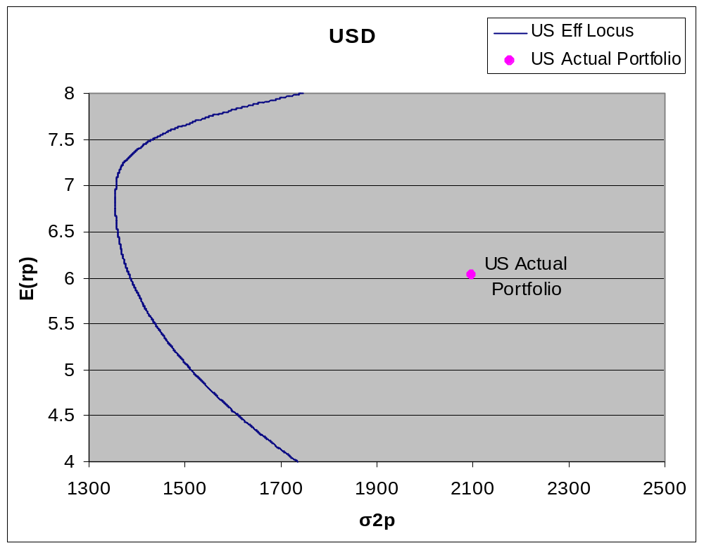

In this diagram, the cost of home bias is the difference in portfolio variance for the actual US portfolio and the efficient portfolio with the same expected return. This large difference is the extra risk associated with failure to properly diversify, and is represented by the bold line.

Appendix C

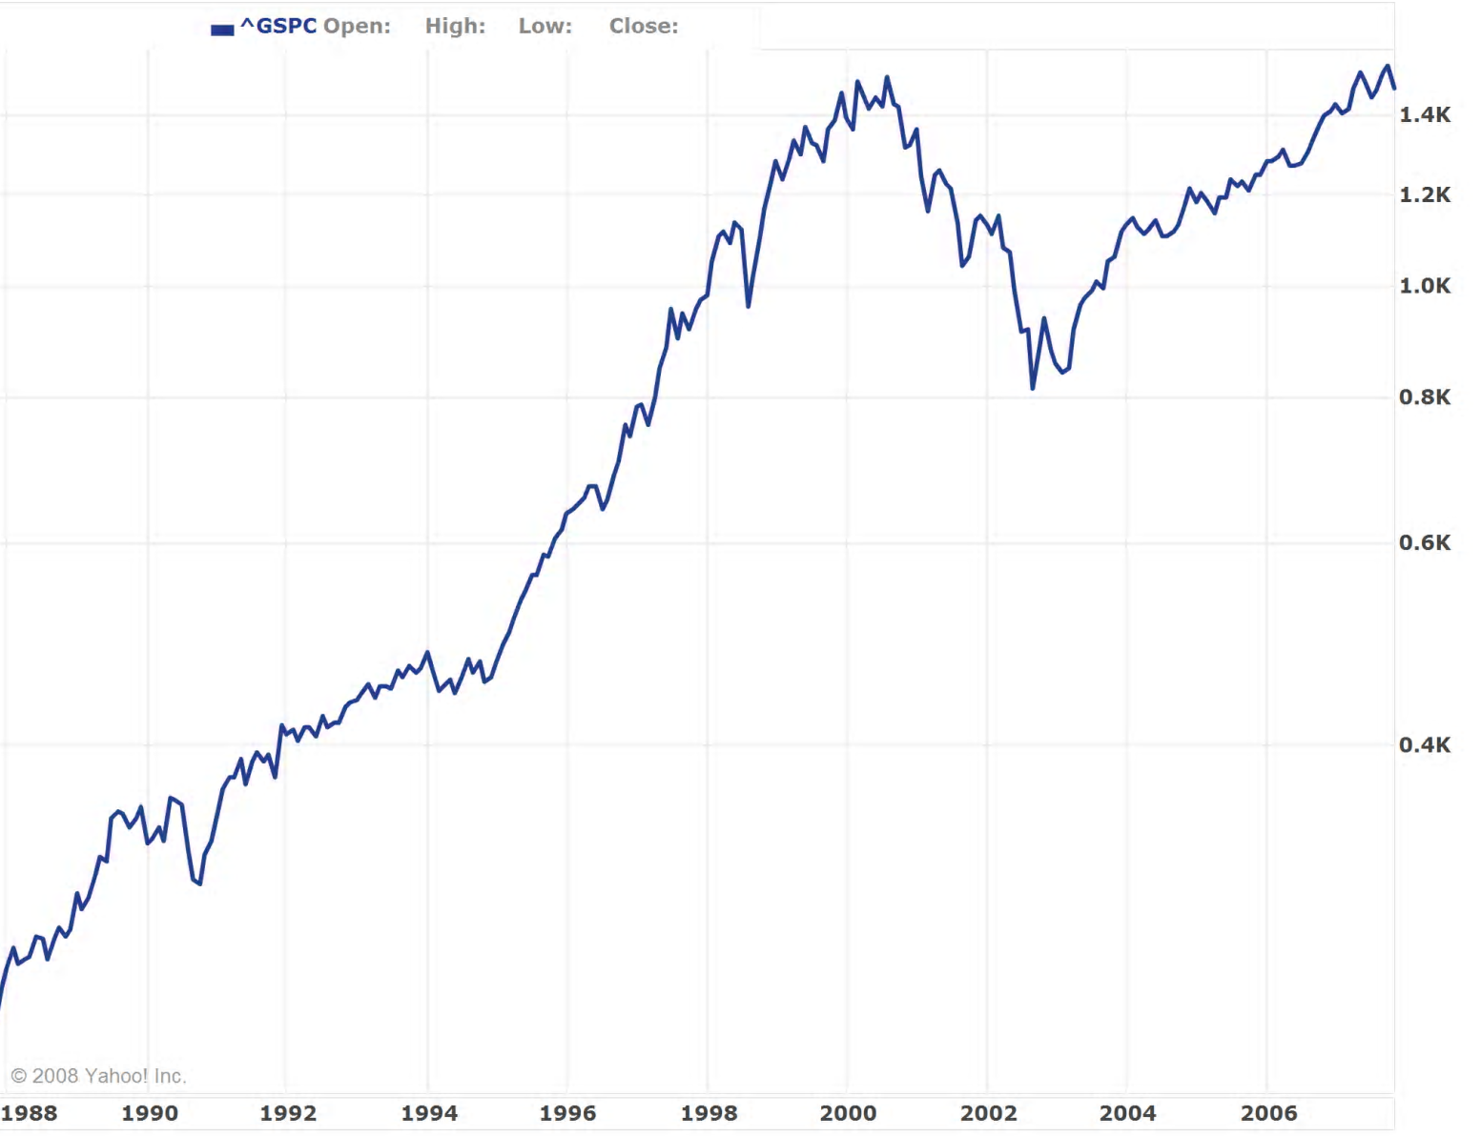
This appendix shows a graphical representation of the stock activity for each market. Each graph is scaled logarithmically.

AORD

Source: yahoo.com/finance

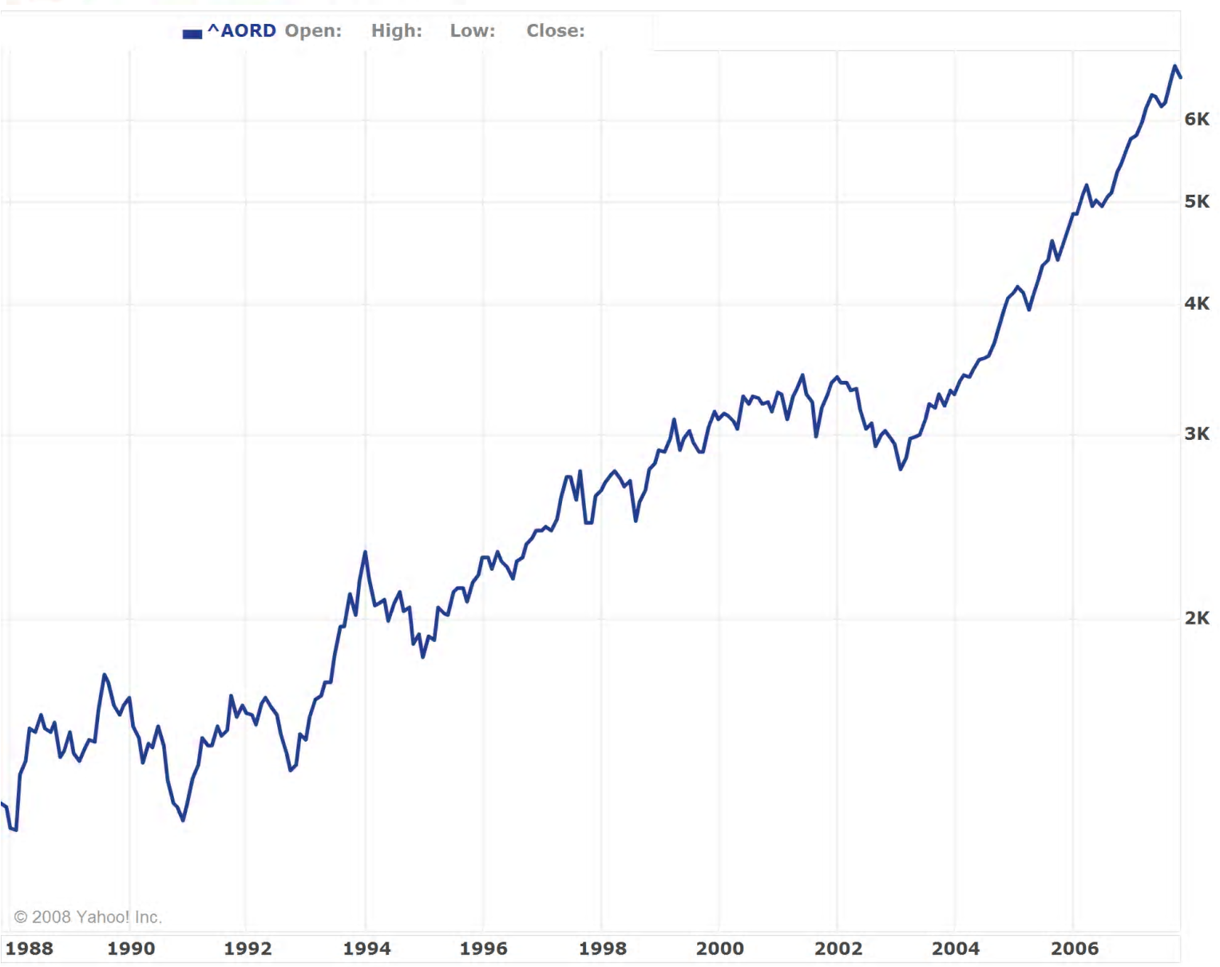
S&P 500

Source: yahoo.com/finance

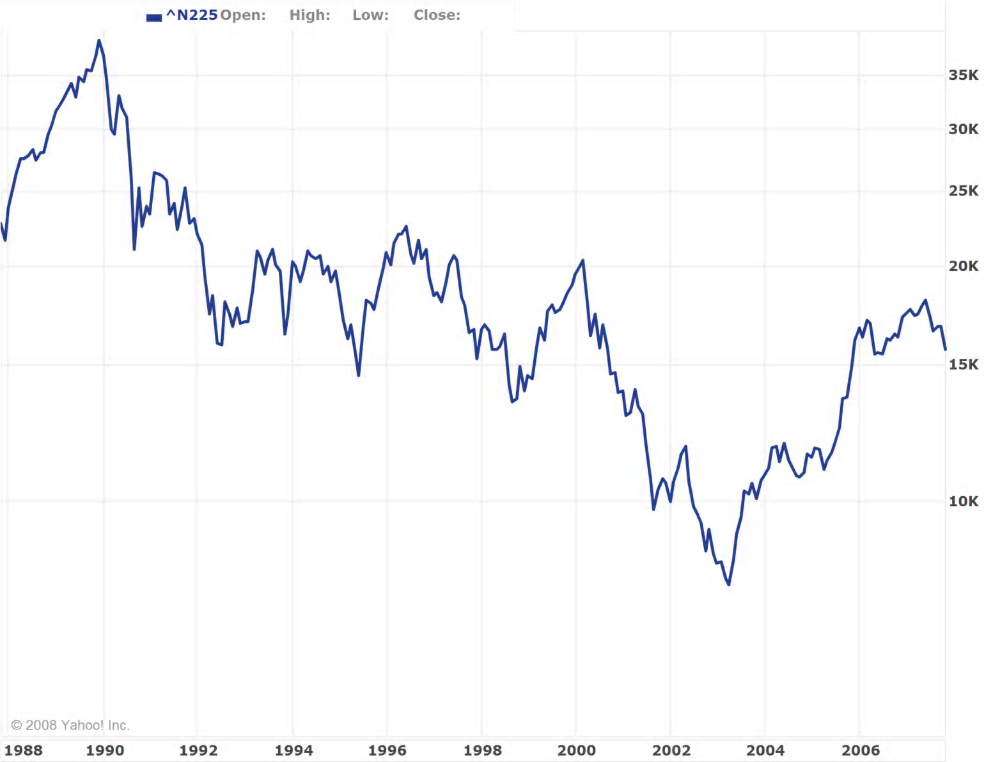
Nikkei 225

Source: yahoo.com/finance

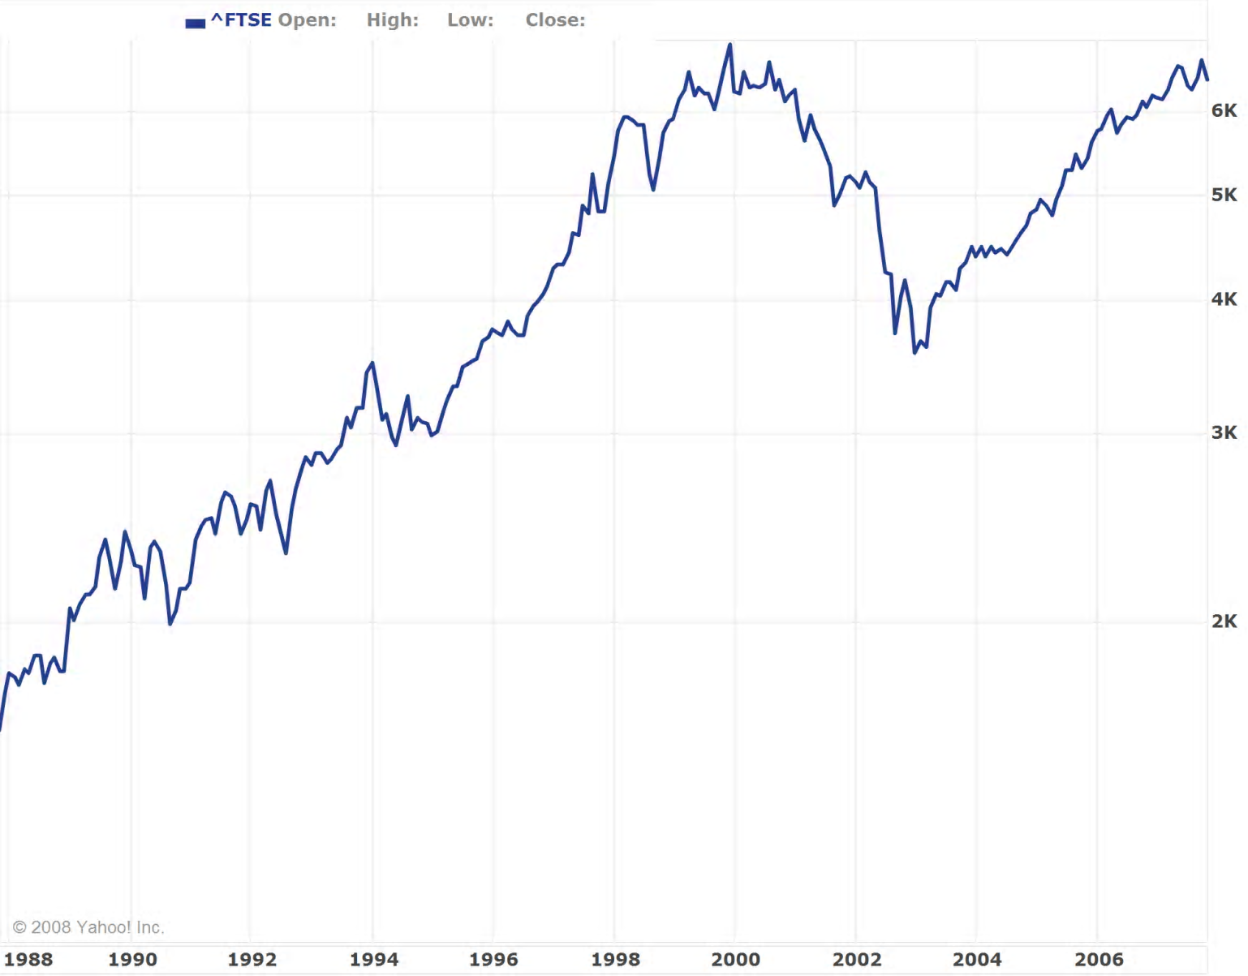
FTSE 100

Source: yahoo.com/finance

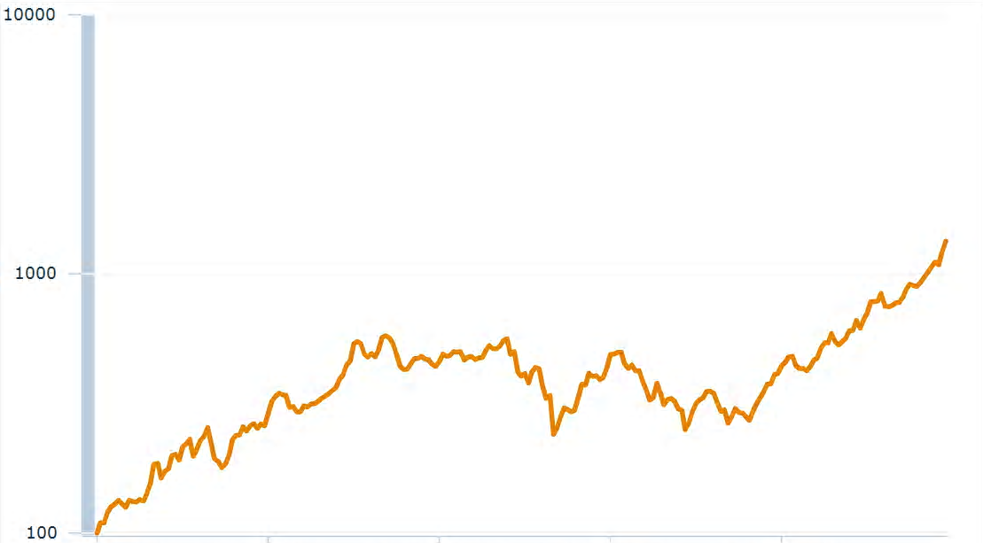
MSCI EM

Source: mscibarra.com

Literature Reviewed

Adler, M. a. B. D. (1983). International Portfolio Choice and Corporation Finance: A Synthesis. The Journal of Finance, XXXVIII(3), 925-984.
Anyanwu, J. C. (2006). Promoting of Investment in Africa. African Development Review/Revue Africaine de Developpement, 18(1), 42-71.
Bellalah, M., & Aboura, S. (2006). The Effect of Asymmetric Information and Transaction Costs on Asset Pricing: Theory and Tests. International Journal of Business, 11(2), 219-236.
Black, F. (1972). Capital Market Equilibrium with Restricted Borrowing. Journal of Business, 45, 444-455.
Bodie, Z. a. R. C. M. (1998). Finance (Preliminary ed.). Upper Saddle River: Prentice-Hall, Inc.
Bohn, H. a. L. L. T. (1996). U.S. Equity Investment in Foreign Markets: Portfolio Rebalancing or Return Chasing? The American Economic Review, 86(2), 77-81.
Cai, F., & Warnock, F. E. (2006). International Diversification at Home and Abroad: National Bureau of Economic Research, Inc, NBER Working Papers: 12220.
Cecchetti, S. G. (2006). Measuring Risk. In Money, Banking, and Financial Markets (1 ed.). New York: McGraw-Hill/Irwin.
Cooper, I. a. E. K. (1994). Home Bias in Equity Portfolios, Inflation Hedging, and International Capital Market Equilibrium. The Review of Financial Studies, 7(1), 45-60.
French, K. R. a. J. M. P. (1991). Investor Diversification and International Equity Markets. The American Economic Review, 81(2), 222-226.
Friend, I. a. M. E. B. (1975). The Demand for Risky Assets. The American Economic Review, 65(5), 900-922.
Gehrig, T. (1993). An Information Based Explanation of the Domestic Bias in International Equity Investment. Scandinavian Journal of Economics, 95(1), 97-109.
Kho, B.-C., Stulz, R. M., & Warnock, F. E. (2006). Financial Globalization, Governance, and the Evolution of the Home Bias: National Bureau of Economic Research, Inc, NBER Working Papers: 12389.
Levy, H. a. M. S. (1970). International Diversification of Investment Portfolios. The American Economic Review, 60(4), 668-675.
Lewis, K. K. (1999). Trying to Explain Home Bias in Equities and Consumption. Journal of Economic Literature, XXXVII, 571-608.
Ross, S. A. (1977). The Capital Asset Pricing Model (CAPM), Short Sale Restrictions and Related Issues. The Journal of Finance, 32(1), 177-183.
Sharpe, W. F. (1970). Portfolio Theory and Capital Markets. New York: McGraw Hill Book Co.
Solnik, B. H., Karolyi, G. A., & Stulz, R. M. (2003). An Equilibrium Model of the International Capital Market. In International capital markets. Volume 1 (pp. 3-27): Elgar Reference Collection. International Library of Critical Writings in Financial Economics, vol. 12.
Cheltenham, U.K. and Northampton, Mass.:
Elgar; distributed by American International Distribution Corporation, Williston, Vt.
Suh, J. (2005). Home Bias among Institutional Investors: A Study of the Economist Quarterly Portfolio Poll. Journal of the Japanese and International Economies, 19(1), 72-95.
Tversky, A. a. C. H. (1991). Preferences and Beliefs: Ambiguity and Competence in Choice Under Uncertainty. Journal of Risk and Uncertainty, 4, 5-28.
Wallerstein, I. (1974). The Modern World-System as a Capitalist World-Economy. In F. a. J. B. Lechner (Ed.), The Globalization Reader (3rd ed., pp. 55-61): Blackwell Publishing.
Woglom, G. a. R. K. (2003). Incorporating Non-financial Wealth in College and University Investment Strategies. Journal of Educational Finance.

The marginal rate of substitution between risk and return for an investor is the slope of his indifference curve.
This graphical representation plots expected return against variance (σ²). If the independent variable was instead standard deviation, σ, the indifference curves would be bowed.
This is done using historical foreign exchange data from dates corresponding to the index return data. In some cases, the foreign exchange data was generated from other foreign exchange data. This process is accurate because arbitrage prevents discrepancies in the prices of currencies. For example, the data for the exchange rates between the Yen and the Australian dollar were found by multiplying the Yen/USD ratio by the USD/AUD ratio.
This is true with the exception of the emerging markets index. The MSCI EM is denoted in terms of US dollars, so the emerging markets are measured in terms of the US domestic currency.
As discussed in the literature review, the assumption that investors can freely short risky assets is unrealistic. While the complete restriction of short selling probably overcompensates for real world barriers, it is a better assumption than complete freedom to short sell.
The indifference to risk/reward combinations was graphically depicted with indifference curves.
As described in the literature review, this tangent line is the indifference curve for investors.
The literature review details Friend and Blume’s (1975) finding that the average RRA for an investor is greater than 1 and possibly greater than 2. As a result, I assume 2 to be a valid level of relative risk aversion for investors.

