The new american public school:
recent Immigrant children and peer effects
by
Ryan Yeung
Submitted to the
Department of Economics
of Amherst College in partial fulfillment of the requirements for the degree of
Bachelor of Arts with Honors
Amherst College
2004
Advisor
George Perkins

May 7, 2004
Date

Table of Contents
List of Figures iv
List of Tables v
Introduction 1
A New America 1
Immigrant Characteristics 4
Peer Effects 7
Chapter 1: The Immigrant Experience 10
Who 10
Why 13
Ethnic Capital 16
Student Sorting 18
Effects of Immigration 21
Conclusion 24
Chapter 2: Data and Methodology 25
Source 25
Descriptive Analysis 26
Empirical Model 28
Quadratic Modeling 31
Breaking up the Recent Immigrant Variable 32
Chapter 3: Measuring the Effects of Immigrant Students 33
Cross-sectional Estimates 33
First Differences Estimates 34
Quadratic Regressions 35
Country Specific Regressions 35
Teacher Choice 36
Appendix 38
Chapter 4: Conclusion 44
Summary of Findings 44
Policy Implications 45
Suggestions for Further Research 46
Bibliography 48
List of figures
Number Page
- Immigrant Students’ Birth Regions 3
- Distribution of Foreign-Born in NYC by Borough 11
- The Immigration Surplus 22
List of tables
Number Page
1.1. Composition of the Foreign-born Population 12
2.1. Scale Score Ranges for Performance Levels 26
  - Elementary School Descriptives 26
  - Middle School Descriptives 27
  - Description of Variables Used in Regression Analyses 29
  - Estimated Effects of Recent Immigrant Students of Achievement Level
of Non-ELL students (Cross-Sectional) 38

  - Estimated Effects of Recent Immigrant Students on Achievement Level
of Non-ELL students (First Differences) 38

  - Estimated Effects of Recent Immigrant Students on Achievement Level
of Non-ELL students (Cross-Sectional/Quadratic) 39

  - Estimated Effects of Recent Immigrant Students on Achievement Level
of Non-ELL students (First Differences/Quadratic) 40

  - Estimated Effects of Dominican Recent Immigrant Students on
Achievement Level of Non-ELL students (First Differences) 41
  - Estimated Effects of Chinese Recent Immigrant Children on
Achievement Level of Non-ELL students (First Differences) 42

  - Coefficient of Percentage of Recent Immigrants Variable in
Teacher Characteristics Regressions 43
Acknowledgments
The main topic of this essay is peer effects. Therefore, it makes sense the author acknowledges the peer effects involved in the creation of this thesis. I have always seen education as the single most important agent in social change. The author wishes to express his gratitude to the following people who are devoted to education in the same way:

Daniel Barbezat, for teaching me that economics belonged to everyone,

Colin Chellman, for believing that I could tackle any challenge,

George Perkins, whose humor and genuine love of teaching was infectious,

Jeanne Reinle, whose presence makes the economics department function,

Steve Rivkin, for introducing me to the economics of education and forcing me to
work harder and dig deeper to find the real answers to difficult questions,

Karen Sánchez-Eppler, whose efforts helped make two theses possible,

Frank Westhoff, whose door was always open for questions,

And finally my family, who I aspire to emulate each day of my life.

abstract
A tenth of the population of the United States today is foreign-born, the highest proportion since 1930. Children 18 years or younger represent a significant and growing percentage of the foreign-born in the United States. Data from this paper is from New York City, quite possibly the ideal location to study immigration. This paper examines and reviews the economic theories of immigration, and then empirically analyzes the effects immigrant children may have on non-recent immigrant peers in a school.
There are two main models in this paper. One is a simple cross-sectional education production function, and the second model is a first differences model that uses two years of data to remove any school omitted variables that do not change over time. The empirical evidence reveals that immigrant children detract from the learning experience of non-English Language Learner (ELL) peers, though the effect is relatively small.
Policy implications include improving the quality and quantity of limited English proficiency classes to bring ELL students up to speed. In addition, schools are advised to devote additional resources to train teachers in managing a multicultural classroom. Further research with student-level data is recommended.

Introduction
The new, new york
A New America
America has always been a nation of immigrants. Today America is riding the tide of another wave of immigration. In 2000, there were 28.4 million foreign-born individuals in the United States, representing 10.4 percent of the total U.S. population, the highest percentage since 1930. In central cities, the proportion has ballooned to 16 percent.
The last great wave of American immigration occurred between 1880 and 1930 in an event called “The Great Migration.” Individuals who reached the United States after 1880 came from a much wider geographic area than earlier. Among these immigrants were people considered “good” immigrants from Western and Northern Europe, but also “bad” immigrants from Eastern Europe and the Mediterranean, who brought languages and customs that were hardly known of in the New World. New York, was as it is now, the greatest receiving port (Oscar Handlin, 1972).
Today’s immigrants, however, are very different from their European counterparts. Today’s immigrants arrive from numerous nations, speaking numerous languages, come from a variety of educational backgrounds, and differ most from their predecessors in not being predominantly male. 10 percent of America’s foreign born is less than 18 years old and immigrant children represent a large and growing proportion of school children in the United States, especially in urban areas (Ingrid Gould Ellen et al., 2002, Lisa Lollock 2001). Yet despite the growing presence of immigrant children in America’s public schools, the research on their role in the production of education remains surprisingly sparse.
New York City is quite possibly the perfect place to study immigrant children. What is striking about New York City’s immigrant population is not only its size but also its overwhelming heterogeneity. In Los Angeles, the nation’s other premier immigrant capital, the foreign-born population is mostly comprised of immigrants from Mexico, El Salvador, and Guatemala, with relatively few Europeans and only tiny proportions of Caribbeans. New York City, on the other hand, has attracted sizable numbers of nearly every nationality in the world (Ellen Parcy Kraly and Ines Miyares, 2001).
Like New York City, the public school system is a melting pot. Of the 660,000 elementary and middle school students in New York City schools, almost 16 percent are foreign born, and approximately 43% of these immigrants are recent immigrants, foreign-born students who have been in the American school system for less than three years. The city’s foreign-born students hail from all around the world with the largest group originating from one dominant sending country: the Dominican Republic. As can be seen in Figure 1, Dominicans make up 18.6 percent of the city’s foreign born students, with Russians making up 6.7 percent, and Jamaicans 6.4 percent. In total, immigrant students in New York City hail from 192 countries, territories, and provinces (Dylan Conger et al., 2003).

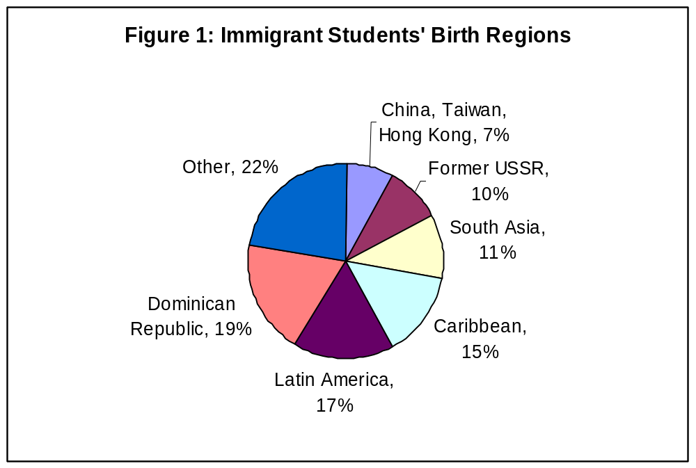
Excerpted from Conger et al. (2003)

In this paper, I hope to understand the interactions that recent immigrant children in New York City have with their schools, teachers and most importantly their peers. There are many theories that hypothesize that the peer effects from recent immigrants may be different from the peer effects from native-born students. On average, recent immigrants tend to have lower achievement. Consequently, classroom discussion may not be as stimulating or intense as it would be otherwise. On the other hand, it is thought that immigrants see education as a means for social mobility and by their example may cause their peers to worker harder (Conger et al., 2003, Ellen et al. 2002). My study attempts to ascertain the existence and sign of the recent immigrant peer effect.

Immigrant Characteristics
Conger et al. (2003) have used student-level data in elementary and middle schools to create a descriptive analysis of New York City’s public school immigrant students. Not surprisingly, a far higher percentage of the foreign-born are limited English proficient compared to their native-born counterparts. Approximately 30 percent of foreign-born students are limited English proficient in comparison to only 8 percent (39,000) of native-born students. In addition, Asians represent a far higher percentage (28%) of all immigrant students than native-born students (8%). Hispanics represent the largest racial group among both the native-born (39%) and foreign-born (36%).
Nationally, the foreign born are far more likely to live in poverty than natives. In 1999, 16.8 percent of foreign-born residents lived below the poverty level, compared with 11.2 percent of natives (Lollock, 2001). Because of the peculiarities of the New York City public school system, namely the considerable number of middle- and upper- class children attending private schools in the city, the poverty gap between foreign-born and native-born is much less pronounced. A striking 85.7 percent of native-born students in New York City are eligible for free or reduced lunch. Only a slightly larger percentage of immigrant children (89.6%) are in this same category (Conger et al., 2003).
A somewhat surprising result that Conger finds is that immigrant students actually outperform native-born students on standardized tests in both English and mathematics. Conger finds that there is much more variance within foreign-born students than between foreign-born students and native-born students. Along racial lines, native-born students always outperform their foreign-born counterparts on reading exams. The only unique case is among white immigrant students who outperform white native-born children in math. In fact, most of the variance between foreign-born students and native-born students is the result of larger proportions of whites and Asians in the foreign-born group.
Part of the variance between ethnic immigrant groups can be explained by differences in the parent’s human capital attainment. Nationally, Asian and Europeans immigrants have been found to have the highest percentages of high school graduates, with 83.8 percent and 81.3 percent in each group with high school degrees. Immigrants from South America have been found to be the most educated among the foreign born from Latin America. 79.6 percent from this group have high school degrees. On the other side are immigrants from Central America who are the least likely to have graduated from high school (37.3 percent). The proportion that had attained a bachelor’s degree ranged from 44.9 percent for those from Asia to 5.5 percent for immigrants from Central America (Lollock, 2001).
Of particular interest to my study is Conger’s analysis of recent immigrants. Not surprisingly, one of the main challenges that recent immigrants face is with language. 46.6 percent of recent immigrants are limited English proficient, compared to 19.2% of non-recent immigrant students and 7.0 percent of native-born students. Recent immigrants also have higher proportions of Asians than other immigrants and native-born students (Conger et al., 2003).
As for test scores, the story on recent immigrants is somewhat complicated. Recent immigrants as a whole have lower test scores than non-recent and native-born students. But Hispanic students who are recent immigrants have higher reading test scores than both non-recent immigrants and native-born students, while white students who are recent immigrants have higher reading scores than non-recent immigrants. A large number of Hispanic recent immigrants are excluded from the standardized exams (88%) and significant percentage of white students as well (55%), leading to this unexpected finding (Conger et al., 2003).
A concern of particular importance that immigrant children may face, especially in New York City, is the possibility of segregation. By calculating various segregation indices Ellen et al. (2002) find that just about one-third of foreign born students would need to change schools to achieve a completely even distribution. The segregation of immigrant children is actually far less severe than the racial segregation that exists. The dissimilarity index, a measure of segregation, for non-whites and whites is 0.683, about twice as worse. The dissimilarity index is calculated as 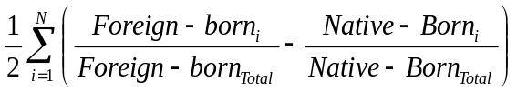, where Foreign-born_{i} and Native-born_{i} sum to the population of school i, and Foreign-born_{Total} and Native-born_{Total} sum to the total school system population. The index of .683 means that just over two-thirds of minority students would need to change schools to achieve a completely even distribution.
When broken down into particular groups of foreign-born students, the authors find significantly higher levels of segregation, especially among students from the Soviet Union, China, Hong Kong, and Taiwan. At one extreme is the typical Soviet immigrant who attends a school where students are far less likely to be poor or non-white, have stronger English skills, and achieve mean standardized test scores that are significantly above the citywide average. The Soviet students typically attend schools with teachers who have more experience and are better educated than the teachers found either in the schools of other immigrant groups or of the native born. At the other extreme is the Dominican immigrant student who attends schools with students who are virtually all poor, virtually all black or Hispanic, and more likely to be limited English proficient. They also attend schools where test scores are significantly below average and where the teachers are less experienced and less educated compared to teachers for all other groups (Ellen et al., 2002).
Segregation is important for my study because of the possible existence of peer effects. The effects recent immigrant children project onto other students may affect the educational outcomes of other students in the classroom.

Peer Effects
As America becomes more diverse, it is important to understand the peer effects recent immigrant children exert on their native-born peers. Peer effects may play a role in a student’s decision about how much to study, how to behave in the classroom, and in the development of a student’s aspirations and expectations. Perhaps more directly, the nature of classroom discussion and teaching is thought to be a function of the composition of the students in the classroom.
There are several levels of peer effects: the classroom level, the school level, and the district level. This study will focus on the school level peer effect of recent immigrants.
By controlling for student and school by grade fixed effects and a number of time varying student, family, and school characteristics, Eric Hanushek et al. (1999) conclude that average peer achievement does affect learning in mathematics, though the magnitude is quite small.
Caroline M. Hoxby (2000) uses a first differences approach with cohort data and finds larger effects from the achievement level of peers. She finds that a credibly exogenous change of 1 point in peers’ reading scores raises a student’s own score between 0.15 and 0.4 points, depending on the specification. Other studies have attempted to isolate the peer effect by instrumenting regressions with variables thought to be correlated with a particular peer effect as Joshua D. Angrist and Kevin Lang (2002) do in their study of Boston’s METCO Program, a program which aims to achieve school integration by busing Boston students into the surrounding suburbs. Despite much lower achievement by METCO students, the authors find little or no statistically significant effects on non-METCO students.
While there is a long literature on peer effects to my knowledge this concept has not been extended to immigrant children, a demographic group that is proving to be more and more important to the development of American society, particularly in large metropolitan areas where recent immigrants are the only factor increasing populations over the past decade. I will use a first differences model that controls for fixed effects to mitigate the effects of endogeneity to determine the effect of recent immigrants on non-recent immigrants. This study is the first step towards a greater understanding of what makes immigrant children different, and what effect those differences have on others.
Chapter 1
the immigrant experience
Before we delve into the issue of immigrant student peer effects let us examine more deeply the economics of immigration in general. To truly understand their effects on native born students within the classroom it is important that we understand what makes these individuals different and what effects these differences may have on others. Who are these people? Why do they come? What are their effects on host residents?

Who?
The U.S. Census defines the foreign-born population as including all people who were not U.S. citizens at birth. Foreign-born people are those who indicated they were either a U.S. citizen by naturalization or they were not a citizen of the United States. Immigrants are not classified by immigration status; consequently this is a heterogeneous group that includes resident aliens, refugees, and illegal aliens.
The 2000 Census recorded 28.4 million foreign born residents in the United States, representing 10.4 percent of the total U.S. population. Latin America comprised 51.0 percent of the foreign born, including 34.5 percent from Central America, 9.9 percent from the Caribbean and 6.6 percent from South America. Nearly a quarter, 25.5 percent, was born in Asia and 15.3 percent from Europe.
In New York City, 38 percent of residents (2,871,032) were foreign born as surveyed by the 2000 census. Queens, as can be seen in Figure 2, was the home of the greatest number of foreign born residents, with 36 percent of the city’s foreign born living in Queens.
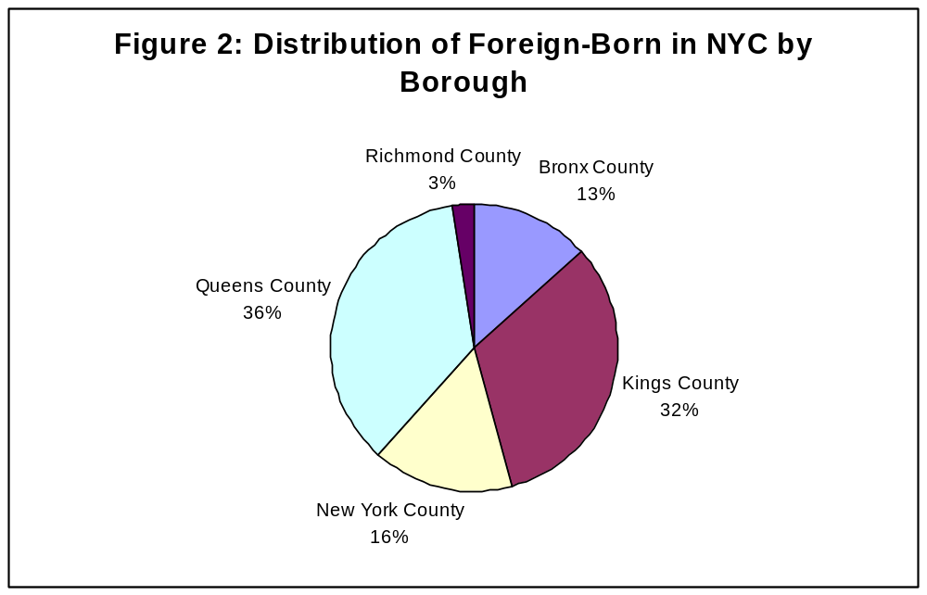
Data from 2000 U.S. Census

As can be seen in Table 1.1, the Dominican Republic is the largest sending country (11 percent), followed by China, Taiwan, Hong Kong, and the Former U.S.S.R. both at 6 percent. The diversity in the city is remarkable and it is this variety that makes this current wave of immigration unique.
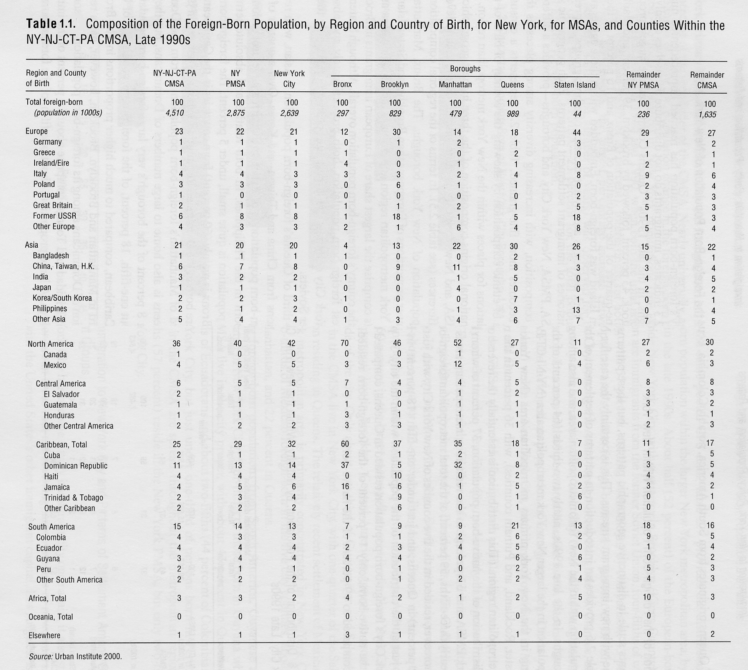
Excerpted from Kraly and Miyares (2001)

The range of ethnicities that are immigrating to the U.S. and New York City are the result of changes to U.S. immigration policy in 1965. 1965 was an important year because amendments were passed to the Immigration and Nationality Act that effectively abolished the discriminatory national-origins quota system (Borjas 1990). Asians were the biggest winners under the new system, as they were previously prevented from immigrating. Currently, the system targets 675,000 immigrants each year, composed of 480,000 immigrants admitted as immediate relatives or under family-based preferences, 140,000 immigrants admitted under employment-based preferences, and 55,000 “diversity” immigrants. Family reunification is now the primary emphasis in current immigration policy and explains the growth of ethnic groups and ethnic enclaves in New York City (Kraly and Miyares, 2001). In addition, there are an estimated 500,000 illegal immigrants in New York City, who enter via the porous New York State border with Canada (Kenneth R. Bazinet, 2004).

Why
Theories that attempt to model the size and skill composition of immigrant flows to any particular country have been in existence since at least the 1930s. Most recently, economists have turned to neoclassical principals of utility-maximization for individuals and profit-maximization for employers in order to explain empirical observations. Borjas (1989) posits that individuals migrate because it is in their benefit.
Borjas states that immigrants are sorted across potential host countries via the influence of an “immigrant market.” Individuals in this market receive “migration offers” from competing host countries which individuals then compare and choose. Borjas bases his theory on a two country model where individuals maximize income, or more correctly the present value of the earning profiles of the individual in each of the two potential countries of residence.
Residents of the source country (country 0) have (log) earnings which are characterized by the earnings function:
(1.1) 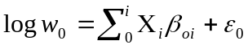
where w₀ are the individual’s earnings in the source country (country 0), X is a vector of i observable demographic characteristics (such as education and age), and ε₀ is a random variable which is assumed to be normally distributed with mean zero. The error term ε₀ is assumed to be uncorrelated with the socioeconomic variables in X. ε_{o} should be interpreted as the component of earnings associated with the unobserved “ability” or “luck” among individuals who have the same observable characteristics (X).
Individuals in the host country (country 1) face a similar earnings structure as the potential immigrants:
(1.2) 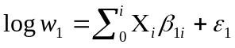
where ε₁, is also normally distributed with mean zero. Because the logarithm of earnings is assumed to be normally distributed, earnings will be log-normally distributed and skewed to the right side of the earnings distribution. As a result, the assumed shape of the earnings distribution is thought to approximately match the actual shape of observed income distributions for many countries (Lydall, 1968).
The random variables ε₀ and ε₁, have correlation coefficient ρ. ρ is the key to understanding Borjas’ theory. If ρ is positive and close to 1, the labor markets of the host country and the source country “value” unobserved ability in the same way. In other words, individuals who are exceptional or “lucky” due to unobservable factors perform well in both countries. On the other hand, if ρ is close to zero then ε₀ and ε₁ are independent, and if ρ is negative then one country values the person’s skills while the other attaches a negative value to them. For most pairings of host and source countries, ρ is expected be positive and close to 1.
If we add costs (C) to equation (1.2) we get an index function where potential migrants face mobility costs:
(1.3) 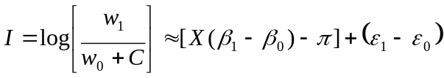
where π is a “time-equivalent” measure of the costs of migration (i.e., π = C/w₀), and [X(β₁ - β₀) − π] + (ε₁ − ε₀) is a linear approximation of the index function. The key assumption in this equation is that individuals compare the net present value of earning streams in various countries and choose to reside in the country that maximizes the index function. Individuals will migrate when the index function I is positive. The probability that an individual (with characteristics X) born in the source country migrates to the host country is given by:
(1.4)
Where v = ε₁ − ε₀, z = [-X(β₁ - β₀) + π]/σ_{v}; and φ is the cumulative distribution function for a normal random variable. Equation (1.4) reveals several key properties of the emigration rate in an economy populated by income maximizing individuals. For example, the emigration rate (for persons with characteristics X) is higher the greater the mean income in the host country, what has traditionally been called the pull factor. In addition, the emigration rate (for persons with characteristics X) is higher the lower the mean income in the source country, commonly called the push factor. Finally, the model predicts that for persons with characteristics X, the emigration rate is lower the greater the level of migration costs, and is higher the greater the payoff to the observed demographic variables X in the host country relative to the payoff in the source country.
This theory helps to explain the large flow in the number of immigrants from Asia and Latin America to the United States and to New York City after 1965. Borjas posits that the family of the migrant that resides in the United States provides a “safety net” that insures the immigrant against poor labor market outcomes and unemployment periods after migration. In other words, the kinship regulations create a lower bound in the income levels that low skilled immigrants can attain in the United States, and individuals are negatively selected because ρ > 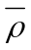, and σ₁ < σ₀, where is a positive constant defined by min
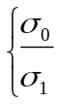, 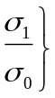. These kinship ties may have helped to create ethnic enclaves in New York initially, but the reasons for their persistence and perpetuation are more complicated.

Ethnic Capital
One can almost think of New York City as a tapestry of different cities, each unique and each with distinct cultures, languages and ethnicities. The existence of these ethnic enclaves is somewhat surprising, considering the theories at the turn of the century were that all Americans would melt into a single ethos. Instead, Americans remain “hyphenated” maintaining many of their ethnic characteristics.
Borjas (1992) explains why these ethnic communities exist and how ethnic differences in skills and earnings have been transmitted across generations. Ethnicity acts as an externality in the human capital accumulation process. Specifically, the human capital investment and skills of the next generation are a function not only of parental inputs, but also of the average quality of the ethnic environment in which parents make their investments. He calls this externality “ethnic capital”:
The introduction of ethnic capital into an economic model of intergenerational mobility has one important implication: if the external effect of ethnicity is sufficiently strong, ethnic differences in skills observed in this generation are likely to persist for many generations (and may never disappear). (Borjas, 1992)

The derivation of Borjas’ theory is somewhat complicated. His production function for child quality is given by:
(1.5) 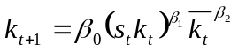
where k_{t+1}, is the level of human capital investment in children, k_{t} is the human capital stock of parents, k_{t} is average human capital stock of the ethnic group, which Borjas calls ethnic capital, s_{t} is the portion of time a parent can devote to the production of the child’s human capital, and s_{t}k_{t} is the effective amount of the parent’s human capital stock that is devoted to children.
Ethnic capital is related to my work because it acts through the theory of social interactions, which are at the heart of my study. In this case the social interactions (direct nonmarket interactions between individuals) are in the form of neighborhood effects (Moffitt 2001). Persons who grow up in “high-quality” ethnic environments will be on average exposed to social, cultural, and economic factors that will increase their productivity as they age. For a given level of parental inputs, the larger or more frequent the amount of exposure to these social interactions, the more productive the worker will be. The theory also explains the child who grows up in the “culture of poverty” and whose is exposed to parents and neighbors with low levels of educational attainment.
If the production function specified above exhibits constants returns to scale, i.e. β₁ + β₂ = 1, then the human capital inequality among different ethnic groups that exists in the parent’s generation will persist indefinitely. On the other hand, if the human capital externality (ethnic capital) is not strong enough to achieve constant returns to scale, the discrepancy in ethnic differences in human capital will eventually disappear. The ethnic capital theory may explain the slow economic progress of African-Americans, who are thought to have relatively low levels of human capital, across generations.

Student Sorting
The theories of ethnic enclaves and ethnic capital mean that immigrant residents are not randomly located throughout the city. Instead, they choose to locate where there are people like themselves. Robert A. Moffitt (2001) has identified this endogenous group membership issue as an empirical problem. It is a problem for my study and one that I attempt to mitigate.
Although New York City is but one district among 735 districts in New York State, its size makes it unique. Within this single district are 32 smaller districts that are mainly determined by neighborhood boundaries. Students are assigned to neighborhood schools with the smaller districts.
Parental choices about where to live determine the size of the immigrant student population in a neighborhood elementary school. Immigrant families prefer to reside in ethnic communities seeking kinship ties and ethnic capital. For example, recent immigrants from the Dominican Republic are concentrated in six main areas: Washington Heights/Hamilton Heights, Manhattan Valley/Morningside Heights in Manhattan, Williamsburg/Bushwick in Brooklyn, University Heights/Morris Heights/High Bridge in the Bronx and Jackson Heights/Elmhurst/Corona/ Flushing in Queens. Immigrants from the former Soviet Union tend to settle in Brooklyn, and immigrants from China tend to settle in one of the three Chinatowns in New York City (Kraly and Miyares, 2001).
While families may ask to attend another elementary school, few families receive permission because most schools are already at their capacity. Kindergarten classes are capped at 25 students, and fifth grade classes at 32 in New York City and most schools are at maximum or excess capacity (Larissa Phillips). For a family who wishes to send its children to a “good” school, it should live within the school’s boundaries. Because most recent immigrants settle along ethnic lines, there seems to be little evidence of “Tiebout” sorting, but sorting from kinship ties. Immigrants when they arrive in the United States are not able to distinguish somehow aware of school quality and hence do not intentionally settle in neighborhoods where “good” schools are located. The descriptive analysis in the next chapter provides some evidence that there immigrants are indeed being sorted as achievement appears to be higher in schools that they attend.
At the middle school level, it is much easier for parents to receive variances to send their children to schools outside the neighborhood zoned school. Moreover, New York City subsidizes the transportation cost associated with sending a child to a different school by providing free public transportation passes. The system is more or less a system of open enrollment, allowing for school choice even without residential choice.
In a school system of open enrollment and commuting were costless, Epple and Romano conclude that there would be no differences in school quality, because each school will be comprised of a peer group of average ability. This result is thought to occur because the voter equilibrium would reflect the preferences of the median voter who demand a “median” level of student ability. Students with income below the median attend better schools unambiguously. But this is not what we see in New York City. Descriptive evidence from Leanna Steifel et al. (2000) show that there is a clear stratification in school quality. High performing middle schools have more whites and Asians, low performing schools more blacks and Hispanics. In addition, my descriptive analysis of middle schools in the next chapter seems to show that on average immigrants attend lower performing schools. Why is there so much diversity in quality in New York City?
The answer is unclear. Part of the reason may be that the New York City middle school system is at excess capacity. Because of a lack of seats in the better performing schools, many of the students who want to attend better quality schools cannot and end up attending their local school. But anecdotal evidence suggests that many parents do apply for variances and do receive them. Perhaps the educational attainment of the pupils’ parents is a factor. The variance application process is a rather complicated process, requiring a firm grasp of language and knowledge of the New York Public School system. This complexity of the process would explain the lack of recent immigrants who are attending high performing middle schools.
These issues of sorting, whether it occurs as the result of gravitation to ethnic enclaves or whether it results through school choice may bias my cross-sectional analysis. Recent immigrant children, my independent variable of interest, may be correlated with another factor that affects achievement but is not accounted for by one of the variables in the regression. Consequently, the coefficient on the recent immigrant variable may be biased from this problem of endogeneity

Effects of Immigration
The effects of immigration are numerous. For example, immigrants serve as a crucial part of the migrant farm worker labor force, but may also push down the wages of native born workers. But no satisfying estimates exist for proponents and opponents of immigrant. I will review both the positive and negative effects of immigration in this section.
Borjas (1995) argues that natives benefit from immigration, “mainly because of production complementarities between immigrant workers and other factors of production, and that these benefits are larger when immigrants are sufficiently “different” from the stock of native productive inputs.” Figure 3 illustrates his model.

Figure 3
The Immigration Surplus
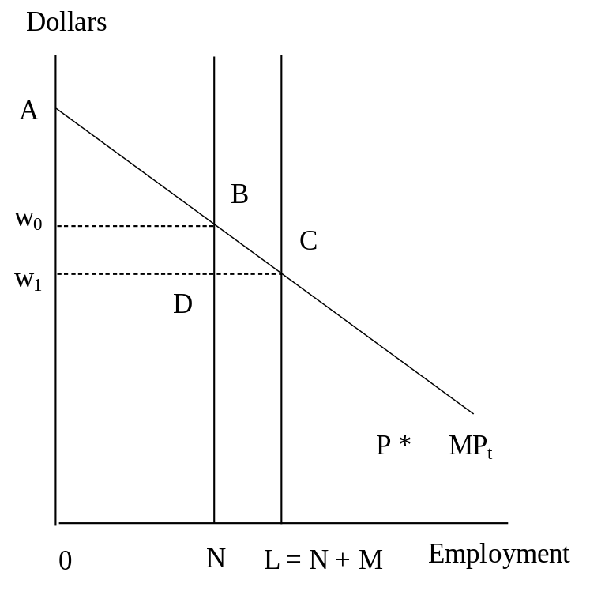
In this model, the labor force is made out of N native workers and M immigrant workers. Borjas assumes immigrant workers and native workers are perfect substitutes. In the initial equilibrium, because the supply of labor is inelastic (which makes the concept easier to understand but does not alter the fundamental analysis), the area under the value of the marginal product of labor curve (MP_{t}) represents the economy’s total output. The national income accruing to natives is the trapezoid ABN0.
When immigrants enter the country, the supply curve shifts, and the market wage falls from w₀ to w₁. National income is now represented by the area in trapezoid ACL0. Part of the increase in the national income is distributed directly to immigrant workers (who get w₁M in labor income). But the national income increase also accrues to natives (Triangle BCD). Borjas calls this triangle the immigration surplus. This result occurs because the market wage equals the productivity of the last immigrant hired. Consequently, immigrants increase national income by more than what it costs to employ them.
However, if the demand curve for labor were perfectly elastic, so that immigrants had no effect on the wage rate, immigrants would receive the entire additional product, natives would receive nothing of the addition, but their income does not fall. If the labor supply curve were downward sloping, native workers would receive a lower wage rate, but these losses are more than offset by an increase in income accruing to employers in the host country.
While immigrants may have positive economic benefits, the passage of the 1996 welfare reform legislation—which restricted the access of legal and illegal immigrants to a variety of federal social programs including Temporary Assistance to Needy Families (TANF)—and Proposition 187 in California—which denied funding for public services to illegal immigrants—proves that many Americans believe immigrants pose a fiscal burden that is negative and large. Is this really the case? The answer involves a remarkably complicated accounting of the added tax burden imposed on native residents to fund the current level of services received by natives and now extended to immigrants, and the taxes paid by immigrants towards these services. James P. Smith (1997) finds that in 1996 the national average immigrant imposes a net annual fiscal impact of -$1,613 per immigrant household when calculated using the New Jersey budget and a net fiscal burden of -$2,206 per immigrant household when calculating using the California budget. The aggregate impact, found by multiplying these per-immigrant burdens by the number of immigrant household as a whole ranges from $-14.77 billion (under the New Jersey budgets) to perhaps as high as -$20.16 billion (under the California budgets). It should be noted that this accounting may change in a general equilibrium analysis. Among other things the effects of children born to these immigrants are not included in these calculations.

Conclusion
Immigrants have always been important in the American labor force. Economists have studied the positive and negative effects immigrants have had on natives. But their role in the production of education has not been the subject of such scrutiny. In the next section, I will study the effects of recent immigrant students in NYC public schools on their teachers and school peers.
Chapter 2
data and methodology
Source
The main dataset for this study is the Annual School Reports (ASR) of the New York City Department of Education. The ASR provides school level data on academic performance as well as characteristics about students and teachers. The student characteristics include the percentage of students who are eligible for free lunch, enrollment by racial group and sex, and the percentage recent immigrants enrolled. A recent immigrant is one who had immigrated within the last three years.
The current testing for English-Language Arts and mathematics for primary schools in New York State were instituted in 1998-99. They improved on previous testing by assessing a broader range of achievement levels from severely deficient to advanced.
According to the State:
Students scoring at Level 1, the lowest, have serious academic deficiencies and show little or no proficiency in the standards for their grade level. Students at this level need extensive academic intervention services to reach the standards. Students at Level 2 show some knowledge and skill in each of the required standards for elementary- or middle-level students but need extra help to reach all of the standards and pass the Regents examinations. Students at Level 3 meet the standards and, with continued steady growth, should pass the Regents examination in the assessed area. Students at Level 4, the highest level, exceed the standards and are moving toward high performance on the Regents examination. (Clara Browne and Carolyn Bulson, 2002)

Scoring in levels 3 and 4 is considered to be “meeting standards.”
The scale range for each performance level is presented below:
Table 2.1: Scale Score Ranges for Performance Levels
New York State Assessment Program
Assessment | State Score Ranges
Assessment | Level 1 | Level 2 | Level 3 | Level 4
Elementary-Level ELA | 455-602 | 603-644 | 645-691 | 692-800
Elementary-Level Mathematics | 448-601 | 602-636 | 637-677 | 678-810
Middle-Level ELA | 527-661 | 662-700 | 701-738 | 739-830
Middle-Level Mathematics | 517-680 | 681-715 | 716-759 | 760-882

Descriptive Analysis
The elementary and middle school datasets were divided into four quartiles by the percentage of recent immigrants in a school. Each number for each school is weighted by the number of students in fourth grade for elementary schools and eighth grade for middle schools. This technique will give us an “average” student number and weight the larger schools more heavily (Stiefel et al. 2000). The data in each quartile were then averaged and reproduced in tables 2.2 and 2.3

Table 2.2: Elementary School Charcteristics (2001-2002)
 | All | 1st quartile | 2nd quartile | 3rd quartile | 4th quartile
% arrival to US < 3 yrs, 01-02 | 7.06 | 1.88 | 4.65 | 7.95 | 13.68
% meeting standards,  State ELA Grade 4, 02 | 47.70 | 44.08 | 44.70 | 47.51 | 54.45
% meeting standards,  State Math Grade 4, 02 | 53.49 | 49.06 | 50.19 | 53.02 | 61.63
% meeting standards, State ELA Grade 4 non-ELL students, 02 | 49.75 | 45.39 | 46.49 | 50.28 | 56.77
% meeting standards, State Math Grade 4 non-ELL students, 02 | 55.46 | 50.42 | 51.79 | 55.62 | 63.92

Table 2.3: Middle School Descriptives (2001-2002)
 | All | 1st quartile | 2nd quartile | 3rd quartile | 4th quartile
% arrival to US < 3 yrs, 01-02 | 6.86 | 1.51 | 4.24 | 7.40 | 14.02
% meeting standards,  State ELA Grade 8, 02 | 30.30 | 35.11 | 29.17 | 28.24 | 28.79
% meeting standards,  State Math Grade 8, 02 | 30.96 | 34.02 | 29.20 | 30.23 | 30.34
% meeting standards, State ELA Grade 8 non-ELL students, 02 | 31.92 | 35.89 | 30.70 | 30.29 | 30.83
% meeting standards, State Math Grade 8 non-ELL students, 02 | 32.29 | 34.65 | 50.57 | 31.86 | 32.02

Recent immigrants attend schools with higher achievement on both the English and mathematics examinations. Non-ELL students in elementary schools also seem to have higher achievement with greater concentrations of recent immigrants. Since there are few non-ELL recent immigrants, the results of the descriptive analysis may be some evidence that recent immigrants are exerting effects that increase the achievement of other students. The middle school descriptive analysis does not seem to exhibit such clear patterns but seems to indicate that on average recent immigrants are attending lower performing schools. This is consistent with my discussion of school choice in the previous chapter. In addition, middle schools often draw their populations from several feeder schools, thereby increasing their heterogeneity.

Empirical Model
To further study the effects of immigrant students on their school peers, a simple linear model is used that attempts to control for the variation in achievement that may result from a number of different variables. The dependent variable was the percentage of students in a demographic group that meet standards on a specific standardized exam. My main objective is to measure the effect from recent immigrant children on the achievement of non-ELL students within a school. A natural model to begin with is a cross-sectional education production function such as:
(2.1) 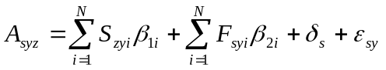
where A_{syz} the achievement of school s in year y for demographic group z as a function of school characteristics (S_{s}) student characteristics (F_{s}) including the percentage of enrollment comprised of recent immigrants, δ_{s} is a vector of school fixed effects, and ε_{sy} is a random error term for school s in year y. Table 2.3 provides a description of the variables used in these analyses.

Table 2.4: Description of Variables used in Regression Analyses
Dependent Variables
Percentage of non-ELL students who are meeting standards on the ELA exam
Percentage of non-ELL students who are meeting standards on the mathematics exam
School Characteristics
Percentage of teachers fully licensed/permanently assigned
Percentage of teachers with more than 5 years of experience
Percentage of teachers with a master's degree or higher
Student Characteristics
Percentage of students who are White
Percentage of students who are Black
Percentage of students who are Hispanic
Percentage of students who are male
Percentage of students who are special education
Percentage of students who are limited english proficient
Percentage of students who are eligible for free/reduced lunch
Percentage of students who are recent immigrants

Equation (2.1) is estimated is using a weighted least squares method, where the square root of the number of students in either fourth or eighth grade depending on the type of school is used to correct for heteroskedasticity. This method was chosen after a White test for general heteroskedasticity was unable to reject the null hypothesis of heteroskedasticity. Intuitively, it also makes sense that small schools will have larger variances than large schools.
The cross sectional analyses are highly influenced by the sorting issues described in the previous chapter and may be fraught with error. If the presence of recent immigrants in a school is correlated with other omitted variables then the estimate of the effect of recent immigrants may be biased. This is a more pressing issue at the elementary school level because of the system of neighborhood schooling. For immigrant students, the choice of their families to reside in ethnic enclaves means that schools in these enclaves possess characteristics that make them from different from other schools. Some of the effects of this endogenous group membership are captured in δ_{s.}
The vector of fixed effects δ_{s} captures the effects of omitted variables that vary across schools but do not change over time. Take curriculum for example. One high school may have a method of teaching multiplication that involves memorizing multiplication tables, while another may not. The effect of these curriculum differences on achievement would not be accounted for in the cross-sectional model.
Although δ_{s} captures the effects of omitted variables their omission biases the estimates of the regressors. If these effects are fixed through time, the bias resulting from their omission, may be correlated with the presence of recent immigrants. A first differences form of equation 2.1 will remove any fixed effects that do not change over time that may be correlated with the presence of recent immigrants.
Equation (2.2) subtracts from equation 2.1, the same equation for year y-1, allowing me to estimate the effect from changes in school and student characteristics on the change in achievement for demographic group z in school s. In my case, this will be the effect of a change in the percentage of immigrants on the percentage of non-ELL students meeting standards of a school.
(2.2) 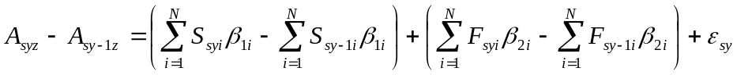
My first differences model attempts to mitigate many of the problems that Moffitt (2001) raises in detecting the existence and estimating the magnitude of various social interactions. Since it is unlikely that the achievement level of non-ELL students affects the percentage of recent immigrants in a school, the regressors appear to be independent. The more worrisome problem is the problem of endogeneity, which I described previously. This model alleviates this endogeneity problem as the effect from the locational decision of students is considered a constant that will be removed by the first differences approach.
However there may still be omitted variable problems from variables that are omitted but do change over time with this empirical model. A school’s achievement may be improving or worsening based on some general trend, not accounted for the variables in model. If such is the case my estimates may be biased. Changes in teacher quality not controlled for by observable characteristics may also cause a problem. Multicollinearity in this model is almost a certainty because of the relationship between recent immigrant students and LEP students. However, I do not believe this problem is a major issue because estimates in regressions with and without LEP change little.

Quadratic Modeling
Achievement and recent immigrants may have a non-linear relationship. Because recent immigrant peer effects have not been extensively studied in the past, the quadratic may be a better fit for the model. It may be that a small number of recent immigrants do not alter the functioning of a school much, but a larger number has a greater impact. Vice-versa, there may be a large effect with a small number of recent immigrants but the effect becomes smaller as the number is increased. To test for this possibility, the square of the recent immigrants variable is included in the regressions.

Breaking up the Recent Immigrant Variable
The recent immigrants variable is a very heterogeneous variable, which includes individuals from a number of different nations. Because there are obvious linguistic, educational attainment as well as other cultural differences depending on an immigrant’s sending country, breaking the recent immigrant variable into country variables would provide information as to whether an immigrant’s sending country has an effect on the achievement of native-born students. The theory of ethnic capital supports just an assertion.
In order to create country specific variables I created two new variables out of the recent immigrant variable. The first variable is a dummy variable that is 0 when the percentage of students from a specific country is less than 4.5 percent, a natural cutoff point in the data, and 1 when the percentage of students from a specific country is greater than 4.5 percent. The other variable is a variable that is 0 when percentage of students from a specific country is less than 4.5 percent and continuous between 4.5 percent and 100 percent. Both variables are needed to ensure that most of the entire dataset is used in the regressions.
Chapter 3
measuring the effects of immigrant students
Cross-sectional Estimates
Table 3.1 in the Appendix provides the results of the 2001-2002 school year cross-sectional regressions (equation 2.1) using one year of data without controlling for fixed effects.
Because both the recent immigrant students variable and dependent variable are both percentages, the coefficients that are estimated can be interpreted as elasticities. The results seem to suggest that recent immigrant students have little or no effect on non-ELL students in the fourth grade on either the English-Language Arts exam or the mathematics exam. In the eighth grade the effect is much more striking as a one percentage increase in the percentage of immigrant students in a school leads to a .793 percent drop in the percentage of non-ELL students who are meeting standards on the ELA exam and a 1.067 percentage drop on the mathematics exam in the cross-sectional model including school characteristics. In numerical terms, in a school with 1112 students, the mean middle school size in my sample, an increase of 11 immigrant students is directly related to approximately 8 students who are no longer meeting standards on the ELA exam and an almost one for one relationship on the mathematics exam. The estimates do not change much whether or not one is controlling for school and teacher characteristics.
Significant estimates in the eighth grade, when none exist in the fourth grade is surprising and leads me to believe that the peer effects I see in these regressions are spurious. There is a greater possibility of student tracking and within-school segregation in middle schools. Therefore the existence of a peer effect in middle school and not in elementary school may be explained by immigrant student sorting, though it is possible that younger children and their peers are more adaptable than older children and thus they achieve more, and at a faster rater.

First Differences Estimates
The first differences regressions, presented in Table 3.2, provide results more in line with a theory that peer effects should appear in fourth grade if they appear at all. Immigrant children seem to have negative peer effects in the fourth grade and little or no effect in eighth grade, though neither the estimate on the ELA or Mathematics exam is significant at a 95% confidence level. In the fourth grade, the elasticity of immigrant peer effects is relatively inelastic. In a school with 854 students, the mean sample size in the elementary school sample, an increase in eight immigrant students is related to a drop in five and a half students who would have been meeting standards on the math exam had the increase in recent immigrant children not occurred. The drop is four and a half students on the English Language Arts exam.

Quadratic Regressions
While the first differences regressions in Table 3.2 do not exhibit any significance at 95% confidence level, my regressions that model the recent immigrants variable as a quadratic function do have a significant first differences result (Table 3.4). In math grade four, both terms of the quadratic regression model have significant estimates. Based on a simple t-test the significance of the quadratic term leads me to believe that this specification is superior to the linear model. Interpreting the results from a quadratic regression model is challenging because the slope is no longer constant, the value of the independent value depends upon the value of the recent immigrants variable. Intuitively, the results indicate that the peer effect from recent immigrants grows as the percentage of recent immigrants grows. The zero value for the English exam implies that the quadratic form is not the right functional form for the English exam.
Also of note are the cross-sectional regressions in Table 3.3. Whereas under the linear model, the recent immigrants estimate is highly significant in grade 8, under the quadratic function, they are no longer significant. These results are further evidence that the cross sectional regressions under the linear model are capturing endogenous effects.

Country Specific Regressions
Recent immigrant students in New York City come from a multitude of nations, cultures and background. Consequently, there is a great deal of heterogeneity in the recent immigrants variable in my previous regressions. In order to see if the immigrant effects we were seeing in the previous regressions were country dependent, I employed the combination of a country dummy variable and a country continuous variable as described in the previous chapter. The results are given in Table 3.5 for regressions with Dominican Republic Variables and Table 3.6 for regressions with Chinese Variables.
While there are no significant values, Dominican immigrants in general seem to be exerting positive effects on their non-ELL peers as the continuous variable is positive in every First Differences regression is positive no matter the grade or the exam. There are no clear effects from Chinese immigrants as the continuous variable’s sign changes often depending on the examination.

Teacher Placement
A related issue to immigrant peer effects is their effect on teachers. Regressions that controlled for race, school achievement in English and Math, LEP, Special Education, Free Lunch, and percentage recent immigrants were performed to see if the percentage of recent immigrants in a school had an effect on the percentage of teachers who were fully certified and the percentage of teachers who had two or more years of experience. The estimates are reproduced in Table 3.7. Cross-sectionally these regressions may show that immigrant children are attending “better” schools with more qualified teachers. When I run the regressions using the first differences technique the recent immigrant variable may show the effects of teacher choice. It is possible that the better qualified teachers are drawn to schools with large immigrant populations because immigrant children are seen as better behaved than their native-born counterparts.
The regressions only show immigrant effects in the cross-sectional regressions, providing further evidence of the sorting effect. Immigrant children are sorting, because of the presence of ethnic enclaves to better schools. The lack of significance in the first differences regressions seem to confirm that immigrant students have little or no effect on teacher placement. The percentage of recent immigrant students in a school plays little or no role in the decision and assignment of teachers.

Chapter 4
conclusion
Summary of Findings
Because of the existence of ethnic enclaves, immigrant students may be attending better schools. The cross-sectional regressions seem to show that as the percentage of immigrant students in school increases, the percentage of non-ELL students in the eighth grade who are meeting standards decreases. But I believe these results are spurious as the significant coefficients are in the eighth grade and not the fourth grade, where contact between immigrant students and native-born students is much more likely.
My set of first differences regressions are more convincing evidence for the existence of an immigrant peer effect. These regressions show negative coefficients on both the math and English grade 4 exams (though neither coefficient is significant) and little or no effect in the eighth grade exams, as expected. The -.545 elasticity found on the math grade 4 exam is inelastic but still considerable. Attempts to measure a country specific effect proved difficult, though on average Dominicans seem to be associated with positive peer achievement on both the English and mathematics exams. This result is not terribly surprising as recent immigrant Hispanics actually outperform non-recent immigrant Hispanics on English exams in elementary and middle schools.
Quadratic regression modeling of the recent immigrants variable yields two significant coefficients on the math grade 4 exam in the first differences specification, a
-.260 coefficient for the quadratic term and a -.698 coefficient for the linear term. The intuitive interpretation from these results is that a few immigrants may not have much of a peer effect, but their effect rises as their number rises. There may be increasing achievement diseconomies of scale in mathematics due to the presence of recent immigrants in a school.
The negative peer effect is not unexpected. Both Hanushek et al. (1999) and Hoxby (2000) find significant and negative peer effects from lower achieving peers. Recent immigrant students have lower achievement on average in both mathematics and English, which partially explains their negative peer effects. Their lower achievement may affect the type of discussion in the classroom to the detriment of their native-born peers.
Analyzes that use teacher experience and teacher certification as dependent values show that recent immigrants, because of the sorting effect, are attending schools with more qualified teachers. In the first differences specifications they have little effect leading one to believe that teachers do not themselves select schools based on the percentage of recent immigrants.

Policy Implications
One may read into my research that the most obvious policy implication is to segregate recent immigrant children and native-born children. I do not believe such is the case. Throughout American history, the public school classroom has played a special role in educating immigrants in the ideals and values of this nation. In addition, the classroom is a place where children have the opportunity to learn about children from other cultures, thereby reducing and removing prejudices and misconceptions about other cultures.
However, I do think there are some policy implications to take away from my research that do not go to such an extreme. One reason immigrant students exert negative peer effects may be because of resources. Recent immigrant students may require a disproportionate amount of support, especially around language. If schools do not grant additional resources for this work, it may drain resources from other students, as teacher time.
In addition, if special classes are not created for limited English proficient students, or if their teachers are not specially trained in managing a multicultural classroom, the presence of recent immigrant students may slow the progress of the class on a whole. These outcomes would negatively affect their non-ELL peers as well.

Suggestions for Further Research
My research is only a first step to understanding the role immigrant children play in the production of education, and there is the potential for much work to be done in this field. My study only uses two years of data. Multiple years of data would be better able to control for the school fixed effect. The data was also organized in such way that estimating a country specific effect was very challenging. Future studies with better data on the percentage of students from a particular country for all schools would be better able to estimate if country of origin had an effect on native born students.
In addition, this study relied upon school-level data which has the disadvantage of not being able to estimate recent immigrant effects on non-ELL students within the same classroom. Student level data which can link students with teachers would be able to achieve this result. Student level data would also allow for the estimation of interaction terms, such as Male*Immigrant for example, which may have different peer effects. Furthermore, student level data would allow a researcher to control for achievement, and creating a recent immigrant variable peer effect that is close to being the “pure” immigrant effect.
bibliography

APPENDIX
Full set of regressions are available upon request from the author
(Absolute Value of t-statistics in parentheses)

Table 3.1: Estimated Effects of Recent Immigrant Children on Achievement Level of Non-ELL students
 | ELA Grade 4 | Math Grade 4
 | % recent immigrants | % recent immigrants
Cross-sectional with school characteristics | .078 | .167
 | (.618) | (1.136)
Cross-sectional without school characteristics | .073 | .152
 | (.587) | (1.058)
 | ELA Grade 8 | Math Grade 8
 | % recent immigrants | % recent immigrants
Cross-sectional with school characteristics | -.793 | -1.067
 | (2.951) | (3.763)
Cross-sectional without school characteristics | -.745 | -.994
 | (2.810) | (3.573)

Table 3.2: Estimated Effects of Recent Immigrant Children on Achievement Level of Non-ELL students
 | ELA Grade 4 | Math Grade 4
 | % recent immigrants | % recent immigrants
First differences with school characteristics | -.431 | -.545
 | (1.409) | (1.658)
First differences without school characteristics | -.445 | -.535
 | (1.467) | (1.635)
 | ELA Grade 8 | Math Grade 8
 | % recent immigrants | % recent immigrants
First differences with school characteristics | -.120 | -.315
 | (.268) | (.703)
First differences without school characteristics | .001 | -.589
 | (.001) | (1.388)

Table 3.3: Estimated Effects of Recent Immigrant Children on Achievement Level
of Non-ELL students modeled as a quadratic function
 | ELA Grade 4 |  | Math Grade 4
 | % recent immigrants | % recent immigrants² | % recent immigrants | % recent immigrants²
Cross-sectional with school characteristics | 0.198 | -.003 | -.016 | .010
 | (0.698) | (.215) | (.050) | (.654)
Cross-sectional without school characteristics | .244 | -.009 | .079 | .004
 | (.857) | (.668) | (.242) | (.246)
 | ELA Grade 8 |  | Math Grade 8
 | % recent immigrants | % recent immigrants² | % recent immigrants | % recent immigrants²
Cross-sectional with school characteristics | -.356 | .022 | -.646 | -.024
 | (.799) | (1.014) | (1.375) | (1.061)
Cross-sectional without school characteristics | -.240 | -.030 | -.413 | -.035
 | (.527) | (1.357) | (.863) | (1.490)

Table 3.4: Estimated Effects of Recent Immigrant Children on Achievement Level
of Non-ELL students modeled as a quadratic function
 | ELA Grade 4 |  | Math Grade 4
 | % recent immigrants | % recent immigrants² | % recent immigrants | % recent immigrants²
First differences with school characteristics | -.437 | -.012 | -.698 | -.260
 | (1.394) | (.004) | (2.074) | (2.018)
First differences without school characteristics | -.446 | -.001 | -.693 | -.264
 | (1.429) | (.009) | (2.067) | (2.049)
 | ELA Grade 8 |  | Math Grade 8
 | % recent immigrants | % recent immigrants² | % recent immigrants | % recent immigrants²
First differences with school characteristics | -.026 | -.123 | -.309 | -.007
 | (.057) | (1.099) | (.676) | (.066)
First differences without school characteristics | .107 | -.133 | -.582 | -.009
 | (.249) | (1.198) | (1.338) | (.084)

Table 3.5: Estimated effects of Recent Immigrant and Dominican Recent Immigrant Students on the
Achievement of Non-ELL Students
 | % recent immigrants | Dominican Dummy Variable | Dominican Continuous Variable
ELA Grade 4
Cross-sectional with school characteristics | .056 | 3.156 | 1.155
 | (.442) | (.415) | (1.053)
First differences with school characteristics | -.535 | 1.330 | 1.174
 | (1.711) | (.148) | (.703)
Math Grade 4
Cross-sectional with school characteristics | .169 | -7.118 | -.519
 | (1.141) | (.807) | (.408)
First differences with school characteristics | -.690 | 4.898 | 2.060
 | (2.055) | (.508) | (1.149)
ELA Grade 8
Cross-sectional with school characteristics | -.747 | -9.720 | -.487
 | (2.754) | (.321) | (.108)
First differences with school characteristics | -.170 | 4.260 | 1.415
 | (.371) | (.146) | (.293)
Math Grade 8
Cross-sectional with school characteristics | -1.031 | -12.413 | -1.162
 | (3.597) | (.388) | (.243)
First differences with school characteristics | -.325 | .899 | .296
 | (.709) | (.031) | (.061)

Table 3.6: Estimated effects of Recent Immigrant and Chinese Recent Immigrant Students on the Achievement of Non-ELL Students
 | % recent immigrants | Chinese Dummy Variable | Chinese Continuous Variable
ELA Grade 4
Cross-sectional with school characteristics | .127 | -7.374 | -.340
 | (.957) | (.936) | (.377)
First differences with school characteristics | -.380 | -.502 | -.643
 | (1.240) | (1.537) | (.726)
Math Grade 4
Cross-sectional with school characteristics | .197 | -1.453 | .169
 | (1.284) | (.159) | (.162)
First differences with school characteristics | -.516 | .041 | -.051
 | (1.563) | (.604) | (.698)
ELA Grade 8
Cross-sectional with school characteristics | -.910 | -3.391 | -1.120
 | (3.307) | (.400) | (1.393)
First differences with school characteristics | .210 | -.099 | -1.353
 | (.423) | (.431) | (1.281)
Math Grade 8
Cross-sectional with school characteristics | -1.130 | -1.458 | -.596
 | (3.872) | (.162) | (.699)
First differences with school characteristics | -.152 | -.380 | .024
 | (.307) | (1.652) | (.023)

Table 3.7: Coefficient of percentage of recent immigrants variable on teacher characteristics
 | Percentage of teachers who are fully certified | Percentage of teachers with more than two years of experience
Grade 4
Cross-sectional | .498 | .431
 | (4.586) | (3.423)
First differences | .156 | -.064
 | (.837) | (.191)
Grade 8
Cross-sectional | -.004 | .647
 | (.015) | (2.397)
First differences | .530 | -.525
 | (1.142) | (.718)

This assumption is further justified by the correlations between the percentage of recent immigrant students in a school and the percentage of non-ELL students in a school. In elementary schools this correlation has a value of -.460, significant at the 0.01 level. The middle school correlation has a value of -.660, which is also significant at the 0.01 level.

