Memory and the Brain
________________________________________

1) Provide a very brief overview of neuroanatomy.

2) Describe the methodologies use to examine the relationship between memory and brain function.

3) What are the neural changes that correspond to our experience of memory?

4) Examine the question of ‘localization of function’.

5) Review the data linking specific brain areas to specific areas of function.
A simple map of the brain
________________________________________

Hindbrain
medulla
pons
cerebellum

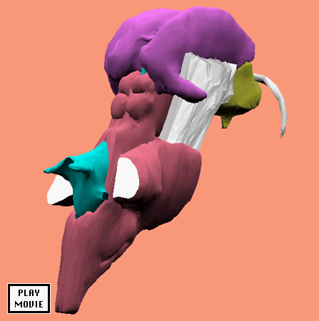

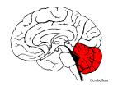
Midbrain
______________________________________________

RAS
Tectum

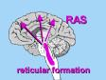

Forebrain – Thalamus and Hypothalamus
______________________________________________

Thalamus and Hypothalamus
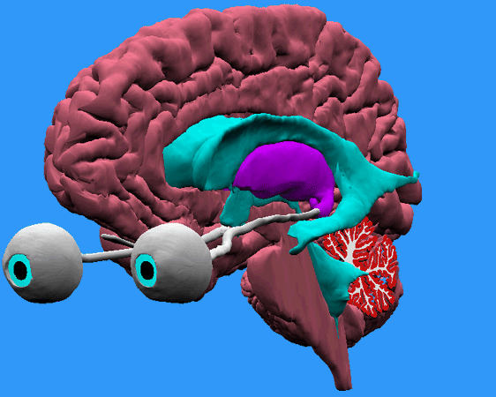
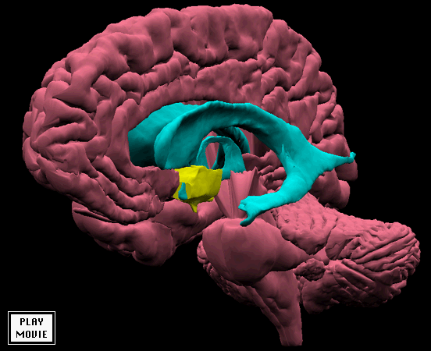
Forebrain – Limbic system
______________________________________________

hippocampus
amygdala
fornix

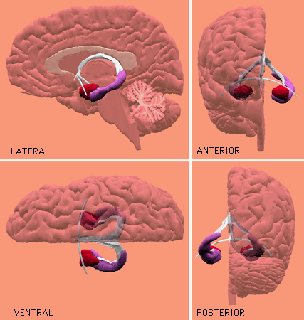
Cortex
______________________________________________

frontal

parietal
occipital
temporal

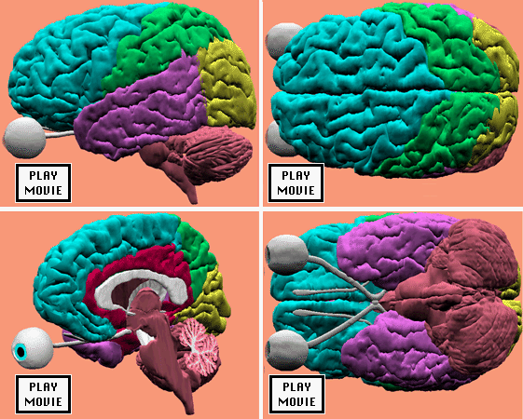
Experimental methods - Animal
________________________________________

Lesion studies – remove a portion of an animal’s brain, and see how performance differs relative to

Important questions
- How do we know that the hippocampus is involved in storing memory? Could it not just be a region in which neurons from other circuits pass through?
EX: I want ice cream

- How do we know that lesioning a brain area does not affect the way that other brain areas function?
EX: Basketball demo
Data from nerve cuts

______________________________________________

So, we need converging operations.

Experimental methods – Animals II
________________________________________

Cellular recording -
an electrode is embedded in an animal's brain and

Good news:
- Very precise
- Very precise
- Tons of data

Bad news:
- Technically demanding
- Electrodes sometimes
- Wind up losing lots of animals
- Tons of data

Famous applications:
- Red/green cells in monkey cortex
- ‘Place’ cells in the hippocampus

Experimental methods - Humans
________________________________________

Case / Population studies
Find an individual/group with a specific brain injury or behavioral syndrome

Applications:
- Amnesia:
- Dysexecutive syndrome:

Wada test
Sodium amobarbital is injected into one carotid artery. Selectively anaesthetizes

Applications:
- Examination of hemispheric differences
- Neural surgery

CT (computerized axial tomography)
Shoots X-rays through the brain, into receptors on the other side. Computers then use the amount of radiation that reached the detectors to construct a map of the brain.
Applications:
- More structure
- Used to evaluate
Experimental Methods – More Humans
________________________________________

fMRI (functional magnetic resonance imaging)
A powerful magnet aligns atoms in the brain including oxygen. More activity = more oxygen. The brain is bombarded by radio waves that alter the alignment of these atoms. More mis-alignment, more molecules, more activity.
Pluses/Minuses
- Expensive
- limited resource
- No radioactivity involved.

PET (positron emission tomography)
The subject is injected with radioactive glucose. Active brain areas require glucose.

Method of subtraction
I want to see the areas involved in LTM.
Task 1: Subjects the National Anthem
Task 2: Subjects the National Anthem

Experimental Methods – Humans (the end)
________________________________________

ERP (event related potential)
Big shower cap of electrodes that measure electrical changes at or near the scalp.

Two components:
- positive or negative
- Latency of the peak of the response.
  - EX: P300; N400

Applications:
Cortical regions
Arbitrary interpretation
- Late P300?
- Early N600?

Guilty Knowledge Test -
- Method: shown list of words

- Results: P300 for
- Interpretation:

Neural Code (plasticity)
________________________________________

Engram (Lashley)
A persistent change in the relationship between neurons, either through structural modification or through biochemical events within neurons that change the way in which neighboring neurons communicate.

Environmental changes
- Enriched environment led to more

- Improved mental
- Caution: link between brain changes and

- perfect pitch
- phrenology
- athletics analogy

LTP/LTD:
A cell is removed from the hippocampus and treated to a patterned series of electrical impulses.

Problems:
- cells removed
- hazy link between
Modeling behavior in aplysia
________________________________________

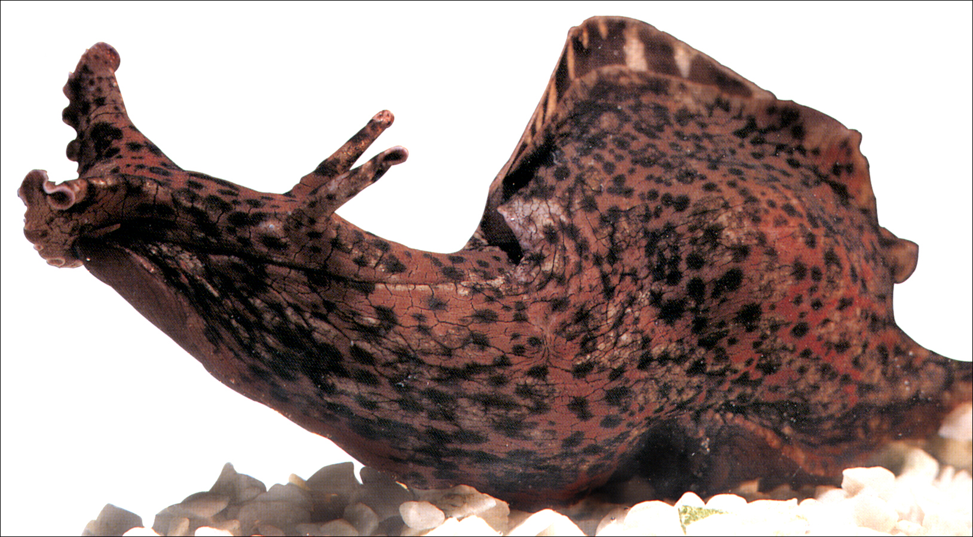
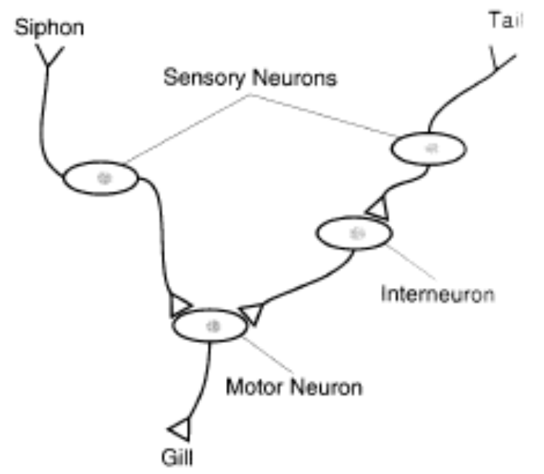
Modeling behavior in aplysia
________________________________________

Synaptic plasticity - mediated by synaptic changes in
- polarization
- NT release
- enzymes

Habituation –
1) Less NT released into the synapse
- Less CA++ flows into the axon
- NT depleted from recent firing

Sensitization –
- Neurons with synapses near the axon terminals facilitate release of the NT
- Activates adenylate cyclase, which increases free cyclic AMP in axon terminals.
- Free cyclic AMP, activates another enzyme
- 2nd enzyme closes up K+ channels
- This allows more C++ to enter axon terminal

Classical Conditioning - similar to sensitization,

Take home message:
simple system…
Localization of Function – Historical View
________________________________________

Distributed View –
Lashley found that location of lesion was not as important as
EX: vegetable soup / chocolate chip ice cream

Localized View –
Broca's area strongly suggests that there are areas of

EX: Seder plate

Current View: Networks of Specialists –
We have pockets of neurons that handle different functions,

EX:
- Hubel & Wiesel –
- Kandel & Schwartz –
- Fuster & Jervey –
- Place cells

Hubel and Wiesel
______________________________________________

What does what: Hippocampus
______________________________________

Spatial Memory
- Space-sensitive cells

Consolidation:
- Transfer of info from
- Integration within
Evidence:
- HM and other amnesics
STM – not affected
LTM –

INBETWEEN –
- Animals
Discrimination
DNMS
Notes: relation to work with rats
- monkeys smarter than rats
- RI very different
- neural code a mystery

Haist, Gore, & Mao (2001)
______________________________________

Theoretical question:
- Can consolidation be linked to
- What is the time course of

Empirical question:
- Would MTL activation with the age of information tested on a famous faces test?

Important methodological/theoretical issues
- Competing theory and predictions?
- Use of remote memory task?
- Baseline for subtraction?

Results:
- Hippo activity inversely related to
- Face identification areas active

Interpretation:
- Role of the hippo is
Problems:
- Reverse pattern in not observed
- Autobiographical memory data

Haist, et al. (2001): Famous Face test
___________________________________________

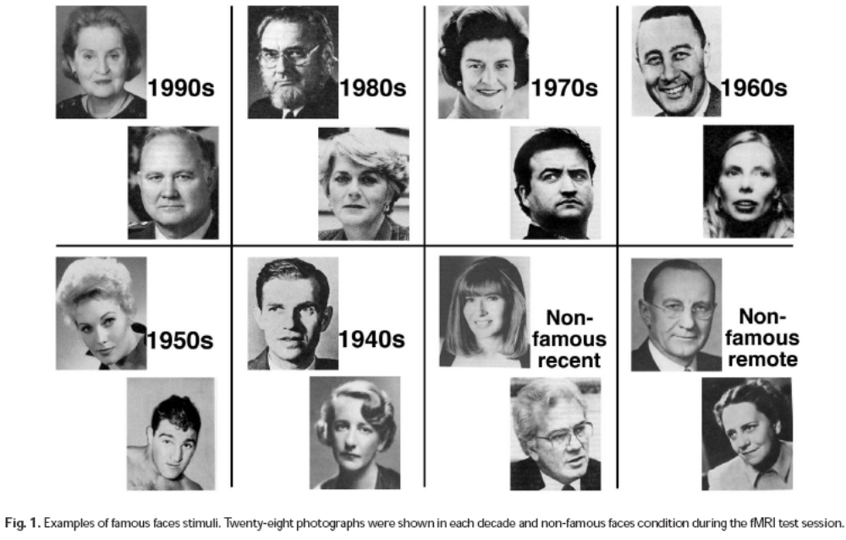

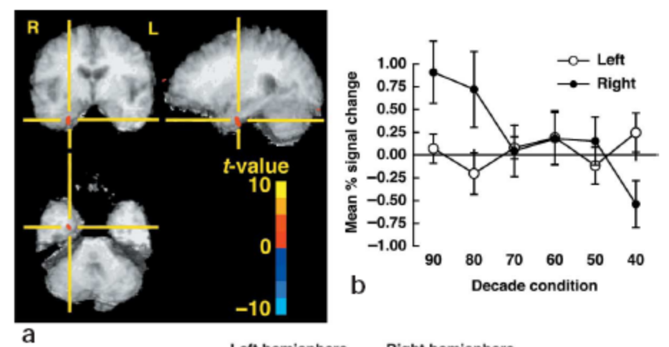

What does what: Frontal Lobes
______________________________________

Interesting point:
- FL do not have direct connections to sensory areas.
  - Makes secondary connections to

implication: FL involved in

LTM:
- Storehouse of
- Inhibition of behavior (emotion)
EX: Phinneas Gage
- Temporal order memory
- Central Executive
EX:
- Strategic Behavior

Mangels, Gershberg, Shimamura, & Knight (1996)
______________________________________

Theoretical question:
- Are FLs specifically related to

Empirical question:
- How would frontal and control patients differ on recall and recognition tests
- Would their ability to use cues differ?

Why did they think FL involved in strategic behavior?
- Encoding: subjective organization; use of categories
- Retrieval: Retrieval cues reduce/eliminate deficit
- Performance of AD patients on remote memory tests is correlated with performance on

Why is there any ambiguity about FL/strategic bhvr?

Why did they use a remote memory test?

Does FL damage reduce remote memory?

Mangels, Gershberg, Shimamura, & Knight (1996)
______________________________________

Methods:
Public events test:
  - recall and recognition
Famous Face Test –
  - free recall, cued recall, recognition
6 patients with FL lesions
- normal IQ; poor at WCS and Boston Naming
10 controls
- matched on age, education, and IQ (mostly)
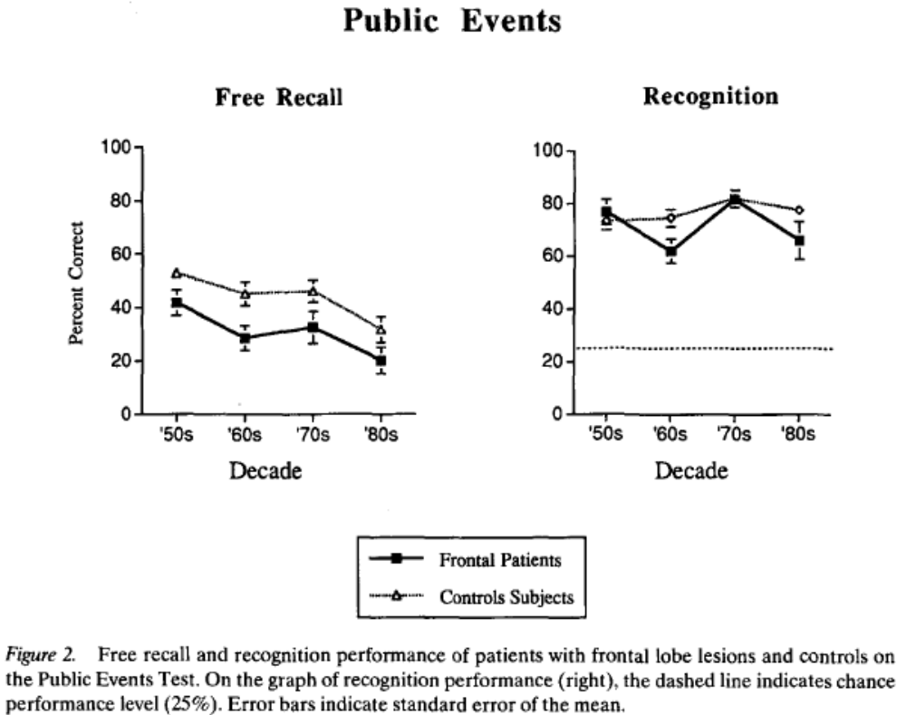

Mangels, Gershberg, Shimamura, & Knight (1996)
______________________________________

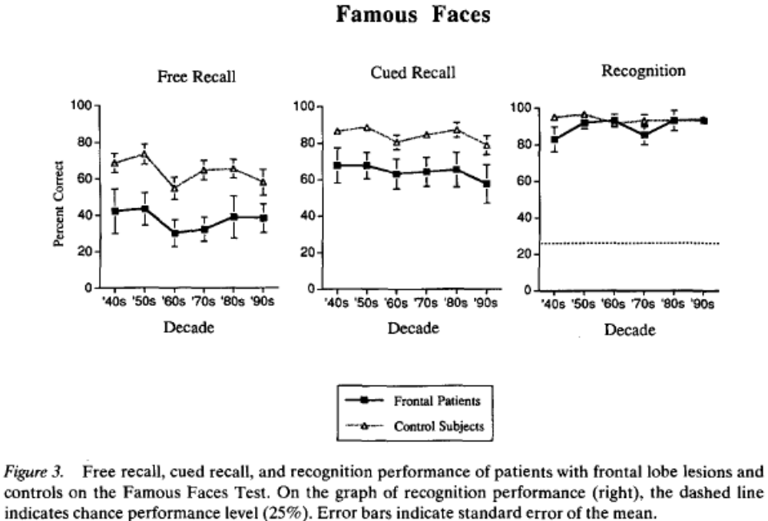

Results: (normal IQ, bad at WCST, Boston naming FAS)
- FL were impaired on recall
- FL were not impaired on recognition
- Cued recall
- FL better with phonemic than semantic, but overall, cues were much less helpful
- Correct cued recall for free recall performance
- Temporal gradient in memory sounds a lot like…

Mangels, Gershberg, Shimamura, & Knight (1996)
______________________________________

Interpretation:
- FL are involved in strategic retrieval from memory
  - Deficits extend through
  - Recall/recognition

- However:
  - FL showed greater deficit for recent decades than

  - Cues did not eliminate deficit

- Differenetial effectiveness across cue types:
  - Phonemic strategies are more impaired?
  - Semantic processing is more impaired?
  - Semantic information is less helpful?
  - BUT

Lingering question:
What causes FL deficits?

What does what: Hemispheric Differences
______________________________________

Semantic / Episodic memory
LFL:
RFL:
Evidence: LOP task
Deep encoding------------->
Shallow encoding--------->
Interpretation:
Brain deteriorates right to left
However…

Lateralization of function
Left | Right
Logic | Creativity
Science | Art
Speech | Music
Analytical | Holistic

Spiers, et al. (2001)
______________________________________

Theoretical Question: Can we show a double dissociation between

Empirical Question: Will RMTL and LMTL damage produce different patterns of impairment on

Why did they expect to see a dissociation?
Unilateral MTL not as impaired as HM but…
LTL –

RTL –

No differences on AM retrieval.

Ecological approach
Test topographical memory with real-world tasks
Problem:
- Large enough to allow exploration
- no prior experience
- control of available cues
Solution:

Spiers, et al. (2001)
______________________________________
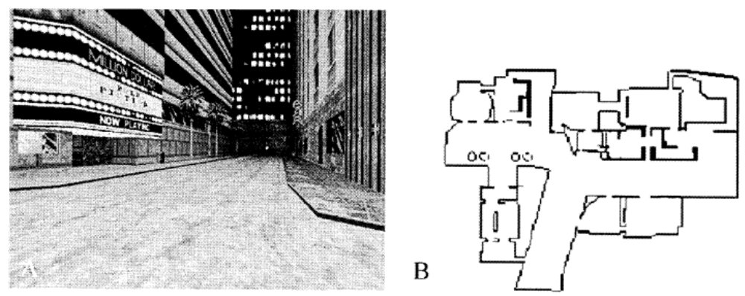

Method:
- Navigation – get from point A to point B
- Scene Recognition – 2AFC (old/new)
- Map Drawing
- Episodic memory tests –

Results:
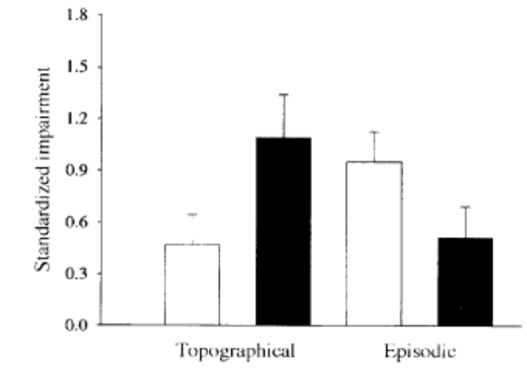 | 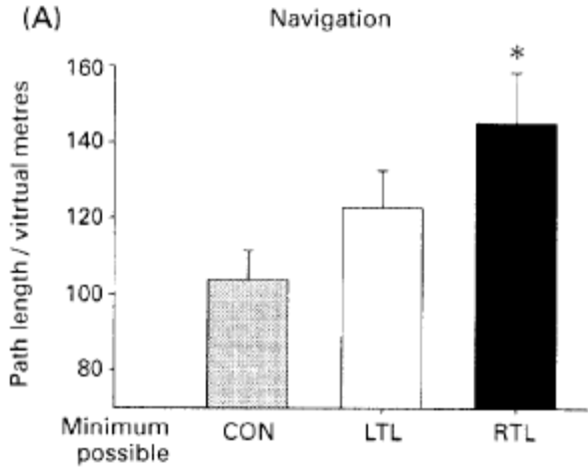

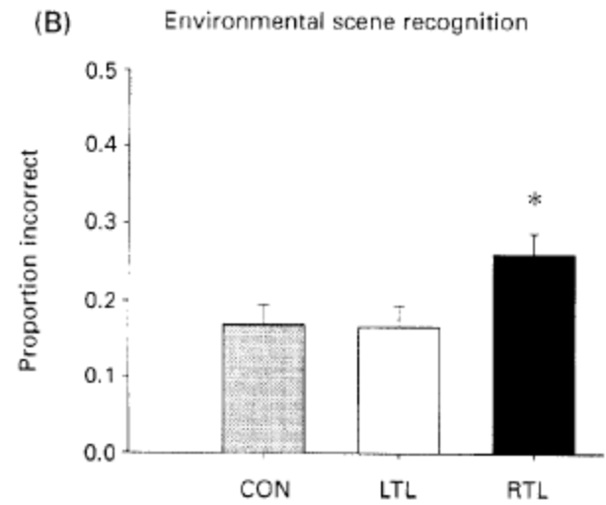 | 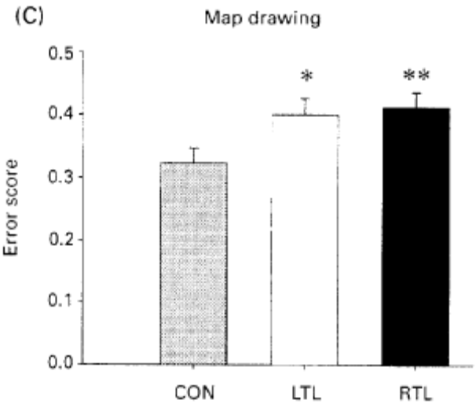

RTL: impaired on
LTL: impaired on

Interpretation:
- LH and RH make differential contributions to memory performance with the RH being particularly useful on

Big question:
Is this consistent with the idea that the LH is specialized for analytical processing and the RH is specialized for holistic processing?

