Overview
Declare your major--called a Program of Study in Workday

Process

- On your Workday homepage, click on your photo in the upper right hand corner (this may also appear as a blue cloud icon if you have not submitted a photo
- Click View Profile

- On the left menu of your student profile, click Academics

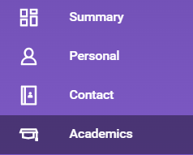
- On the next screen, find the Educational Objective box. If you are Undeclared, click Request, then select Change My Program of Study from the drop-down menu

If you are adding an additional major, click the Add Program of Study button rather than Request, and skip to step 8

- Next, click the X in the box that reads Undeclared

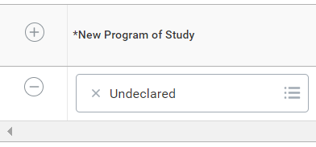

- Click on the now empty box and select your intended program of study and check the Is Primary box

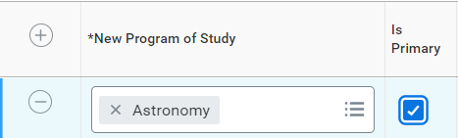

- Click the Reason box and select Student Initiated. The declare date will auto-populate

- If you are adding an additional major, click the plus sign (+) above your current program of study and enter the additional program in the box
- Click Submit

