History 263

Popular Protest and Struggles for Democracy in Modern Latin America, 1820 to the Present
(updated Feb. 8, 2012)

Prof. Rick López
S2012: TTh 2:00-3:20pm
Chapin 101
Contact information: 23 Chapin, x5846, ralopez@amherst.edu
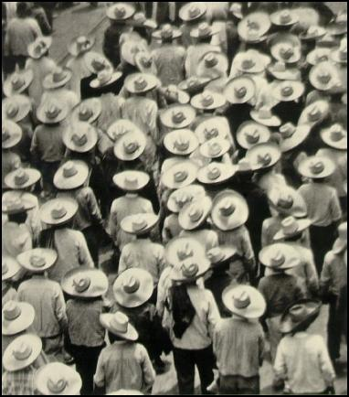
A decade ago the Latin American masses launched a movement to reclaim democracy from international development organizations and a corrupt national elite. Today, in the movement known as Arab Spring, masses in the Middle East once again focus the world’s attention on struggles for democracy. The movements in Latin America and in the Middle East display major differences from one another, but they both force us to ask how popular democratic struggles emerge, when they manage to seize power and when they collapse in the face of state repression, and how participants reconcile conflicting understandings of “democracy”. The Latin American movement that began in the 2000s represent struggles that trace back at least to the Independence wars of the early nineteenth century. To understand these movements, we need to analyze them in relation to their historical context.
This course will follow the permutations of the Latin American saga, while considering the changing meanings of democracy. We will address the relationship between Liberalism and democracy in the nineteenth century; the broadening of democracy at the start of the twentieth century; the rise and fall of military dictatorships in the 1960s-80s and their corrosive impact upon civil society; clashes between pro-democracy advocates and the neo-Liberal economic technocrats and international financial institutions that took control of much of Latin America from the 1980s through the early 2000s; the neo-populist resurgence of the Left in the 2000s; and the current impasses. Through readings and discussions we will focus on the ways broad economic and political shifts impacted individuals’ lives; how each economic class experienced these shifts differently; the way race and gender have shaped peoples’ experience with democratization and repression; and the personal processes of radicalization by which individuals became inspired to take risks in their struggles for inclusion and against repression. Because the approach is thematic and chronological, some countries and regions will receive more attention than others. Meetings and readings will draw on secondary studies, historical documents, testimonials, music, images, and film.

Attendance: Required.
Readings: Be an engaged, critical reader. Don’t absorb the text, argue with it. See “Getting to Know a History Book” on my website.
Written work: Three journal installments, map quiz, and final paper.
- Journals. Your journal for each week will consist of the following
  - News analysis: At the start of each week (or the weekend prior) you must carefully read and analyze two (2) news stories related to Latin America.
    - Use the New York Times, along with any other newspaper you want.
    - I am reading the same news, so don’t give me bland summaries. Instead, tell me what you see as the its implications of these events, evaluate how the news is being reported (what is not being asked, what the reporters unquestioned assumptions might be, and so forth), and how the news relates to the long-term processes we are discussing.
    - You MUST include a complete citation for each news article, including author, article title, publication title, and date. Example: Alexei Barrionuevo, “Difficult Road Ahead for New Paraguay Leader,” NYT 16 August 2008.
    - Your news entry for each week should be between 150-400 words.
  - Reading Responses: for each meeting write a 1 page response that grapples intellectually with the assigned readings, bringing them into conversation with one another and with previous material we have covered in class. Write these before the meeting, then revise them, or add to them, after the meeting.
- At intervals indicated on the syllabus you will turn in installments of your response journals. The journal must be organized by week. For each week include, in this order:
  - your newspaper response
  - Your response to the Tuesday reading
  - Your response to the Thursday reading
- Final paper: Select and analyze a monograph, film, novel, or collection of short stories dealing with some aspect of Latin American history. Note: if you select the film option, you must watch two to three films.
- Formatting: see appendix

Plagiarism: If you pass the words, work, or ideas of someone else as your own you are committing plagiarism. This includes misusing works that are cited elsewhere in your paper. Always be explicit about when you are building upon the ideas of others, and when you are taking things in your own direction. If you decide to plagiarize your will receive an “F” for the entire course and I will turn the matter over to the dean with a recommendation for expulsion from Amherst College. If you have any doubt about how to acknowledge the work of others in your footnotes, consult the style guide or come see me.
How your semester grade will be calculated:
Class Attendance and Participation……………………………….…………….……...40%
Attendance 10%
Participation 30%
Map quiz……………………………………………………………….……….………..3%
Written work …..…………………………………………………………..….…..……57%
Response journals 50%
Term paper 7%

-Students with any disability should speak with me at the beginning of the semester about any special arrangements they may require

Course Materials:
Movies: This class requires several movies.
- Evita, a cinematic historical opera starring Madonna and Antonio Banderas
- Death and the Maiden, starring Sigourney Weaver
- House of the Spirits, starring Meryl Streep, Jeremy Irons, and Winona Ryder
- “The Empty ATM,” Wide-Angle
- Recommended: Zapatistas, by La Jornada.
Books: available at Food for Thought Books.
- John Charles Chasteen, Born in Blood and Fire (buy any edition you prefer…old editions might be cheaper)
- Anita Brenner, The Wind that Swept Mexico
- Peter Winn, Weavers of Revolution (New York: Oxford University Press, 1986).
- Rigoberta Menchú Tum, I, Rigoberta: An Indian Woman in Guatemala (Verso, 1984)

Coursepacks and coursepack supplement available in the History Office:
- (Supplement) Domitila Barrios de Chungara, Let me Speak! Testimony of Domitila, A Woman of the Bolivian Mines (New York: Monthly Review, 1978), 1-155.

Meetings and Readings

1) Tuesday, January 24
Introduction to the course
Introduction

2) Thursday, January 26
Exclusion and Inclusion before the Rise of Liberalism
(view casta paintings in class)
(coursepack) Sor Juana Inés de la Cruz, Two poems (1689) and “La respuesta” (1691), from Documenting Latin America: Gender, Race, and Empire Volume 1, edited by Erin O’Connor and Leo Garofalo (NY: Prentice Hall, 2011), pp144-146.
(coursepack) Letters related to the Tupac Amaru uprising, Documenting Latin America, pp222-226.
(coursepack) “Caracas’s Cabildo Writes to the King to Denounce a Royal Decree, 1796,” Documenting Latin America pp186-192.

3) Tuesday, January 31
Decolonization and the Emerging Struggle for Citizenship during the First Half of the 19th Century
Independence and Inequality
(book) John Charles Chasteen, Born in Blood and Fire: A Concise History of Latin America (NewYork: WW Norton, 2001), 1st edition 93-113; 119-129; 2nd edition 91-112; 119-130; 3rd edition 87-110, 117-128.
(coursepack) José María Morelos “Sentiments of the Nation,” Chilpancingo, Mexico, 1813, from Colonial Latin America: A Documentary History edited by K. Mills, et al., (Wilmington, DE: SR, 2000), 397-400.

4) Thursday, February 2
Contradictions of Independence: The Rift Between Creoles and the Masses
(coursepack) document: José de Cevallos, letter from Venezuela, 1815, from The Wars of Independence in Spanish America
(coursepack) document: Simón Bolívar, “Speech before the Congress of Angostura,” from Problems in Modern Latin American History, edited by J.C. Chasteen and J. S. Tulchin (Wilmington: SR, 1994), 175-176.
(coursepack) Marixa Lasso, “Revisiting Independence Day: Afro-Colombian Politics and Creole Patriot Narratives, Cartagena, 1809-1815,” from After Spanish Rule: Postcolonial Predicaments of the Americas, edited by Mark Thurner and Andrés Guerrero (Durham, NC: Duke University Press, 2003), 223-240.

5) Tuesday, February 7
Triumph of the Liberal State: Modernization and the Masses in the Second Half of the 19th Century
Progress, Democracy, and Neocolonialism
(book) Chasteen, 1st edition 149-211; 2nd edition 149-214; 3rd edition 149-215.
(coursepack) Guillermo Bonfil Batalla, “Forging a Nation,” from México Profundo (Austin: University of Texas Press, 1996), 94-107.
(coursepack) Charles Walker, “From Colony to Republic and from Indian to Indian: Cuzco Rural Society,” Smoldering Ashes: Cuzco and the Creation of Republican Peru, 1780-1840 (Durham: Duke UP, 2000), 186-221.

6) Thursday, February 9
Brazil and the Problem of Slavery
(coursepack) Documents, from Children of God’s Fire: A Documentary History of Slavery in Brazil, edited by Robert Edgar Conrad (Princeton University Press, 1983), 406-11, 451-58, 480-81.
(coursepack) Emilia Viotti da Costa, “Masters and Slaves: From Slave Labor to Free Labor,” from The Brazilian Empire: Myths and Histories (Chapel Hill: University of North Carolina, 2000), 125-171.
Discuss how to read and how to critique, with da Costa as an example, to use for the next meeting

7) Tuesday, February 14
The Human Price of Comparative Advantage and Mono-Crop Economies at the End of the 19th Century
(Half of class read Joseph, the other half read Dore)
(coursepack) Gilbert Joseph, Revolution from Without: Yucatán, Mexico, and the United States, 1880-1924 (Durham, NC: Duke UP, 1988), 13-69.
(http://hahr.dukejournals.org/content/vol83/issue3/#ARTICLES) Elizabeth Dore, “Debt Peonage in Granada, Nicaragua, 1870-1930: Labor in a Noncapitalist Transition,” Hispanic American Historical Review 2004 83(3): 521-559.

8) Thursday, February 16
How to be Modern: Parisian Ideals and Mestizo Realities in an Age of Comptean Positivism and Scientific Racism
(http://www.jstor.org/stable/i209360) Jeffrey D. Needell, “Rio de Janeiro and Buenos Aires: Public Space and Public Consciousness in Fin-De-Siecle Latin America,” Comparative Studies in Society and History, Vol. 37, No. 3. (Jul., 1995), pp. 519-540.
(coursepack) Blanca Muratorio, “Images of Indians in the Construction of Ecuadorian Identity at the end of the Nineteenth Century,” from Latin American Popular Culture, edited by William Beezley and Linda Curcio-Nagy (Wilmington, DE: SR Books), 105-121.
(coursepack) document: Manuel González Prada, Speech at the Politeama, 1888.

First installment of response journal. Due by the end of Friday at midnight.

9) Tuesday, February 21
The New Nationalism: The Mexican Revolution and the Emergence of Mass Politics
Mexican Revolution: The Birth of the Masses into Latin American Politics
(book) Photographs and captions of Anita Brenner, The Wind that Swept Mexico
(coursepack) Ricardo Flores Magón, Land and Liberty (1910), Mexico Reader, 335-338.
(coursepack) Emiliano Zapata, et al, Plan de Ayala (1911) from Mexico Reader, 339-343.
→ Discuss map quiz that we will take on Thursday

10) Thursday, February 23
→ Map Quiz (administered at the start of class)
Cardenismo: The Push and Pull of Mass Politics
Lecture.

11) Tuesday, February 28
Populism and ISI: Mobilization of the Masses on the Right and the Left, the 1930s through the 1940s
Urban Populism in South America, Part I: Peru
(book) Chasteen, 1st edition, 213-253; 2nd edition 217-256; 3rd edition 217-261.
(coursepack) Orin Starn, et al, “The Advent of Modern Politics,” Peru Reader, edited by Orin Starn, et al (Durham, NC: Duke University Press, 1995), 215-218.
(coursepack) Luis Valcárcel, Tempest in the Andes, Peru Reader, 219-222.
(coursepack) José Carlos Mariátegui, Reflections, Peru Reader, 228-233.
(coursepack)Víctor Raúl Haya de la Torre, speech, Peru Reader, 240-244.

12) Thursday, March 1
Urban Populism in South American, Part II: Brazil and Argentina
(coursepack) Getúlio Vargas, New Years Address, 1938, from Brazil Reader, edited by Robert Levine (Durham, NC: Duke University Press, 1999), 186-189.
(coursepack) Bailey Diffie, Comments on the Estado Novo, from Brazil Reader 200-203.
(coursepack) Interview with María Roldán, by Daniel James, from D. James, Doña María’s Story (Durham, NC: Duke, 2000), 70-90.
(discuss movie) Evita, a cinematic opera about Eva Perón.

13) Tuesday, March 6
Idealists and Authoritarians: Popular Movements and State Repression in the New World Order, 1940s through the 1980s
The Rise and Fall of Guatemala’s “Decade of Spring”
(book) Chasteen, 1st edition, 253-269; 2nd edition, 257-273; 3rd edition 261-279.
(coursepack) Greg Grandin, Empires Workshop (NY: Metropolitan Books, 2006), 42-45.
(coursepack) Deborah Levenson-Estrada, “Legacies and New Beginnings, 1944-1960s,” from Trade Unionists against Terror: Guatemala City, 1954-1985 (Chapel Hill: University of North Carolina, 1994), 14-48.
(discuss part one of term paper)

14) Thursday, March 8
Disillusionment and Radicalization, Part I: Testimonial of a Bolivian Miner
(coursepack supplement) Domitila Barrios de Chungara, Let me Speak! Testimony of Domitla, A Woman of the Bolivian Mines (New York: Monthly Review, 1978), 1-155.

15) Tuesday March 13
Disillusionment and Radicalization, Part I: Testimonial of a Bolivian Miner
(coursepack) Let me Speak!, 156-end
(internet) http://www.newint.org/issue200/domitila.htm

16) Thursday, March 15
Grass Roots Democracy in Chile
(book) Peter Winn, Weavers of Revolution (New York: Oxford University Press, 1986), preface through-181.

Spring Break: March 17-25

17) Tuesday, March 27
The End of Chilean Democracy
(book) Peter Winn, Weavers of Revolution, 182-256.
(discuss movie) Discuss House of the Spirits

Second installment of response journal. Due by the end of Friday at midnight.

18) Thursday, March 29
The Politics of Anti-Politics in South America: In Their Own Words
(book) Chasteen, 1st edition, 275-292; 2nd edition, 279-296; 3rd edition 285-302.
(coursepack) Speeches by military dictators in Argentina, Brazil, Chile, from The Politics of Anti-Politics: The Military in Latin America, edited by Brian Loveman, et al (Wilmington, DE: SR Book, 1997), 158-185.
(discuss movie) Death and the Maiden, based on the play by Ariel Dorfman, starring Sigourney Weaver and Ben Kingsley

19) Tuesday, April 3
The Cold War in Central America
(book) Chasteen, 1st edition, 292-301; 2nd edition 296-305; 3rd edition 302-312.
(coursepack) Interviews with an FMLN commander; a Sandinista leader, a US diplomat, a CIA operative, Fidel Castro, a Contra Rebel. http://www.cnn.com/SPECIALS/cold.war/episodes/18/
(coursepack) document: FDR-FMLN, “A Broad-Based Provisional Government,” from Problems in Modern Latin American History: A Reader, edited by J.C. and J. Tulchin (Wilmington, DE: 1994), 280-283.

20) Thursday, April 5
Cold War Terror and Activism: The Testimonial of Rigoberta Menchú Tum
(coursepack) Conclusions to the Guatemalan Truth Commission, articles 1-2, 5-9, 11, 15, 31-32, 49-52, 58, 65-67, 69, 80 and 110, 113-114, 117, 122. Note: the complete report is available at http://shr.aaas.org/guatemala/ceh/report/english/toc.html
(book) Rigoberta Menchú Tum, chapters 1, 4, 6, 7, 13-15, 17-19, 21-26, 32, and 34, I Rigoberta Menchú (New York: Verso, 1984).

21) Tuesday, April 10
Faith-Based Activism
(book) Chasteen, 1st edition, 270-273; 2nd edition 273-277; 3rd edition 280-283.
(coursepack) Scott Mainwaring and Alexander Wilde, “The Progressive Church in Latin America,” in The Progressive Church in Latin America (Notre Dame, IN: University of Notre Dame Press, 1989), 1-37.
(coursepack) Gustavo Gutiérrez, “Liberation Theology (1971),” from Peru Reader, 293-296.

22) Thursday, April 12
Conflicting Idealizations of Democracy under Neo-Liberalism during the 1980s and 1990s: Birth of Neo-Liberalism and the Case of Mexico, Part I
(book) Chasteen, 1st edition, 307-321; 2nd edition, 311-329.
(Lexis-Nexis) Juan Forero, “Still Poor, Latin Americans Protest Push for Open Markets,” New York Times 19 July 2002.
(Lexis-Nexis) Tony Smith, “Power Shifts between Argentina and the IMF,” New York Times 29 July 2003.
(Lexis-Nexis) Tony Smith, “Argentina and Brazil Align to Fight US Trade Policy,” New York Times 23 October 2003.
(Lexis-Nexis) Celia W. Dugger, “Report Finds Few Benefits for Mexico in NAFTA,” New York Times 19 November 2003.
(Lexis-Nexis) Joseph Stiglitz, “The Broken Promise of Nafta,” New York Times 6 January 2004.
(Lexis-Nexis) Eliza Barclay, “Mexico moves to renegotiate NAFTA,” New York Times, 18 June 2005.

23) Tuesday, April 17
Conflicting Idealizations of Democracy under Neo-Liberalism during the 1980s and 1990s: Birth of Neo-Liberalism and the Case of South America, Part II
(email attachment) Larry Birns and Nicolas Birns, “Hemispheric Echoes: The Reverberations of Latin American Populism,” Harvard International Review, 15 June 2007.

24) Thursday, April 19
“Difficult Transitions” in South America
(discuss movie) The Empty ATM

25) Tuesday, April 24
Recent Populism and Mass Politics: The Present & Future of Popular Protest and Democracy in Latin America
Readings and documents for these final four meetings are TBA.

26) Thursday, April 26

27) Tuesday, May 1

28) Thursday, May 3

Third installment of response journal. Due by the end of Friday at midnight.

Appendix A
Formatting Instructions

Important!
Points will be deducted for noncompliance

- Every written assignment must be submitted as a PDF.
- Place your name at the top of the document
- Font must be black, 12pt, Times
- Pages must be numbered
- Ideas and quotes from others that you build upon must be acknowledged in the prose of your writing (Example: “Though Alexander de Grande argues that fascism was thuggery with no intellectual content, Gregor encourages us to consider….)
- Ideas and quotes from others must be footnoted (do not use in-text citations!)
- All footnotes must be properly formatted. Note that bibliography entries and footnotes citations are formatted differently than one another. The first time you cite something in a journal installment or an essay you must include the full citation; subsequently you can use the short form.
- Margins must be 1 inch on all sides (not 1.25”, not .8”)
- Unless otherwise indicated, all written assignments must be posted to the appropriate folder in the course website.

Appendix B
Places to know for map quiz

Countries: | Cities: | Features, States, and Regions:
México  Guatemala  El Salvador  Honduras  Nicaragua  Costa Rica  Panamá  Cuba  Colombia  Venezuela  Ecuador  Perú  Chile  Argentina  Uruguay  Paraguay  Bolivia  Brazil | Guadalajara, Mex  Monterrey, Mex  Mexico City  Mérida, Mex  Ciudad Juárez. Mex  Bogotá, Colombia  Caracas, Ven.  Quito, Ecuador  Lima, Perú  Cuzco, Perú  Trujillo, Perú  Valparaíso, Chile  Santiago, Chile  Buenos Aires, Arg  Tucumán, Arg.  Montevideo, Uruguay  Asunción, Paraguay  La Paz, Bolivia  El Alto, Bolivia  Rio de Janeiro, Brazil  São Paulo, Brazil  Brasilia, Brazil | Valley of Mexico  Isthmus of Tehuantepec (Mex)  Yucatán peninsula (Mex)  Central America  Chihuahua Desert (Mex)  Bajío (Mexico)  Sierra Madre Oriental (Mex)  Andes Mountains  Pampas  Southern Cone  Rio Grande do Sul (Brazil)  Río Grande/Río Bravo (Mex)  Amazonia (Brazil, Peru, and Ven.)  Altiplano (Bolivia, Peru, and Arg.)  Caribbean  Falkland Islands/Islas Malvinas  Atacama Desert  Patagonia  Galápagos Islands  Río de la Plata

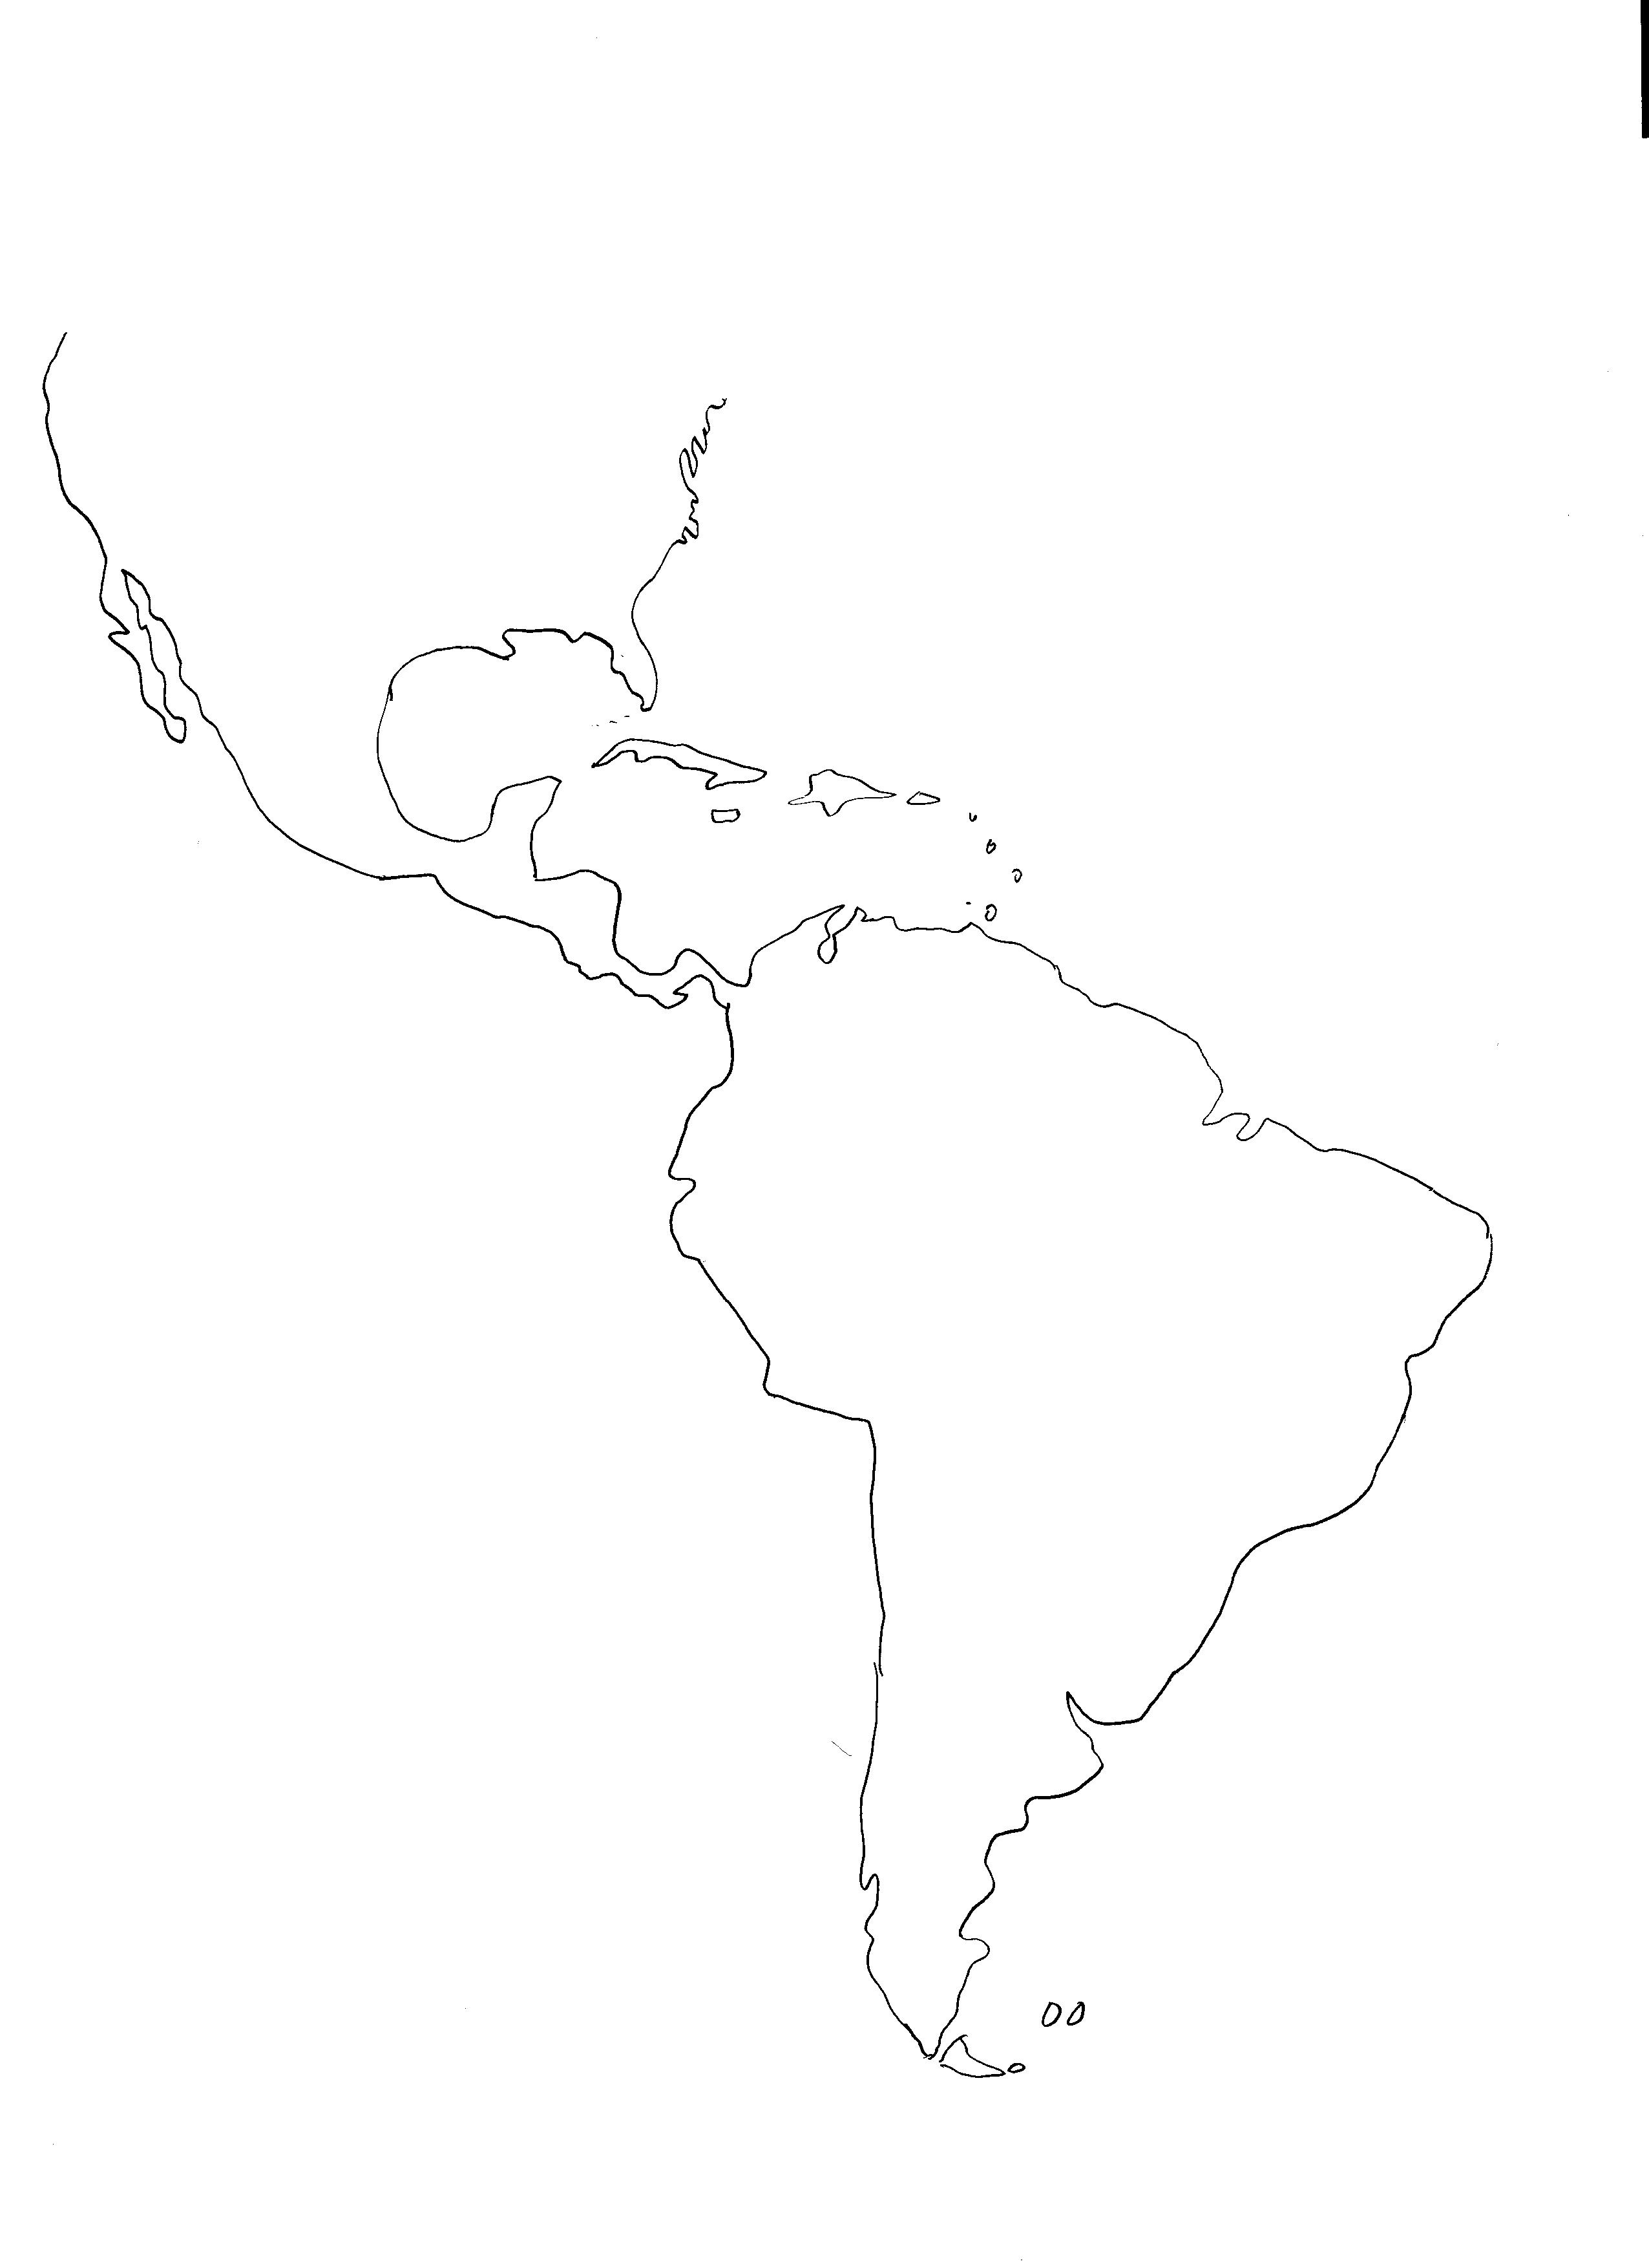
The map for the quiz will be identical to this one:

The Bajío is the central plateau just north of Mexico City, encompassing Guanajuato, Zacatecas, and Aguascalientes, north to San Miguel de Allende. It has long been the heartland of silver, wheat, and cattle production.
Not the town nor the state, but the vast grassland region of Argentina of central/eastern Argentina.
The state.
The estuary and the lands adjacent to it, not the state.

