Hispanic World Unit

Table of Contents:
Argentina
- Works on paper………………………………………….….……..2
- Painting…………………………………………………….……...3

Brazil
- Works on paper………..…………………………………….…….4
- Painting…………………………………………………….……...4

Chile
- Works on paper………..…………………………………….…….5
- Painting…………………………………………………….……...5
- Sculpture…………………………………..……………….……...5

Cuba
- Works on paper………..…………………………………….…….6
- Painting…………………………………………………….……...7

Ecuador
- Works on paper………..…………………………………….…….8

Guatemala
- Works on paper………..…………………………………….…….8

Mexico
- Works on paper………..…………………………………….…….9
- Painting…………………………………………………………..20
- Sculpture…………………………………..……………….…….21

Panama
- Works on paper………..……………………………………...….23

Peru
- Works on paper………..…………………………………...…….23
- Textiles…………………………………………………………...24

Puerto Rico
- Works on paper………..…………………………………...…….25
- Sculpture…….…………………………………………………...25

Unspecified Country
- Works on paper………..…………………………………...…….26

Works on Paper (Argentina)
La Yuyito con muneca
Print
Garcia, Juan Carlos
1975
Xilographia
Argentine, 20th century
AC 1976.26
Gift of Erving Chapman
Luis Felipe
Print
Lasansky, Mauricio
N.r.
Intaglio print
American, born 1914 in Argentina
AC 1977.60
Gift of Mr. and Mrs. James B. Schramm
Untitled (11/275) taken from the album "Miroirs"  Print  Le Parc, Julio  20th century  "Gaufrage" on metallic paper  Argentinian (1928-)  AC 1967.88  Gift of Richard S. Zeisler (Class of 1937) | 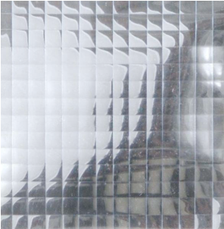
Still Life #1
Porter, Liliana
1970
Aquaforte and collage
Argentina
AC 1994.541
Gift of Rowell A. Schleicher (Class of 1921) and Susan T. Schleicher
Costeritas de Santa Fe
Print
Schurjin, Raul
1961
Lithograph
Argentina
AC 1994.605
Gift of Rowell A. Schleicher (Class of 1921) and Susan T. Schleicher

Painting (Argentina)
Really Really Really Really Really  Painting  Marcaccio, Fabian  1991  Collogra on fabric, oil, wood, silicon gel, burlap  Argentinean, born 1963  AC 2000.417  Gift of Steven M. Jacobson (Class of 1953) | 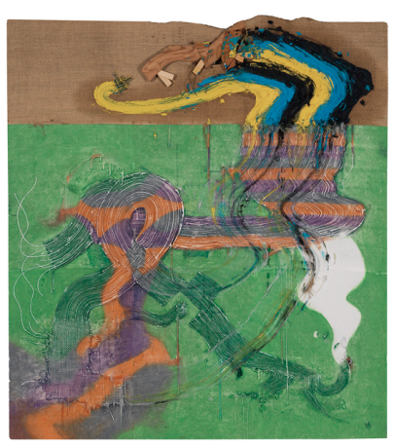  Abstract composition constructed of two panels. The upper 1/4 of the work is a light brown with a wood element, an extension of the stretcher bar, that is part for the composition. Large strokes in black, blue and yellow continues on the lower and larger part of the picture. Bands of orange and lavender on a green ground, dominates this panel. These strokes bend at the bottom edge and runs along horizontally, ending in a swirl at the lower left.

Works on Paper (Brazil)
The Dream
Print
De Lamonica, Roberto
1968
Etching and aquatint
Brazilian
AC 1994.296
Gift of Rowell A. Schleicher (Class of 1921) and Susan T. Schleicher
Angelica (Aftermath Series), Edition 3/10  Photograph  Muniz, Vik  1998  Cibachrome  Brazilian, born 1961  AC 2003.69  Gift of Steven M. Jacobson (Class of 1953) | 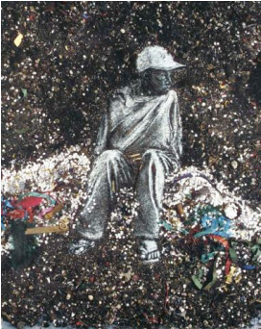  For the Aftermath series, Muniz invited Brazilian street children to pose as figures they selected from art books. He translated the resulting photographs into drawings using street sweepings from the Rio Carnival. The image we see is a photograph of that intermediary work, a portrait of a vulnerable child, formed from the exquisite, glittering refuse of dust, sequins and confetti.
La Comete Rouge
Piza, Arthur Luiz
1967
Etching
Brazil
AC 1994.538
Gift of Rowell A. Schleicher (Class of 1921) and Susan T. Schleicher

Painting (Brazil)
Sunday in Sepetiba  Painting  Teixeira, Oswaldo  1957  Oil on canvas  Brazilian (1904-1974)  AC 1960.5  Gift of Mr. Jesse Thaler | 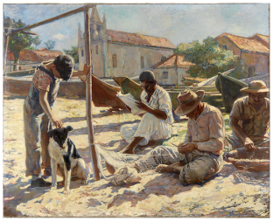

Works on Paper (Chile)
Andean Festival
Print
Antunez, Nemesio
1954
Lithograph
Chilean (1918-1993)
AC 1994.207
Gift of Rowell A. Schleicher (Class of 1921) and Susan T. Schleicher
Fog, Smog, Demogog
Print
Matta (Roberto Sebastian Antonio Echaurren Matta)
Lithographs, color
Chilean (1911-2002)
AC 1978.86.a-d
Gift of Bertram Podell
Fond Beige
Print
Matta (Roberto Sebastian Antonio Echaurren Matta)
Etching in color with aquatint
Chilean (1911-2002)
AC 1980.47
Purchase

Painting (Chile)
Luminare Indombile  Painting  Matta (Roberto Sebastian Antonio Echaurren Matta)  1950  Oil on canvas  Chilean (1911-2002)  AC 1960.10  Gift of Mr. and Mrs. James S. Schramm | 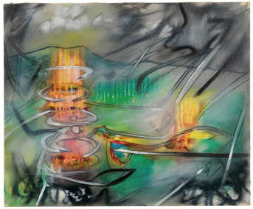

Sculpture (Chile)
Medallion of Gabriel Gonzalez Videla, President of Chile
Sculpture
Waugh, Sidney
20th century
Plaster
American (1904-1963)
AC 1964.79
Gift of Mrs. Sidney Waugh

Works on Paper (Cuba)
Study #2 for Voyeurs & Beholders of...  FINE ART  Photograph  Campos-Pons, Maria Magdalena  2007  Polacolor #7 (Polaroids) on paper  Cuban, born 1959  AC 2007.10.a-e  Purchase with Wise Fund for Fine Arts | 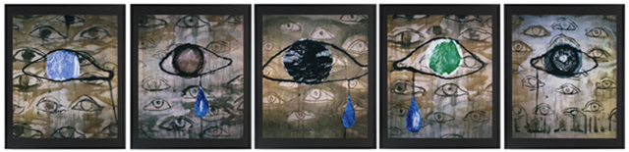  Polyptych
Small Factory, Cuba  Photograph  Evans, Walker  Cuba  1933  Photograph  American (1903-1975)  AC 1993.19  Purchase with Richard Templeton (Class of 1931) Photography Fund | 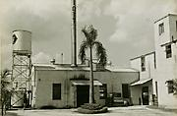
Camera Obscura Image of Umbrian Landscape Over Bed  Photograph  Morell, Abelardo  2000  Gelatin silver print  American, born 1948 in Cuba  AC 2003.03  Purchase with William K. Allison (Class of 1920) Memorial Fund | 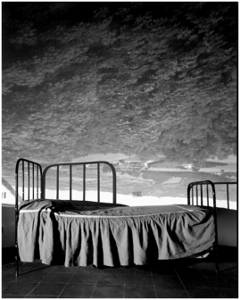
Rosa en la Jardin Tropical, Havana, Cuba, 2000
Photograph
Moore, Andrew
Cuba, Havana
2001
Chromogenic print on Fujicolor Crystal Archive Paper
American, born 1957
AC 2001.572
Purchase with Wise Fund for Fine Arts
Sunday Afternoon
Print
Sanchez, Emilio
1958
Lithograph
Cuban, born 1921 (active in United States)
AC 1994.580
Gift of Rowell A. Schleicher (Class of 1921) and Susan T. Schleicher
Tropical Holiday
Print
Sanchez, Emilio
1962
Woodcut
Cuban, born 1921 (active in United States)
AC 1994.581
Gift of Rowell A. Schleicher (Class of 1921) and Susan T. Schleicher

Painting (Cuba)
Composition
Painting
Milian, Rene
1954
Oil on paper
Cuban
AC 1956.17
Gift of Mr. Joseph Cantor

Works on Paper (Ecuador)
Sketch for "Exercise in Futility"  Drawing  Bastidas, Hugo  2004  Oil on sized paper  American (born in Ecuador), born 1956  AC 2005.34  Gift of the artist | 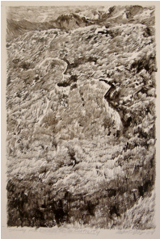

Works on Paper (Guatemala)
Street Photographer, Chichicastenango, Guatemala
Photograph
Newhall, Beaumont
1969
Color photograph
AC 1989.16.c
Bequest of Richard Templeton (Class of 1931)
Witchdoctor, Chi Chi Castenango, Guatemala  Photograph  Solomon, Rosalind  1979  Photograph  AC 1990.2  Museum purchase | 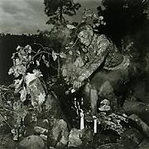

Works on Paper (Mexico)
Photograph  Alvarez Bravo, Manuel  Mexican (1902-2002)  Gelatin silver print  Gift of Frederick and Elizabeth Myers  - Almost (Ya Mero) 1968 (printed in 1977) AC 1981.129.4  - A Fish Called Saw (...Un Pez que llaman Sierra) 1928-9 (printed in 1977)  AC 1981.129.3  Box of Visions (Cajade Visiones) 1930s (printed in 1977)  AC 1979.107.6  - First Act (Acto Primero) 1975 (printed in 1977)  AC 1979.107.6  - Growing Landscape (Paisage de Siembras) 1972-4 (printed 1977)  AC 1979.107.2  - Lengthened Light (Luz Restirada) 1944 (printed 1977)  AC 1979.107.4  - Sand and Small Pines (Arena y Pinitos) 1920s (printed 1977)  AC 1979.107.1  - Skylight (Gorrion, Claro) 1938-40 (printed in 1977)  AC 1981.129.5  - Sleeping Dogs Bark (Los Perros durmiendo Cadran) 1966 (printed in 1977)  AC 1981.129.1  - The Man from Papantla (Senor de Papantla) 1934-5 (printed in 1977)  AC 1979.107.8  - Threshold (Umbral) 1947 (printed in 1977)  AC 1981.129.6  - Two Pairs of Legs (Dos Pares de Piernas) 1928-9 (printed in 1977)  AC 1981.129.2  - Two Women, a Large Blind, and Shadows (Dos Mujeres y la Gran Cortina con Sombras) 1977  AC 1979.107.5  - Votive Offering (Votos) 1969 (printed 1977)  AC 1979.107.3  - Woman Combing Her Hair (Retrato de lo Eterno) 1932-33 (printed in 1977)  AC 1981.129.7 | Fifteen prints in an Acorn Editions portfolio (#3/100); eight were given in 1979 (1979.107.1-8), the rest were given in 1981 and are listed as 1981.129.1-7.
Bread for Day of the Dead (Pan de Muertos)  Photograph  Alvarez Bravo, Manuel; Alvarez Bravo, Lola  North America; Mexico  1930s  Gelatin silver print  Mexican (1902-2002); Mexican (1907-1993)  AC 1998.126  Purchase with Richard Templeton (Class of 1931) Photography Fund | 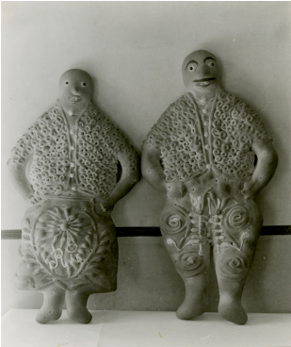
Popular Mural, Mexico City  Photograph  Alvarez Bravo, Manuel  North America; Mexico  1930s  Gelatin silver print  Mexican (1902-2002)  AC 1998.132  Purchase with Richard Templeton (Class of 1931) Photography Fund | 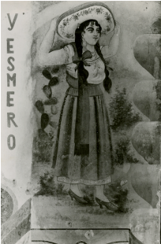  Scene with woman wearing a sombrero; inscription: Y esmero (I make an effort/do a good job)
Popular Mural, Parras, Coahuila  Photograph  Alvarez Bravo, Manuel  North America; Mexico  1930s  Gelatin silver print  Mexican (1902-2002)  AC 1998.133  Purchase with Richard Templeton (Class of 1931) Photography Fund | 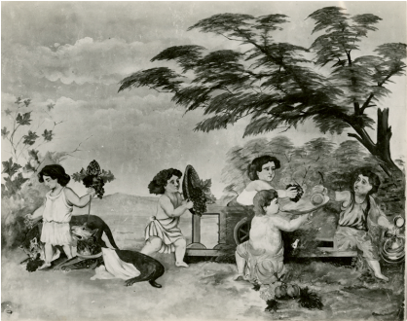  Scene of bacchanalia with putti and grapes
Popular Mural, San Juan Teotihuacan  Photograph  Alvarez Bravo, Manuel  North America; Mexico  1930s  Gelatin silver print  Mexican (1902-2002)  AC 1998.131  Purchase with Richard Templeton (Class of 1931) Photography Fund | 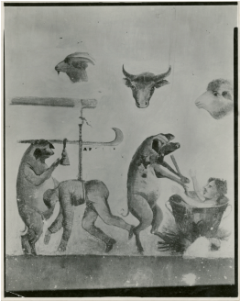  Scene with 2 pigs butchering a man; heads of a goat, cow, and sheep above
Toys, Guadalajara (Juguetes, Guadalajara)  Photograph  Alvarez Bravo, Manuel; Alvarez Bravo, Lola  North America; Mexico  1930s  Gelatin silver print  Mexican (1902-2002); Mexican (1907-1993)  AC 1998.127  Purchase with Richard Templeton (Class of 1931) Photography Fund | 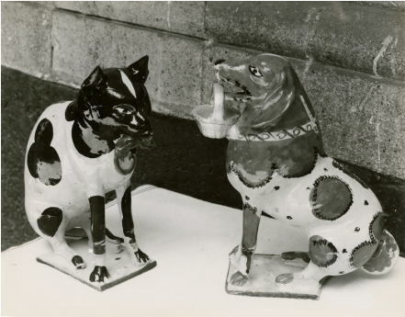  Two ceramic toy banks: one in the shape of a cat with a mouse, the other in the shape of a dog with a basket; objects from Tlaquepaque, Jalisco
Tree of Life (Arbol de la vida)  Photograph  Alvarez Bravo, Manuel; Alvarez Bravo, Lola  North America; Mexico  1930s  Gelatin silver print  Mexican (1902-2002); Mexican (1907-1993)  AC 1998.128  Purchase with Richard Templeton (Class of 1931) Photography Fund | 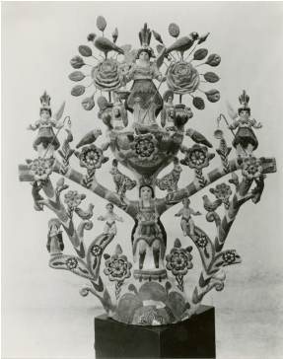  Candleabra with female figures in center, at top, and sides; children, birds, and animals perched on branches; probably from Izucar de Matamoros, Puebla.  **TWO examples in the Morrow Collection: AC 1955.633, AC 1955.632
Fiesta
Print
Amero, Emilio
1951
Color lithograph
Mexican (1900-1976)
AC 1951.442
Tired -- Mexico  Print  Ashbrook, Paul  N.r.  Etching  American (1867-1949)  AC 1951.469  Gift of Edward C. Crossett (Class of 1905) | 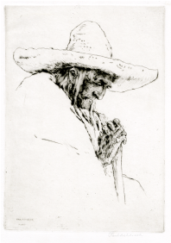
Castillo from the Perpendicular, Chichen Itza, Yucatan, Mexico, 1982  Photograph  Bridges, Marilyn  Central America; Mexico; Yucatan; Chichen Itza  1982 (later print)  Gelatin silver print  AC 1995.66.8  Gift of Stanley and Diane Person | From "Heightened Perspective" portfolio with 16 photographs
Overview, Palenque, Chiapas, Mexico, 1982  Photograph  Bridges, Marilyn  Central America; Mexico; Chiapas; Palenque  1982 (later print)  Gelatin silver print  American (b. 1948)  AC 1995.66.7  Gift of Stanley and Diane Person | 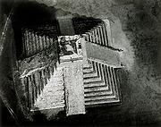  From "Heightened Perspective" portfolio with 16 photographs
Mercado de Ejutla  Photograph  Bucovich, Mario  North America; Mexico;Ejutla  Ca. 1945  Gelatin silver print  Mexican (dates unknown)  AC 1999.135  Purchase with Wise Fund for Fine Arts | View of market place from above; black burnished pottery in foreground; umbrellas in background
From the México y sus Alrededores series,  Castro, Casimiro  Mexico; Mexico City  Mid 19th century  Lithograph with tan tint stone with white highlights  Mexican (1826-1889)  Gift of the children of Dwight W. Morrow (Class of 1895) and Elizabeth C. Morrow  - The Bower, In the Interior of the Chapultepec Park, AC 1955.502  - The Bucareli Promenade, AC 1955.503  - Municipal House, or Deputation, AC 1955.504  - National Palace of Mexico, AC 1955.505  - Roldan Street and Its Wharf, AC 1955.506  - The Town of Guadalupe, Taken from a Balloon, AC 1955.507  - View of the Valley of Mexico, Taken from the Heights of Chapultepec, AC 1955.508 | National Palace of Mexico: From “México y Sus Alrededores” series. A view of Palacio de las Virreyes or National Palace at right. Mexican flag over portal in center of building. Zocolo (public square) in front of building filled with people walking, standing, and on horseback or in carriages. Roldan Street and Its Wharf: Imprinted above: Mexico y Sus Alrededores. Imprinted below: C. Castro y J. Campillo del y lito. Litog de Decaen editor, México Portal del Coliseo Viejo. Propiedad del editor./Roldan Street,/And its Wharf/La Calle de Roldan, y su Desembarcadero./La rue de Roldan/et son debarcadè. Market scene with wharf in right foreground crowded with men and women with baskets of flowers and fruits. At left, small boats filled with goods being handed to people above. Street flanked with low buildings and filled with people.
Zapatista Chief (papa), Mexico
Photograph
Catalan, Mara
Mexico
Circa 1995
Black and white photograph
American, born 1967
AC 2002.381
Gift of Linda Kastan
Pensive  Print  Catlett, Elizabeth  1985  Lithograph  Mexican, born in United States (1915- )  Sheet: 22 1/4 x 15 in.; 56.515 x 38.1 cm  AC 2001.573  Purchase | A native of Washington, D.C., Elizabeth Catlett is highly regarded for both her sculpture and prints in which she portrays the strength and dignity of the African American and Mexican worker. While painting murals for the Federal Art Project of the Works Progress Administration of the mid-1930s, she was introduced to the social activism of the Mexican artist, Diego Rivera. In 1940, while pursuing a master's degree in sculpture at the University of Iowa, Catlett studied with the Regionalist painter Grant Wood, who encouraged her to concentrate on images drawn from her socio-cultural environment. She traveled to Mexico City in 1946 where she is now a Mexican citizen. Throughout her career, she has produced a body of work celebrating both famous individuals and anonymous workers.  Pensive is a prime example of Catlett's ability to capture the essence of her subject using a medium, lithography, that can sometimes resist the nuance of emotion. This frontal portrait depicts a woman with short, cropped hair, high cheekbones, a determined jaw, and weary eyes. The subject establishes direct eye contact with the viewer, projecting a persona that embodies the sitter's integrity and resolution.
Rice Granary, Bali
Print
Covarrubias, Miguel
20th century
Lithograph
Mexican
AC 1996.239
Gift of Lakenan Barnes (Class of 1928)
Flight of the Mexican Army  Print  Currier, Nathaniel  1847  Colored lithograph  American (1813-1888)  AC 1955.471  Gift of children of Elizabeth and Dwight Morrow (Class of 1895) | 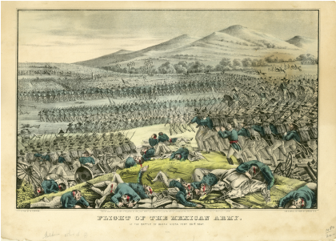
The Gossips
Print
Dosamentes, Francisco
20th century
Lithograph
Mexican, 20th century
AC 1954.38
Gift of Dr. McKinley Helm
Tropical Landscape in Mexico  Print  Drury, William H.  N.r.  Etching  American (1888-1960)  AC 1955.477  Gift of children of Elizabeth and Dwight Morrow, Class of 1895 | 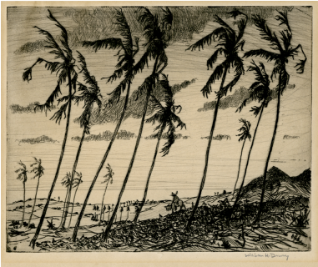
Maria Veronica is dead, Tixan, Ecuador, 1988  Photograph  Garduño, Flor  South America; Ecuador; Tixan  1995  Gelatin silver print  Mexican, born 1957  AC 2004.99  Museum Purchase | Mexican artist, scene from Ecuador
1st Panoramic View of Mexico  Print  Lopez, Urbano  Mexico  Mid 19th century  Chromolithograph  Mexican (dates unknown)  AC 1955.516 | 2nd, 3rd, 4th Panoramic views of Mexico:  AC 1955.513  AC 1955.514  AC 1955.515
Cloister of Our Lady of Merced  Print  Lopez, Urbano  Mexico  Mid 19th century  Lithograph  Mexican  AC 1955.509  Gift of the children of Dwight W. Morrow (Class of 1895) and Elizabeth C. Morrow | From “Mexico Pintoresco" series, pl. 2
Interior of the Cathedral of Mexico
Print
Lopez, Urbano
Mexico; Mexico City
Mid 19th century
Lithograph
Mexican
AC 1955.510
Interior of the Colegio de Mineria
Print
Lopez, Urbano
Mexico; Mexico City
Mid 19th century
Lithograph
Mexican
AC 1955.511
Interior of the Sanctuary of Our Lady of Guadalupe
Print
Lopez, Urbano
Mexico; Mexico City
Mid 19th century
Lithograph
Mexican
AC 1955.512
Mexico
Print
Mendez, Leopoldo
Central America; Mexico
1945
Woodcut
Mexican
AC 1951.1768
Mexico
Print
Menpes, Mortimer L.
N.d.
Etching
British (1855-1938)
AC 1988.6
Purchased
Conversation Piece
Print
Morado, Jose Chavez
20th century
Lithograph
Mexican, born 1909
AC 1954.37
Tower of Cortez, Mexico  Drawing  Moran, Thomas  Mexico  1883  Watercolor on paper  American (1837-1926)  AC 1953.11  Purchase | 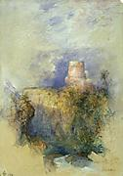
Mexican Study
Photograph
Mullins, William J.
Ca. 1900
Platinum print
AC 1999.150
Museum purchase
Grief
Print
Orozco, Jose Clementé
1926
Lithograph
Mexican (1883-1949)
AC 1952.15
The Masses
Print
Orozco, Jose Clementé
Central America; Mexico
1935
Lithograph
Mexican (1883-1949)
AC 1957.36
Museum purchase
Visiting Underground Passage
Pacheco, Maximo
Charcoal drawing on white paper
Mexican
AC 1952.17
Purchased from E. Weyhe, New York City
Madero  Print  Posada, Jose Guadalupe  Central America; Mexico  1910  Woodcut  Mexican (1852-1913)  AC 1951.1891 | From "Calaveras del Monton" (Skeletons of the Heap) series, 1910. A wealthy lawyer from the north of Mexico, Francisco I Madero opposed the reelection of Porfirio Diaz and became President of Mexico in 1911.
Cortes's Soldiers Torturing and Plundering [Cuernavaca Mural Study]
Drawing
Rivera, Diego
1930
Pencil on paper
Mexican (1886-1957)
AC 1952.16
Purchased from the Weyhe Gallery, New York City
Head of an Indian Boy
Drawing
Rivera, Diego
Central America; Mexico
20th century
Crayon on rice paper
Mexican (1886-1957)
AC D.1939.3
Museum purchase
Man with a Pickaxe
Drawing
Rivera, Diego
Central America; Mexico
N.r.
Black crayon on rice paper
Mexican (1886-1957)
AC D.1939.4
Museum purchase
Mexican Boy Carrying Sticks  Drawings  Rivera, Diego  Central America; Mexico  N.r.  Conté on paper  Mexican (1886-1957)  AC 1995.2  Gift of Dr. Edward F. Babbott (Class of 1945) | 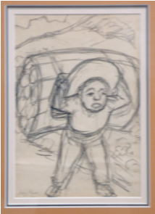
Still Life with Petit Dejeuner and Wine Bottle  Drawing  Rivera, Diego  1918  Graphite on paper  Mexican (1886-1957)  AC 1957.37  Purchase | 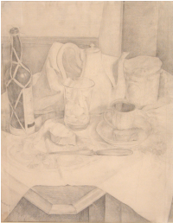
Mexican Girl  Drawing  Rosenthal, Doris  20th century  Charcoal drawing on white paper  American  AC 1947.150  Museum purchase | 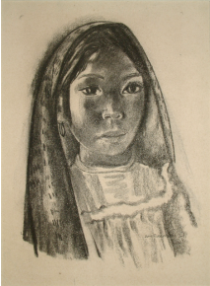
Mexico
Print
Rouargue, Emile
N.r.
Colored engraving
French
AC 1955.500
Gift of the children of Dwight W. Morrow (Class of 1895) and Elizabeth C. Morrow
State of Chiapas, Mexico  Photograph  Salgado, Sebastião  North America; Mexico; Chiapas  1998  Gelatin silver print  Brazilian, born 1944  AC 2002.17  Purchase with Wise Fund for Fine Arts | Children playing ball at a refugee camp. From the project, "Migrations: Humanity in Transition."
Seated Figure
Print
Siqueiros, David Alfaro
20th century
Lithograph
Mexican
AC 1957.38
Museum purchase
Dos Mujeres  Print  Tamayo, Rufino  1969  Color lithograph on paper  Mexican (1899-1991)  AC 2000.434 | From the Mujeres Suit, printed by Atelier Desjobert, Paris. Two female figures, the one on the left outlined in red on a dark ground, the one on the right is green against a rose ground.
Femme Souriante (Mujer)  Print  Tamayo, Rufino  1969  Color lithograph on paper  Mexican (1899-1991)  AC 2000.433 | From the Mujeres Suit, printed by Atelier Desjobert, Paris, Laughing woman, with orange hair against a turquoise ground with red speckles
Mujer
Print
Tamayo, Rufino
1969
Color lithograph on paper
Mexican (1899-1991)
AC 2000.432
Mujeres  Print  Tamayo, Rufino  1969  Color lithograph on paper  Mexican (1899-1991)  AC 2000.436 | From the Mujeres Suit, printed by Atelier Desjobert, Paris. The body is against a tan and dark brown ground.
Mujer en Rojo y Verde
Print
Tamayo, Rufino
1969
Color lithograph on paper
Mexican (1899-1991)
AC 2000.435
House with Flying Shingles
Print
Toledo, Francisco
Aquatint of paper
Mexican, born 1940
Sheet: 15 x 20 in.; 38.1 x 50.8 cm
AC 2000.437
Untitled (Kitchen Interior)  Print  Toledo, Francisco  Aquatint on paper  Mexican, born 1940  AC 2000.438  Gift of Steven M. Jacobson (Class of 1953) | Kitchen interior with female figure to the left with a cat at her feet. A figure with a hat enters the composition at the lower right.
Display Window with "The Painted Pig"  Photograph, Gelatin silver print  Unknown  North America; Mexico  Ca. 1931  AC 1998.125  Purchase with Richard Templeton (Class of 1931) Photography Fund | 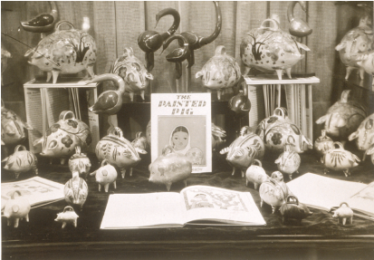
City of Mexico
Print
Unknown
N.r.
Engraving
Dutch
AC 1955.483
Gift of the children of Elizabeth and Dwight W. Morrow
Doña Maria Carlota
Print
Unknown
Mexico
Ca. 1870
Lithograph
Mexican (?)
AC 1955.517.x
Maximilian I
Unknown
Ca. 1870
Lithograph
Mexican (?)
AC 1955.517
Types (Tipos), Zapotecas, Oaxaca, Oax.  Photograph  Unknown,North America; Mexico; Oaxaca  Mid 20th century  Gelatin silver print on post card  Mexican  AC 1999.139  Purchase with Wise Fund for Fine Arts | Two women holding Zapoteca Indian weavings
Mexican Woman
Print
Unwin, Nora S.
1956
Wood engraving
AC 1957.70
Through membership in the Boston Printmakers
Cathedral Repairs, Mexico City
Print
Weidenaar, Reynold Henry
1949
Mezzotint
American
AC 1951.2143
Gift of Edward C. Crossett
Jar Seller (Vendedor de Jarros), Mexico  Photograph  Yañez, Mauricio  North America; Mexico  Circa 1941  Gelatin silver print  AC 1999.137  Purchase with Wise Fund for Fine Arts | Campesino leaning against tree, carry crate of pottery
Jars (Jarros), Mexico  Photograph  Yañez, Mauricio  North America; Mexico  Circa 1920  Gelatin silver print  AC 1999.136  Purchase with Wise Fund for Fine Arts | Campesino carrying a crate full of pottery on his back; holding a walking stick in his right hand
Pottery (Alfareria), Tlaquepaque, Mexico  Photograph  Yañez, Mauricio  North America; Mexico; Tlaquepaque  Circa 1940  Gelatin silver print  Mexican (dates unknown)  AC 1999.138  Purchase with Wise Fund for Fine Arts | Seated man decorating huge ceramic pot with floral designs; other smaller pots on floor and on shelf behind

Paintings (Mexico)
Tecalpexco  Painting  Rivera, Diego  North America; Mexico  1937  Tempera on board  Mexican (1886-1957)  AC 1975.93  Bequest of Mrs. Phillip Youtz (Phillip Youtz, Class of 1918) | 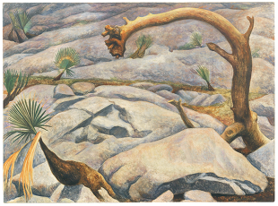
Madonna and Child
Painting
Unknown
Central America; Mexico
Oil on canvas
Mexican, 19th century
AC 1979.145
Estate of Hope Gray
Mexican Landscape  Painting  Wakeman, Marion D. Freeman  Early 1930s  Oil on canvas  American (1891-1953)  AC 1972.16  Gift of Richard King, Class of 1935 | 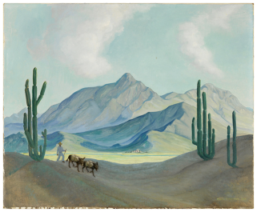

Sculpture (Mexico)
Doll (Muñeca)  Ceramic  Unknown  North America; Mexico; Guerrero, Mezcala Region  Early 20th century  Earthenware  Mexican  AC 1955.626  Gift of the children of Dwight W. Morrow (Class of 1895) and Elizabeth C. Morrow | 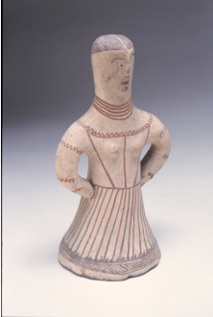
Figure of a Saint  Sculpture  Unknown  Central America; Mexico or Europe; Spain  17th century  Polychromed wood  Mexican or Spanish  AC 1955.539  Gift of children of Dwight W. Morrow (Class of 1895) and Elizabeth C. Morrow | 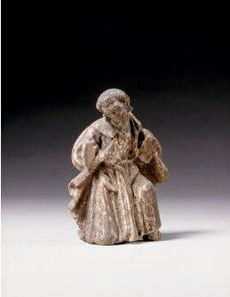
Figurine of a Woman with Chicken (Mujer con pollo)  Sculpture  Unknown  North America; Mexico  Late 18th century  Painted wood and cloth  Mexican  AC 1955.660  Gift of the children of Dwight W. Morrow (Class of 1895) and Elizabeth C. Morrow | Figure of a young woman, standing with head tilted to one side, one arm outstreched, the other by her side holding a chicken. Long dark hair, with gold ribbon in back. Tight-bodiced gown with green bodice, red and gold skirt with sprigs of flowers; gold apron. Small wooden base. One of pair with 1955.659?
Figurine of Dancing Man (Hombre bailando?)  Sculpture  Unknown  North America; Mexico  Late 18th century  Painted wood  Mexican  AC 1955.659  Gift of the children of Dwight W. Morrow (Class of 1895) and Elizabeth C. Morrow | Small carved and painted wood figure of man in 18th-century costume: long green, red and gold coat, with gold waistcoat, red, knee-length breeches and white stockings. Figure stands with one arm bent by his side, the other bent in front; one leg kicked backwards (dancing?). On small wooden base. One of a pair with 1955.660
Head of a woman  Sculpture  Unknown  Central America; Mexico  17th century  Terracotta  Mexican  AC 1957.24  Gift of Miss Katharine C. Cowles | 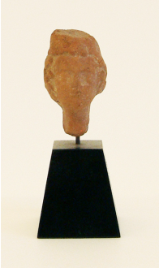
Whistle in the Shape of a Man (Silbato)  Ceramic  Unknown  North America; Mexico; Oaxaca  Early 20th century  Clay  Mexican  AC 1955.631  Gift of the children of Dwight W. Morrow (Class of 1895) and Elizabeth C. Morrow | 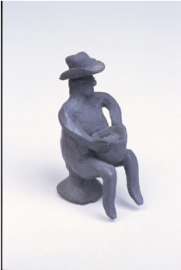  Black figure of a man wearing a large hat, seated on stool holding bowl in his hands; 2 holes in back for whistle; probably from Oaxaca

Works on Paper (Panama)
Black Christ Festival, Panama
Photograph
Grossman, Sid
Central America; Panama
1945
Vintage gelatin silver print
American (1915-1955)
AC 2001.576
Purchase with Wise Fund for Fine Arts

Works on Paper (Peru)
Canete Fishing Village, Bay of Paracas, Peru, 1989  Photograph  Bridges, Marilyn  South America; Peru  1989 (later print)  Gelatin silver print  American (b. 1948)  AC 1995.66.1  Gift of Stanley and Diane Person | From "Heightened Perspective" portfolio with 16 photographs
Machu Picchu Among the Peaks of the Andes, Peru, 1989  Photograph  Bridges, Marilyn  South America; Peru  1989 (later print)  Gelatin silver print  American (b. 1948)  AC 1995.66.2  Gift of Stanley and Diane Person | From "Heightened Perspective" portfolio with 16 photographs
Overview, Nasca, Peru, 1988  Photograph  Bridges, Marilyn  South America; Peru  1988 (later print)  Gelatin silver print  American (b. 1948)  AC 1995.66.3  Gift of Stanley and Diane Person | From "Heightened Perspective" portfolio with 16 photographs
Catalin Valentin's Lamb, Ancash, Peru
Photograph
Solomon, Rosalind
1981
Photograph
AC 1990.1
Museum purchase

Textile (Peru)
Textile fragment  DECORATIVE ART  Textile  Unknown  South America; Peru  Peruvian  AC 1991.52  Gift of Donald Finberg (Class of 1953) | 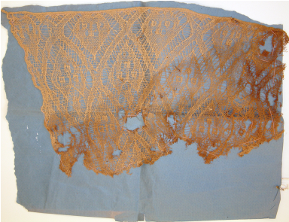
AC 1991.55 | 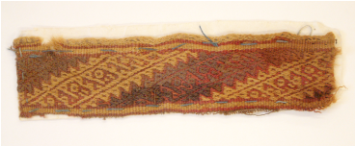
AC 1991.56 | 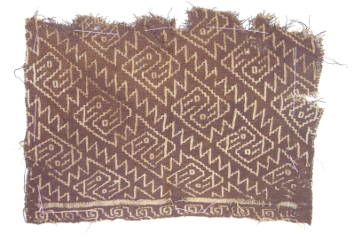
AC 1991.57 | 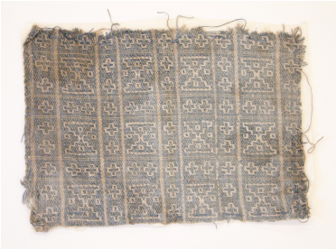
AC 1991.53 | 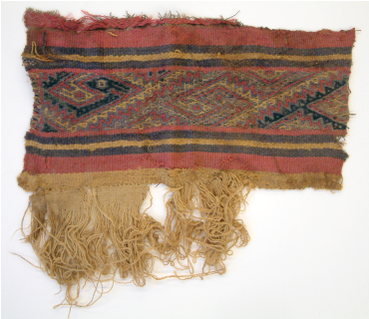
AC 1991.54 | 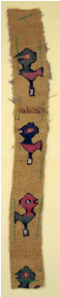

Works on Paper (Puerto Rico)
Forma II
Print
Yrizarry, Marcos
Central America; Caribbean; Puerto Rico
1970
Intaglio
Puerto Rican (1936-1995)
AC 1994.750
Gift of Rowell A. Schleicher (Class of 1921) and Susan T. Schleicher
Puerto Rico
Photograph
Frank, Robert
Puerto Rico
1962
Gelatin silver print
American (1924 - )
AC 1997.33
Gift of Paul Katz

Sculpture (Puerto Rico)
Untitled
Sculpture
Torruella, Luis A.
1988
Welded steel
Puerto Rican
34 1/2 in. tall
AC 1988.86
Purchase, Wise Prize
EXAMPLE OF SANTOS:  Santos: Los Tres Reyes  Sculpture  Caban  Central America; Caribbean; Puerto Rico  19th century  Wood  Puerto Rican  AC 1978.68.i  Gift of Walter Fillin | 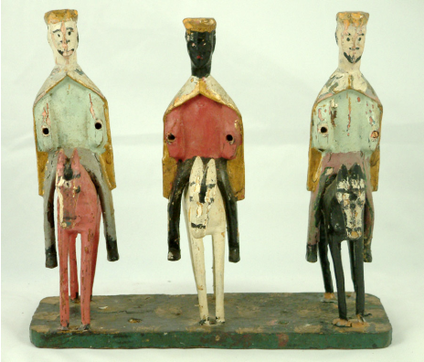
Santos: La Monserrate  Sculpture  Central America; Caribbean; Puerto Rico  19th century  Wood  Puerto Rican  AC 1978.68.g  Gift of Walter Fillin | 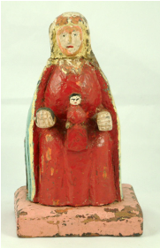

Works on Paper (Unspecified)
Mounting the South American War Horse
Cesare, O E
Ca. 1914
Wash drawing
American
AC 1966.25
Gift of Mrs. and Mrs. Robert Keith Leavitt
Religion contra Tecnologia
Print
Sanchez, Enrique
1966
Woodblock
South American
AC 1994.583
Gift of Rowell A. Schleicher (Class of 1921) and Susan T. Schleicher

A lot of Mexican decorative arts

