Global Environmental History of the Twentieth Century (HIST 27)
– Amherst College, Fall 2010 –
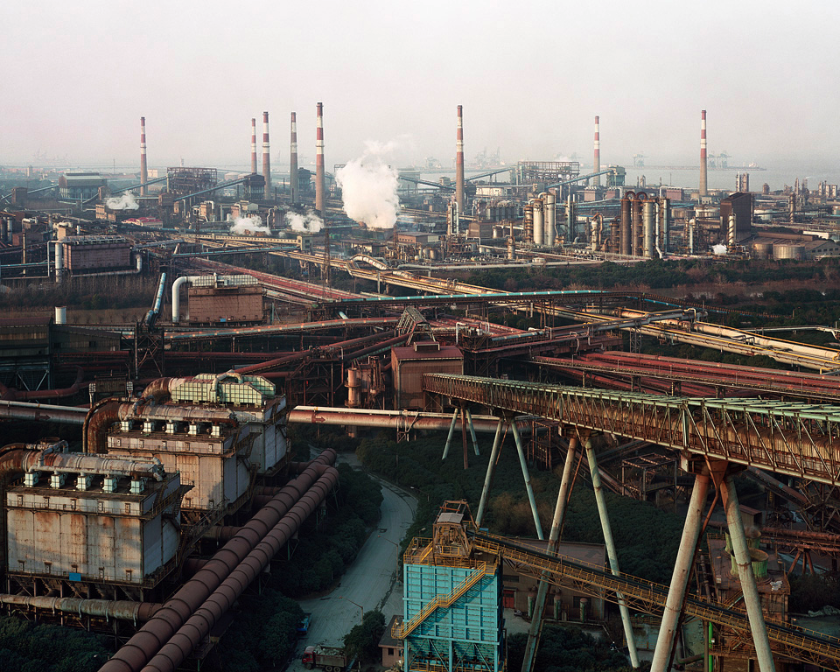
Bao Steel Factory #2, Shanghai (Photo: Edward Burtynsky, 2005)

Instructor: Edward “Ted” Melillo

Office Hours (Morgan Hall-112): Tuesdays from 12:30 PM-2:00 PM & Wednesdays from 10:00 AM-12:00 PM

Office Phone: (413) 542-5415 E-mail: emelillo@amherst.edu

Course Description: This course examines the environmental history of the world since 1900 with a particular focus on Latin America, Sub-Saharan Africa, and China. We will use books, articles, films, and a range of online media to illuminate the comparative and interdisciplinary possibilities of global environmental history. In addition to studying the past, we will explore how to use historical knowledge in the formulation of policy recommendations and grassroots initiatives for addressing contemporary environmental issues.

Format: Our class will meet on Tuesdays and Thursdays from 10:00-11:20 a.m. in Webster 220. Class attendance is mandatory; class participation comprises 20% of your final grade.

Required Texts (available at Food for Thought Books in Amherst):
- Oscar Olivera, in collaboration with Tom Lewis, ¡Cochabamba!: Water War in Bolivia (Cambridge, Mass.: South End Press, 2004)
- Tamara Giles-Vernick, Cutting the Vines of the Past: Environmental Histories of the Central African Rain Forest (Charlottesville: University Press of Virginia, 2002)
- R. Edward Grumbine, Where the Dragon Meets the Angry River: Nature and Power in the People’s Republic of China (Washington, D.C.: Island Press, 2010)
- Ramachandra Guha, How Much Should a Person Consume? Environmentalism in India and the United States (Berkeley: University of California Press, 2006)
Unless I hand them out in class, all other readings will be available online through E-Reserve.

Assignments:
- Three short papers: During the second week of the semester, I will provide you with a list of essay topics for the three short papers that you will write this semester. Each of these topic questions will ask you to use your knowledge of environmental history to formulate a policy recommendation or design a grassroots initiative to help solve a contemporary problem. For each of the essays, you will have three options from which to choose. Your essays should be between 5-6 pages in length (no longer), 12-point font, and double-spaced. Each essay is worth 15% of the final grade. You will hand in your hard copies of the essays at the end of class on the day that they are due. Late assignments will lose at grade point per day (e.g. A → A-).
- Three Map Quizzes: At the beginning of the Latin America, Africa, and China units, I will ask you to locate on a map a series of relevant countries, key cities, and/or major ecological zones. I will provide you with study guides for these quizzes ahead of time.
- Occasional Reading Reviews: When necessary, I will ask all of you to respond to a few, short questions on the reading assignments for a particular session.
- Final Exam: The final exam is a take-home test, which will consist of short identification questions, a short essay section, two long essays, and a matching section.

Assessment of Your Work:
Your final grade will reflect your performance on the short papers (45%), your map quizzes (10%), your final exam (25%), and your class participation (20%). I will factor your performance on the occasional reading reviews into your class participation grade.

Plagiarism: The Amherst College community takes plagiarism very seriously. Plagiarism is the presentation of the ideas or words of others as if they are your own. It amounts to a violation of basic ethical principles and a breach of academic standards of conduct. You must use quotation marks when presenting phrases that you have not written, and you must cite sources for ideas that are not your own. The Amherst College policy on plagiarism appears online at:
https://www.amherst.edu/campuslife/deanstudents/acadhonesty/plagiarism
If you need further clarification, please consult the Amherst College Library website on citation methods: https://www.amherst.edu/library/research/citation

Course Schedule

Latin America:
Tuesday, September 7
Lecture/discussion Topic: “Course Introduction: The Enclosure of The Commons.”
Assignments for next session:
- Guillermo Castro Herrera, “Environmental History (Made) in Latin America” (April 19, 2001): http://www.hnet.org/~environ/historiography/latinam.htm
- Myrna Santiago, “Rejecting Progress in Paradise: Huastecs, the Environment, and the Oil Industry in Veracruz, Mexico, 1900-1935,” Environmental History 3, no. 2 (1998): 169-88.
http://www.jstor.org/stable/3985378

Thursday, September 9
Lecture/discussion Topic: “The Social Ecology of Mexican Oil: An Environmental History of Vera Cruz, Mexico, 1900-1938.”
Assignments for next session:
- ¡Cochabamba!, pages 1-86.
- Peter B.R. Hazell, “Green Revolution: Curse or Blessing?” International Food Policy Research Institute (2002): http://www.ifpri.org/pubs/ib/ib11.pdf

Tuesday, September 14
Lecture/discussion Topic: Lecture/Discussion Topic: “The Green Revolution in Mexico: A Pandora’s Box of Possibilities, 1944-Present”
Assignment for next session:
- Paul S. Sutter, “Nature’s Agents or Agents of Empire?: Entomological Workers and Environmental Change during the Construction of the Panama Canal,” Isis 98, no. 4 (2007): 724-54. http://www.journals.uchicago.edu/doi/abs/10.1086/529265
- Look at Google Maps satellite view of the Panama Canal:
http://maps.google.com/maps?q=Panama+canal&ll=9.277994,-79.913006&spn=0.115880,0.204826&t=k&hl=en

Thursday, September 16
Lecture/discussion Topic: “A Diseased Artery: Mosquitoes, Race, Gender, and the Making of the Panama Canal, 1904-1914.”
MAP QUIZ #1 – Latin America
Assignment for next session:
- Steve Marquardt, “Pesticides, Parakeets, and Unions in the Costa Rican Banana Industry, 1938-1962,” Latin American Research Review 37, no. 2 (2002): 3-36. http://www.jstor.org/stable/2692147
- Complete ¡Cochabamba!

Tuesday, September 21
Lecture/discussion Topic: “Making a Banana Republic: Monocultures, Monopolies, and Movements in Guatemala, 1944-1954.”
Assignment for next session:
- Philip M. Fearnside, “Deforestation in Brazilian Amazonia: History, Rates, and Consequences,” Conservation Biology 19, no. 3 (2005): 680-88. http://onlinelibrary.wiley.com/doi/10.1111/j.1523-1739.2005.00697.x/abstract
- Alexi Barrionuevo, “To Fortify China, Soybean Harvest Grows in Brazil,” The New York Times (April 6, 2007) http://www.nytimes.com/2007/04/06/business/worldbusiness/06soy.html

Thursday, September 23
Lecture/discussion topic: “Vegetable Steel: The soybean’s unlikely journey from China to Brazil.”
Assignment for next session:
- Ed Ewing, “Cuba’s Organic Revolution,” The Guardian (April 4, 2008)
http://www.guardian.co.uk/environment/2008/apr/04/organics.food

Tuesday, September 28
Lecture/discussion topic: In-class film – “The Power of Community: How Cuba Survived Peak Oil” (The Community Solution, 2006)
ESSAY #1 DUE AT THE END OF CLASS
Assignment for next session:
- William Beinart, “African History and Environmental History” (June 11, 2001): http://www.h-net.org/~environ/historiography/africaeh.htm

Sub-Saharan Africa:
Thursday, September 30
Lecture/discussion topic: “Africa is more than the sum of its famines!”
Assignments for next session:
- Lynne Heasley, “Reflections on Walking Contested Land: Doing Environmental History in West Africa and the United States,” Environmental History 10 (July 2005): 510-31.
http://www.historycooperative.org/journals/eh/10.3/heasley.html
- David Quammen (Photographs by George Steinmetz), “Tracing the Human Footprint,” National Geographic Special Issue on Africa (September 2005): http://www7.nationalgeographic.com/ngm/0509/feature1/index.html
- Cutting the Vines of the Past, pages 1-68.

Tuesday, October 5
Lecture/discussion topic: “Peanuts: The Groundnut Scheme in Tanganyika, 1946-1951.”
Assignments for next session:
- Dirk Verschuren, et al., “History and timing of human impact on Lake Victoria, East Africa,” Proceedings of the Royal Society of London 269 (2002): 289-94. http://www.pubmedcentral.nih.gov/picrender.fcgi?artid=1690894&blobtype=pdf
- Cutting the Vines of the Past, pages 69-118.

Thursday, October 7
Lecture/discussion topic: In-class film: Hubert Sauper, dir., “Darwin’s Nightmare” (Image Entertainment, 2007)
Assignments for October 20th session:
- Freek J. Venter, et al. “The Evolution of Conservation Management Philosophy: Science, Environmental Change and Social Adjustments in Kruger National Park,” Ecosystems 11, no. 2 (2008): 173-92.
http://www.springerlink.com/content/1776r2614w120561/
- Edward M. Bruner and Barbara Kirshenblatt-Gimblett, “Maasai on the Lawn: Tourist Realism in East Africa,”Cultural Anthropology 9 (November 1994): 435-70.
http://www.jstor.org/stable/656384
- Complete Cutting the Vines of the Past.

Tuesday, October 12
Lecture/discussion topic: Finish watching “Darwin’s Nightmare.” Discussion of Cutting the Vines of the Past.

Thursday, October 14
– No Class – I will be out of town –

Tuesday, October 19
Lecture/discussion topic: “Frozen in Time, Yet Forced to Change: The Maasai and Serengeti National Park, 1921-2008.”
MAP QUIZ #2 – Sub-Saharan Africa
Assignment for next session:
- Doctors Without Borders/Médecins Sans Frontières, “Sleeping Sickness,” (2008): http://www.doctorswithoutborders.org/news/issue.cfm?id=2401

Thursday, October 21
Lecture/discussion topic: “The Strange Career of Sleeping Sickness: From Ecological Equilibrium to Neglected Disease, 1896-2007.”
Assignment for next session:
- Judith A. Carney, “African Rice in the Columbian Exchange,” The Journal of African History 42, no. 3 (2001): 377-96. http://journals.cambridge.org/download.php?file=%2FAFH%2FAFH42_03%2FS0021853701007940a.pdf&code=91d3968e33a89c70ec9cdaa4de02bcf5

Tuesday, October 26
Lecture/discussion topic: “Rice and Race: Re-examining African Contributions to the Columbian Exchange.”
Assignment for next session:

Khadija Sharife, “DRC’s magic dust: Who benefits?” Pambazuka News 468 (February 4, 2010):
http://www.pambazuka.org/en/category/features/61992\
- Victoria Brittain, “Colonialism and the Predatory State in the Congo,” New Left Review 1, no. 236 (July-August 1999)
http://www.newleftreview.org/?view=2085

Thursday, October 28
Lecture/discussion topic: “A Ghost in the ‘Lungs’ of the World: From Rubber to Coltan in the Congo, 1885-2008.”
ESSAY #2 DUE AT THE END OF CLASS
Assignment for next session:
- Micah S. Muscolino, “Global Dimensions of Modern China’s Environmental History,” World History Connected 6 (2009): http://worldhistoryconnected.press.illinois.edu/6.1/muscolino.html

China:
Tuesday, November 2
Lecture/discussion topic: “All the World’s a Stage…and China Has the Most Players!”
Assignment for next session:
- Where the Dragon Meets the Angry River, 3-59.

Thursday, November 4: In-class film: “Manufactured Landscapes” (Zeitgeist Films, 2007)

Tuesday, November 9
Lecture/discussion topic: “‘Revolution Is Not a Dinner Party’: A Social and Environmental History of The Great Leap Forward, 1958-62.”
Assignment for next session:
- Where the Dragon Meets the Angry River, 60-107.

Thursday, November 11
Lecture/discussion topic: In-class film: “Up the Yangtze” (National Film Board of Canada, 2007) and discussion.
Assignment for next session:
- Complete Where the Dragon Meets the Angry River.
- Susan Greenlaugh, “Science, Modernity, and the Making of China’s One-Child Policy,” Population and Development Review 29, no. 2 (2003): 163-96. http://www.jstor.org/stable/3115224?cookieSet=1

Tuesday, November 16
Lecture/discussion topic: “A Nation of ‘Little Emperors’: China’s Planned Birth (One-Child) Policy (jìhuà shēngyù), 1979-Present.”
Assignment for next session:
- Kenneth Pomeranz, “Political Economy and Ecology on the Eve of Industrialization: Europe, China, and the Global Conjuncture,” The American Historical Review 107, no. 2 (2002): 425-46. http://www.historycooperative.org/journals/ahr/107.2/ah0202000425.html

Thursday, November 18
Lecture/discussion topic: “Life on the Hydrocarbon Frontier: Building the Energy Foundations for the World’s Most Populous Country.”
MAP QUIZ #3 – China
Assignment for next session:
- Megan Sweeney and Susan McCouch, “The Complex History of the Domestication of Rice,” Annals of Botany 100, no. 5 (2007): 951-57.
http://aob.oxfordjournals.org/cgi/content/abstract/mcm128v1

Tuesday, November 23 & Thursday, November 25
-- No class…Thanksgiving Recess! –

Tuesday, November 30
Lecture/discussion topic: “The Word for Rice is also the Word for Food: Rice Culture and Cultivation in Chinese History.”
ESSAY #3 DUE AT THE END OF CLASS

Assignment for next session:
- Peter Dauvergne, “The Problem of Consumption,” Global Environmental Politics 10, no. 2 (2010): 1-10. http://www.mitpressjournals.org/doi/abs/10.1162/glep.2010.10.2.1

The World:
Thursday, December 2
Lecture/discussion topic: In-class film: “Black Gold” (Mongrel Media, 2006)
Assignment for next session:
- How Much Should a Person Consume?, pages 1-124.
- Immanuel Wallerstein, “The Ecology and the Economy: What is Rational?” Paper delivered at Keynote Session of Conference, “World System History and Global Environmental change,” Lund, Sweden, 19-22 September 2003: http://www.binghamton.edu/fbc/iwecoratl.htm

Tuesday, December 7
Lecture/discussion topic: “Synoptic Views and Local Knowledge.”
Assignment for next session:
- Complete How Much Should a Person Consume?

Thursday, December 9:
Lecture/discussion topic: “Cultures of Consumption in a Finite World.”
Assignment for next session:
- Watch and Listen – Amy Goodman and Wangari Maathai, “The View from Nairobi: Nobel Peace Laureate Wangari Maathai Reacts to State of the Union from the World Social Forum in Kenya,” Democracy Now! The War and Peace Report (January 24, 2007): http://www.democracynow.org/2007/1/24/the_view_from_nairobi_nobel_peace
- Vandana Shiva and J. Bandyopadhyay, “The Evolution, Structure, and Impact of the Chipko Movement,” Mountain Research and Development 6 (May 1986): 133-42. http://www.jstor.org/stable/pdfplus/3673267.pdf

Tuesday, December 14
Lecture/discussion topic: “Time to Change the Timeline: Environmental Movements in Other Worlds.”

Friday, December 17: Take-home final exam due at my office (Morgan 112) by 5:00 PM.

