Latin America:
works from the collection addressing
colonialism, identity and culture

Overview:

The following is a group of works from the Mead’s collection explores how artists come to grips with the different national and cultural identities of Latin America through the influences of colonialism, political and social strife, as well as religion.

There are five subgroups, each addressing certain issues under the broad banner of Latin American identity. Part One, “National History and the Colonial Legacy,” explores the region’s complex and enduring relationship to colonialism, and how it has played out over time and effected the politics of every country. It is necessary to question how these artists depict the nature of the conquest in these works, how the resultant intricacies of race and culture manifest themselves, and the nature of continuing political strife in the hemisphere.

Part Two, “A Celebration of the Self,” concentrates on cultural diversity of many Latin American nations, focusing on the unique mixture of indigenous traditions, European influences, and even African heritage drawn from the slave trade. These roots give way to other social considerations, specifically in the 20th century, when the issues of the working class came to the forefront of politics. These works raise many questions about the portrayal of cultural identity as well as the salience of labor in the nation and culture building process.

Part Three, “Religion,” expands on the themes addressed in the previous two units with a focus on the rich hybridization of spiritual belief in Latin America. From Mexico’s dia de los muertos celebration to more day-to-day life, the people of Latin American nations are constantly observing in complex religious practices that hail from the diverse influences at play in the region’s history.

Part Four, “A View from the Outside,” tackles the issue of how foreigners respond to and ultimately portray an alien culture to others. The multifaceted nature of Latin American identity is often in danger of being simplified, or worse, misunderstood. In exploring how American and Europeans perceived various aspects of the region, these works raise many questions about the politics of representation.

The last section, “Contemporary Perspectives,” consists of two works by living artists to stimulate a conversation about whether any or all of the issues raised by the prior works of art are discernable today. Together all five subgroups are meant to foster a discussion about how Latin American identity has been played out in visual terms, and how we as viewers can understand its creation and evolution through artistic media.

Table of Contents:

Part One: National History and the Colonial Legacy……. | 3
Part Two: A Celebration of the Self……………………... | 6
Part Three: Religion……………………………………… | 9
Part Four: The View from Outside………………………. | 11
Part Five: Contemporary Perspectives………………....... | 15

Part One:
National History and the Colonial Legacy:
Political activism and social strife from 1518 to the present

Cortes’s Soldiers Torturing and Plundering (Cuernavaca Mural Study), 1930.
Diego Rivera.
Drawing.
[AC 1952.16]

Maximilian I, c 1870.
Unknown.
Lithograph.
[AC 1955.517]

Maximilian I became the emperor of Mexico in 1864, after the French empire under Napoleon III invaded and took control of the country. France had trade interests in the country and took advantage of the fact that the United States was involved in a civil war and could not respond to the European nation exerting its influence south of the border. Maximilian’s reign as monarch was short-lived, however, as the French withdrew troops from Mexico soon after he was crowned. After many important victories, the Republican insurgency caught and executed him in 1867. In the wake of the conflict, political strife ensued in Mexico that culminated in the tragic events of the Mexican revolution, whose consequences prevail in the contemporary social climate of the country.

Doña Maria Carlota, c. 1870.
Unknown. Lithograph.
[AC 1955.517.x]

Also known as Princess Marie Charlotte Amélie Augustine Victoire Clémentine Léopoldine of Belgium (1840-1927), Doña Maria Carlota was the empress of Mexico along with her husband, Maximilian.

Mounting the South American War Horse, 1914.
O.E. Cesare.
Wash drawing.
[AC 1966.25]

The Masses, 1935.
José Clementé Orozco.
Lithograph.
[AC 1957.36]

Grief, 1926.
José Clementé Orozco.
Lithograph.
[AC 1952.15]

Scholars often classify José Clementé Orozco as a social realist artist. He is well known for his murals, and along with Diego Rivera and David Alfraro Siquieros was a leader in the Mexican mural movement. His work was almost exclusively political, alluding often to the events of the Mexican Revolution. Orozco took populist political stances in his art, fighting on behalf of the working and peasant classes of Mexico. He was also a prolific political cartoonist during his life.

Fog, Smog, Demogog
Roberto Sebastian Antonio Echaurren Matta.
Color lithographs.
[AC 1978.86.a-d]

Roberto Matta is a Chilean artist known for his use of surrealism and political commentary in his work. Although he lived in many different countries throughout his life, his work often referred to his Chilean heritage and the political climate of the country. He was a staunch supporter of Salvador Allende’s socialist regime (1970-1973), and after Pinochet’s coup d’état, one of his most famous murals, The First Goal of the Chilean People was painted over.

Zapatista Chief (papa), Mexico, c. 1995.
Mara Catalan.
Photograph.
[AC 2002.381]

Mara Catalan was born in Spain, in 1996 went to Mexico and worked as a photo archivist at the Museum of Na-Bolon in San Cristobal de las Casas, Chiapas. Her photograph of the Zapatista Chief touches upon the long, drawn-out insurgent conflict in Mexico which began with the Revolution and the remains of which are still volatile even today. In 1994, the Zapatista Army of National Liberation (EZLN), a group of mostly indigenous demographic, declared war against the Mexican government and seeks mostly to gain control over their land. The conflict touches upon many issues salient to Latin America including race tensions and management of resources.

State of Chiapas, Mexico, 1998.
Sebastião Salgado.
Photograph.
[AC 2002.17]

Sebastião Salgado is a well-known social documentary photographer and photojournalist originally from Brazil. He is celebrated mostly for his documentations of the social strife of poorly developed countries. Salgado was originally an economist, but in the 1970s chose to seek a career instead as a photographer. Travelling with humanitarian organizations like Doctors Without Borders, Salgado documented political and social strife in Africa and Latin America.
The “Migrations” series, of which State of Chiapas, Mexico belongs, contains photographs from over 43 countries that address the theme of people abandoning the countryside and moving to urban areas in search of work. In an essay accompanying the series, Salgado’s website declares: “In recent decades, hundreds of millions of people across the globe have been uprooted from their homes by poverty, wars and repression. Some flee to save their lives; others risk their lives to escape destitution. Most end up in refugee camps or in the slums of Third World cities; a lucky few find a better life in an affluent country far from their own. All in their different ways are at the mercy of economic and political forces beyond their control.” State of Chiapas, Mexico in particular portrays children from a refugee camp in Chiapas playing with a ball. The ball, however, is not in the frame of the photograph, so it is just as reasonable to suspect that the photographer has captured a religious moment in which the children’s arms are directed upward at the sky. Salgado implies this spirituality by cropping the ball, a connotation directly underscored by the presence of the telephone pole or power line in the background that heavily alludes to a cross.
As a photojournalist his intent is explicit: to show the children as victims of rural poverty and political interests whose only remedy is seeking spiritual fulfillment. Nonetheless, they are still just children, they are still human beings, playing with a ball as normally as any ordinary children would do.

Part Two:
A Celebration of the Self:
Indigenous, Mestizo, and Working Class Identities

Popular Mural, Parras, Coahuila, 1930s  Manuel Alvarez Bravo  Gelatin silver print  [AC 1998.133] | 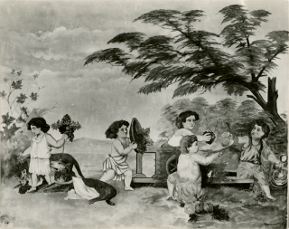
Popular Mural, San Juan Teotihuacan, 1930s  Manuel Alvarez Bravo  Gelatin silver print  [AC 1998.131] | 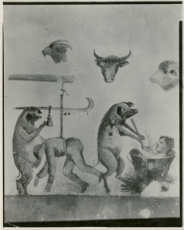
Pulqueria Mural, Mexico City, 1930s  Manuel Alvarez Bravo  Gelatin silver print  [AC 1998.130] | 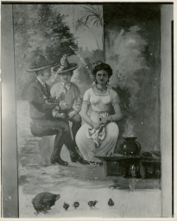
Popular Mural, Mexico City, 1930s.  Manuel Alvarez Bravo.  Gelatin silver print.  [AC 1998.132] | 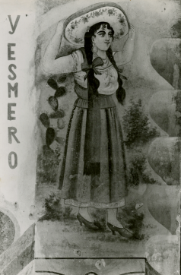
Popular Mural, Mexico City is a photograph that was taken during the 1930s, most crucial moment in Mexico’s formulation of a modern national identity. Scholars call the period the Mexican Renaissance, due to the cultural boom that followed the conclusion of the Mexican Revolution in 1917. Manuel Alvarez Bravo, one of Mexico’s most well-known photographers, participated in a search to discover his country’s essence (referred to as mexicanidad or “Mexicanness”) through art. He is renowned for producing complicated images that question the clichés, otherness, and exoticism that plagues representations of Mexican culture. Often Alvarez Bravo preferred to capture images of working-class people as they participated in their normal, every-day activities. In addition to showing anonymous figures caught in banal or humble moments, Alvarez Bravo also sought to document the street environment in which these people went about their daily lives. Murals and other forms of street signage were other preferred subjects for Alvarez Bravo, exemplified in Popular Mural, Mexico City.
Popular Mural, Mexico City shows an old, hand-painted mural that depicts a young Mexican woman. On the left side of the photograph is perhaps what is the end of a sentence or a slogan: the phrase “y esmero,” which means “and dedication” or “and great effort.” The implication that the mural is a propaganda piece does not escape the viewer’s attention, nor does the overt idealization of the woman’s mexicanidad. She wears her hair in two braids with a sombrero on top, and is dressed in a china poblana, a traditional style of dress that was revived in the early 20th century and embodies Mexico’s complicated and mixed cultural heritage. According to popular belief, the china poblana has its roots in the colonial era, where legend details the story of Mirra, a slave who after many trials and tribulations journeyed from India and the Spanish East Indies to the colony of New Spain. Throughout her life Mirra continued to dress as she had in India, and her sari supposedly inspired the china poblana. Alvarez Bravo’s reproduction of the mural of the woman in a china poblana may be considered a conscious use of a stereotype of Mexican culture.

Head of an Indian Boy, 20th century.
Diego Rivera.
Drawing
[AC D 1939.3]

Man with a Pickaxe. N.r.
Diego Rivera.
Drawing
[AC D.1939.4]

Mexican Boy Carrying Sticks, N.r.  Diego Rivera.  Drawing  [AC 1995.2] | 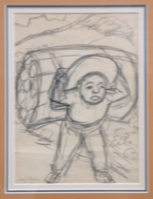
Diego Rivera is widely recognized for his depiction of the Mexican worker, almost always informed by his leftist political views. Mexican Boy Carrying Sticks is a sketchy drawing, cartoonish and crude in appearance. The boy is doubled over from the weight of the load, walking alone on a path. The viewer is not privileged to know his name, who he is working for, where he is coming from, or where he is going. The boy’s anonymity makes him a stand in for many young workers, bearing the burden of economic woes.

Types (Tipos), Zapotecas, Oaxaca, Oax.
Mid 20th century.
Unknown artist.
Gelatin silver print.
[AC 1999.139]

The small photograph shows two women holding Zapoteca Indian weavings. The Zapoteca people are the descendants of one of the few pre-Hispanic Indian cultures that has been present in the Oaxaca area of Mexico since 500 BC. The Mixtecs later conquered the Zapoteca, but in turn were fell to the Aztec empire. Today in Mexico there may be as many as 500,000 people who identify with the Zapoteca legacy. One of the important vestiges of the Zapoteca culture is weaving. With the arrival of the Spanish in the 16th century, the Zapoteca people abandoned their traditional cotton weaving in favor of a new material, wool, that they adopted when the conquerors brought sheep into the Oaxaca region. The Zapoteca also made use of European wool technology to create a distinctive style. To create a Zapoteca weaving is a lengthy, technical process involving many people. Younger boys tend the sheep, while women spin and dye the wool. Traditionally, men grow the natural dye materials and execute the actual weaving. Though the photograph is black and white, the weavings are quite colorful and graphic, and are a great source of pride for those of the Zapoteca heritage.

Jar Seller (Vendedor de Jarros), Mexico,
Circa 1941.
Mauricio Yañez.
Gelatin silver print.
[AC 1999.137]

Part Three:
Religion

Black Christ Festival, Panama, 1945.  Sid Grossman.  Gelatin silver print.  [AC 2001.576] | 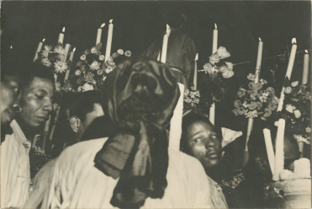
The Black Christ Festival is centuries old celebration in Portobelo, a small city on Panama’s Caribbean coast. On October 21, the city celebrates a black statue of Christ—“El Nazareno”—that Panamanians believe a fisherman found in a box that appeared magically on a beach. Once the town began to worship the statue, a cholera epidemic that was ravaging the population ended. Consequently the statue became an object of devotion for the entire country. The statue is carried through the streets during the festival, and the people of Panama celebrate all night long. As many as 60,000 pilgrims journey to the small city every October, and some even walk the 53 miles from the capital of Panama City. Over time, the Black Christ has become the patron saint of criminals, and among those that complete the pilgrimage to Portobelo for the festival are many who are seeking forgiveness for their crimes.
The statue paraded through the streets of Portobelo by the bearers is made of a dark wood. The face of Christ bears a distinct resemblance to facial features of those of Ethiopian descent. The statue is controversial to those of the Western Christian faith, who depict the savior as a light-skinned Jew. While there is no substantial proof either way, it is likely that Jesus Christ was more darkly skinned than the traditional Western Christendom chooses to portray him.
Grossman’s photograph of the festival, as a result, brings several issues of race to the fore. The stark contrast in the photo between the light of the candles, flowers, robes and reflections with the dark of the night and the revelers’ skin, speaks literally to this consideration.
In Latin America and Panama specifically, the percentage of the population that is interracial is much higher than it is in the U.S., for example. This is largely because of the United States’ long history of Protestantism that frowned upon mixing races and in contrast, Latin America’s relationship with Catholicism did not place the same taboo on interracial marriages and procreation. Indeed, studies estimate that 50% of population of Panama has some African ancestry.

Andean Festival, 1954.
Nemesio Antunez.
Lithograph.
[AC 1994.207]

Bread for Day of the Dead (Pan de Muertos),  1930s.  Manuel Alvarez Bravo and Lola Alvarez Bravo.  Gelatin silver print.  [AC 1998.126] | 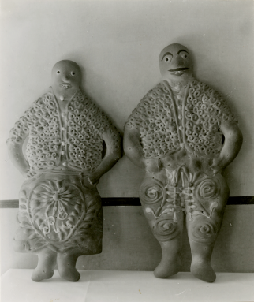
The dia de los muertos is celebrated in Mexico and parts of the Southwestern United States on November 1st and 2nd—All Saint’s Day and All Soul’s Day in the Catholic calendar. On these festival days, people build altars for deceased loved ones and fill them with food, drink, photographs, and other objects of the person in question. The pan traditionally made for the holiday that graces many altars is a sweet bread. Families eat the bread as well as the favorite foods of their dead family members. It is normally baked in a rounded shape with bone-like pieces of dough laid on top in the shape of a cross. However at the same time, the pan de los muertos can be baked into many shapes including skulls and people, like the bread shown in the photograph.
While similar celebrations occur in other parts of Latin America as well, in Mexico in particular the festival also takes origin from ancient Aztec festivals that celebrated both gods and the dead. The hybridization of the Catholic faith with indigenous tradition is what makes the celebration unique.

Witchdoctor, Chi Chi Castenango, Guatemala. 1979.  Rosalind Solomon.  Photograph.  [AC 1990.2] | 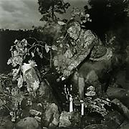
In Guatemala today, people still practice the traditional spiritual rituals that originate from Mayan and other indigenous heritage. Despite the prevalence of both Catholicism and Protestantism in the country, many Guatemalans maintain some tie with these pre-Colombian customs. However, while the Guatemalan constitution allows for religious freedom, at times both the Catholic and evangelical Protestant churches have denounced traditional rituals by branding them as acts of devil-worship, witchcraft, and sorcery. Nonetheless, long-established practices like the one pictured in Rosalind Solomon’s photograph play integral roles in the indigenous Guatemalan culture and its preservation in the nation’s modern identity.

Part Four:
The View from Outside:
American and European artists addressing Latin American subject matter

Tower of Cortez, Mexico. 1883.  Thomas Moran.  Watercolor.  [AC 1953.11] | 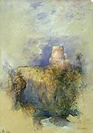
While most of the works listed in this subject group are made by Latin American artists addressing issues of Latin American identity, there are also several works in the Mead’s collection that illuminate how outside perspectives view these complex heritages. The existence of many portraits and landscapes demonstrates that artists from the United States and Europe considered similar themes, though noticeably for a distinct purpose and to a different effect, due to their foreign standpoint.
Thomas Moran’s Tower of Cortes is an impressive and delicate watercolor, portraying a majestic view of a stone tower rising above a lush landscape. The structure bears its name and its legacy from Hernando Cortez, the explorer who history credits with conquering Mexico in 1518 in the name of the Spanish crown. However, in spite of the obvious allusion to Mexico’s colonial history, Moran’s watercolor is steadfastly picturesque and painterly. Moran traveled to Mexico in 1883 for an artistic pilgrimage, so he was not seeking to get involved in the political or ideological issues swirling about the nation and focused totally on themes of nature, beauty, and serenity. The watercolor depicts a pristine land; but for the European imposition of civilization, the landscape would have been entirely untouched.
Moran’s representation of the Mexican countryside—an American vision depicting a Latin American subject—appears naively romantic and idealized when compared to a Mexican artist’s depiction of his or her homeland and history. Diego Rivera’s Cortes's Soldiers Torturing and Plundering, [AC 1952.16], a study for a series of murals in Cuernavaca. The violent imagery Rivera uses formulates an obvious commentary about the explorer and the country’s victimization at the hands of European colonialism. Rivera’s perspective, in this manner, postulates a completely distinct perspective on the existing societies before the European conquest and the legacy thereof than Moran’s perspective; whereas Moran appreciates the pictorial scenery, Rivera’s connection to the land is markedly more emotional. The dichotomy between the foreign perspective that romanticizes and the native perspective carries through other subject matter also, which is particularly visible in the portraiture of the Mead’s Latin American collection as well.

Tired – Mexico, N.r.  Paul Ashbrook.  Etching.  [AC 1951.469] | 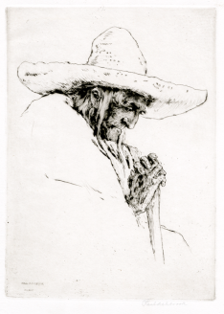
Paul Ashbrook was an American artist, active in the late 19th and 20th centuries. In 1926, Ashbrook began to make trips to Mexico to paint and etch. Unfortunately, he died on one of these excursions in 1949 due to a case of pneumonia. His print Tired—Mexico is a quiet image of an old man with his head downcast. The man’s face and hands are sculpted with etch-marks, while his clothing, walking stick, and sombrero are only hinted at with quick outlines. The etching technique lends itself to the mottled appearance of the old man’s wrinkly skin, and his expression couples with it to imply a life of hardship. The man’s portrait as rendered by Ashbrook is romantic and sentimentalizing; he only hints at the hard labor the man has done throughout his life and in this quiet moment Ashbroook reflects on his subject’s poise in spite of his situation.

Pensive, 1985.
Elizabeth Catlett.
Lithograph.
[AC 2001.573]

Elizabeth Catlett, an African-American born in Washington D.C., married Mexican artist Francisco Mora in 1947 and became a Mexican citizen. Catlett is renowned for her portraits of African-American and Mexican workers that show a certain strength of character and dignity. Pensive is a prime example of Catlett’s aesthetic, as it depicts a wise and steadfast-looking woman, confronting the viewer directly.

Mexican Woman, 1956.
Nora S. Unwin.
Wood engraving.
[AC 1957.70]

Mexican Girl, 20th century.  Doris Rosenthal.  Charcoal drawing.  [AC 1947.150] | 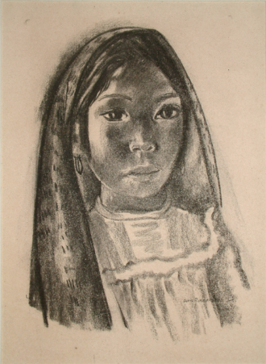
Doris Rosenthal won two Guggenheim fellowships, one in 1931 and the other in 1936, which allowed her to travel to Mexico and solidify her reputation as a painter of Latin American themes. On her trips she would journey on the back of a burro to different parts of the country, bringing her art materials to make the sketches she would base later paintings off of. Her work concentrated mostly on daily life and domestic experiences, and she often chose to portray children. Scholars and critics hailed Rosenthal for her “ethnic studies” approach to her work and for her unromantic representations of the day-to-day existence of rural Mexicans. Despite this praise, when looking at Mexican Girl, it is hard to deny the beautification and idealization of this particular subject, indicating that the passage of time can dramatically change the perception of particular works of art.

Overview, Palenque, Chiapas, 1982. Marilyn Bridges.  Gelatin silver print.  [AC 1995.66.7] | 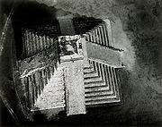
Castillo from the Perpendicular,
Chichen Itza, Yucatan, Mexico, 1982.
Marilyn Bridges.
Gelatin silver print.
[AC 1995.66.8]

Castillo at Chichen Itza, Yucatan, 1982.
Marilyn Bridges.
Gelatin silver print.
[AC 1989.13]

Machu Picchu Among the Peaks of the
Andes, Peru, 1989.
Marilyn Bridges.
Gelatin silver print.
[AC 1995.66.2]

Like Thomas Moran’s depictions of the Mexican landscape discussed above, American photographer Marilyn Bridges’ more recent portrayals of Mexico and Peru are characterized by similar considerations: her photographs illustrate sweeping panoramas and a focus on architecture. For the most part her photos are devoid of human presence, and equally evoke ideas of the mystical wonders of the nation.
Part Five:
Contemporary Perspectives

Angelica (Aftermath Series), Edition 3/10. 1998.  Vik Muniz.  Photograph.  [AC 2003.69] | 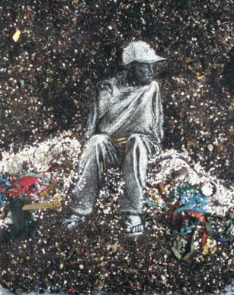
Although Brazil is technically not part of the Hispanic world, as it was originally a Portuguese colony, Brazilian artist Vik Muniz addresses many similar issues in his work as those found in work by Latin American artists. The “Aftermath” series of 1998 which includes this work, Angelica, comments on several salient topics such as poverty, layered identities, and the creation of culture in a post-colonial and industrial world. Angelica is a monumentally sized portrait of a young girl, one of the many street children in the capital city of Rio. Muniz took her photo, recreated the image by delicately arranging the refuse from the street after the Rio Carnival, and finally documented the original work with another photograph. The final product itself plays with the notion of scale, as the ultimate image magnifies the size of the original work of art.
The Rio Carnival is one of the most famous cultural spectacles that the country of Brazil is known for. Celebrated all over Latin America and the Caribbean, Carnival represents the mixture of several influential cultures traced back to the colonial era including Spanish Catholicism and ancient Yoruba beliefs brought to the Western hemisphere from Africa through the slave trade. In evoking Carnival, Muniz draws attention to the process of creating culture, and acknowledges his heritage’s unique origin in the masses; it is not a culture imposed from the upper echelons of society but rather a culture born in the streets. Muniz goes so far as to say: “The culture that they—the oppressed and abandoned, people who have less than what they need to live—developed is one of the most beautiful cultures in the world.”
While Angelica praises the beauty of a culture that arises from the bottom of the socioeconomic ladder, it also draws attention to the tragedy of poverty and those left behind to live amongst the trash once the celebration has concluded. The girl’s pose is resilient and strong, implying a sense of dignity, and the large scale of the work augments her importance. No longer are the children of the “Aftermath” series merely the faceless and nameless refuse of society. In his work Muniz identifies victims of inequality and provides a visual touchstone for the poverty crisis in Rio.

Study #2 for Voyeurs & Beholders of... 2007.  Maria Magdalena Campos-Pons.  Polaroids on paper  [AC 2007.10.a-e] | 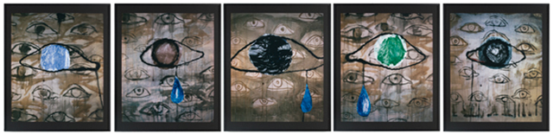
María Magdalena Campos-Pons was born in Cuba of parents of Nigerian descent. She moved to the United States upon marrying a citizen, and has lived in Boston since. Her art constantly addresses how history, ancestry, and memory inform her Black Cuban lineage as well as her expatriate identity.

Sources:

http://www2.udec.cl/~mariasmo/pintores/Roberto%20Matta.htm
http://en.wikipedia.org/wiki/Zapatista_Army_of_National_Liberation
http://www.mexconnect.com/articles/305-tragedy-and-triumph-the-drama-of-jose-clemente-orozco-1883%E2%80%931949
http://www.paradigmproductions.org/films/orozco/?c=synopsis
http://www.manuelalvarezbravo.org/english/Biography.php
http://www.getty.edu/art/gettyguide/artMakerDetails?maker=1740
http://www.mexconnect.com/articles/1070-the-photography-of-manual-alvarez-bravo-1902-2002
http://www.guardian.co.uk/artanddesign/2004/sep/11/sebastiaosalgado.photography2
http://www.amazonasimages.com/
http://en.wikipedia.org/wiki/French_intervention_in_Mexico
http://www.latinartmall.com/zapotecweaving.htm
http://www.oldlivery.com/about/zapotec_weavings.htm
http://www.thepanamanews.com/pn/v_09/issue_19/travel_01.html
http://www.coloncity.com/blackchrist.html
http://www.palomar.edu/multicultural/DiadelosMuertos/
http://www.state.gov/g/drl/rls/irf/2006/71462.htm
http://www.cincinnatiartgalleries.com/painting/artist.aspx?id=ART66
http://jwa.org/encyclopedia/article/rosenthal-doris
http://www.marilynbridges.com/pages/bio.html
http://americanart.si.edu/collections/search/artwork/?id=17847
http://www.ndmoa.com/campos/index.html
http://www.smfa.edu/facultymodule/view/id/79/src/@random4a83044d9a8b2/
www.philagrafika.org/pdf/magda%20campos%20pons.pdf
http://video.google.com/videoplay?docid=-5457190437445130515

http://www.thequietintheland.org/brazil/category.php?id=vik-muniz

