Enfants terribles: Childhood in Nineteenth Century French Literature and Art
Accession Number | Title | Maker | Maker Culture | Date Made
SC 1929:1 | Preparation of the Dead Girl | Courbet, Gustave | French (1819 - 1877) | ca. 1850-1855 | 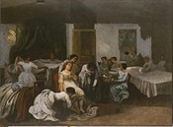
SC 1931:6 | Portrait of a Youth | Girodet de Roucy-Trioson, Anne-Louis (attributed to) | French (1767 - 1824) | possibly ca. 1795 | 
SC 1934:3-10 | Beach Scene | Carr, Samuel S. | American (1837 - 1908) | ca. 1879 | 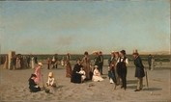
SC 1935:12 | René de Gas (1845-1926) | Degas, Edgar | French (1834 - 1917) | 1855 | 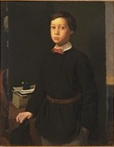
SC 1953:129 | Mourning Picture | Elmer, Edwin Romanzo | American (1850 - 1923) | 1890 | 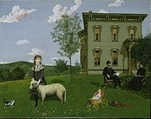
SC 1986:47 | Young Girl with a Basket of Fruit | Bouguereau, Adolphe-William | French (1825 - 1905) | 1883 | 
SC 2000:9 | Recolte des Oranges a Capri | Sain, Edouard Alexandre | French (1830 - 1910) | 1868 | 

