Popular Revolution in Modern Mexico
History 53
Fall 2010, MW 12:30-1:50, Chapin 119
Office hours: W 2-3pm & Th 1-3pm , Chapin room 23,
Contact information: x5846, ralopez@amherst.edu

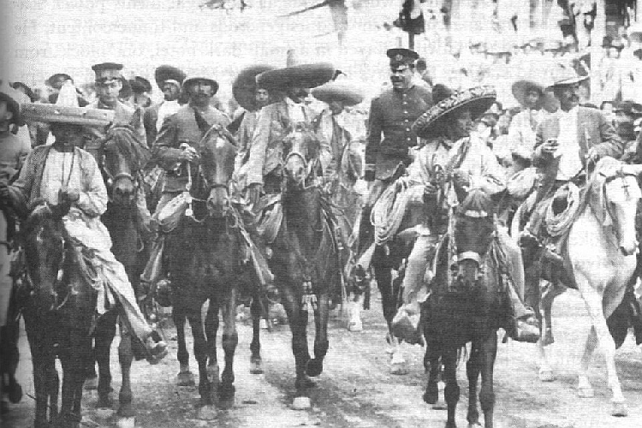

In September 2010 Mexicans will commemorate two revolutions. In September they will celebrate the revolution of 1910-1920, which redirected Mexico’s historical trajectory. And then in October they will celebrate the bicentennial of Miguel Hidalgo’s famous 1810 “Grito de Dolores” that launched a decade of bloody wars for liberal government and independence from Spain. Mexico’s first revolution, the one from 1810, set the country on the road toward a great experiment in republican democracy. In the wake of that war, Mexico’s new leaders confronted the challenges of modernizing the economy, overcoming regional fragmentation, and figuring out what roles European-Mexicans, mestizos (racially and culturally mixed individuals), and Indians each would play in the new nation. A hundred years later, at the height of Liberal triumphalism when Mexico seemed to be set to join the small club of “modern” nations, the country dissolved into the revolution of 1910-1920, which transformed Mexico and altered the course of history all Latin America. In this year of weighty commemorations, we will take stock of 200 years of struggle among Mexico’s popular classes.
What transformations did these two wars set in motion, how revolutionary were they, and what possibilities did they open or cut off for future development? To some these revolutions seemed to usher in the hope for a better world, for others they unfolded as nightmares. For some, they seemed like opportunities to transform the population, for others they were opportunities to grab power and wealth, and, for yet others, they signaled a threat of a takeover by the “Indian” masses. One might argue that enduring change comes not from the moment of violent upheaval, but from the social changes that it inspires. What kinds of changes came in the wake of each of these revolutions? How and why did the revolution of 1910-1920, in particular, became a mandate to transform the population (which was socially, culturally, linguistically, and politically fragmented) into a unified modern nation? In this course we will consider the nature of these two revolutions, how they came to pass, and the political and social transformations that followed in the wake of each.
Few countries are as well known, yet so poorly understood, as is Mexico among North Americans. Headlines about illegal immigration, street violence, and drug smuggling often take the place of real understanding. As a result, few North Americans appreciate their neighbor’s historical odyssey in search of political stability, national unity, democracy and economic prosperity. This course provides a general overview of some dominant narratives within Mexican history, while challenging those narratives through an examination of the experience of subaltern groups (including women, indigenous peoples, peasants, and those from the periphery). We also will grapple with the question of what genuine social revolution looks like, how it unfolds, and to what degree it has been attained in Mexico. Additionally, the course will address such questions as: What is a revolution? Given the many structures that bolster political, economic, and cultural systems of domination, is genuine social revolution possible? If revolutions are not just about violence, but also about ideas, who shapes these ideas? Does the ideology have to be “organic”, or proclaimed by an intellectual? What does it mean for a rebellion to come “from below”? Are peasants capable of formulating an ideology? It is relatively easy to identify the year when a revolution begins, but how do we know when a revolution ends? The ruling party that dominated twentieth-century Mexican politics has often been referred to itself as the “institutionalized revolution.” Can a revolution be institutionalized and still be popular and revolutionary? Is there any real hope of meaningful populist change once the masses have laid down their weapons? Because this is a year of so much commemoration, we will take the opportunity to will give particular attention to the formation of collective memory and how historical events became endowed with particular meanings, how these meanings were contested, and how they changed over time.
Original documents, testimonials, movies, images, music, and art will supplement discussions and secondary readings. Two class meetings per week.

Attendance: Required. Five-College students must follow the Amherst College schedule for meeting times.
Readings: Be an engaged, critical reader. Don’t absorb the text, argue with it. See “Getting to Know a History Book” on my website.
Written work: Weekly analytical questions, three reading responses, two analytical essays, and a book analysis.
- Analytical questions: For each meeting you must email to the entire class two (2) questions. Due by 1am the night before. All students must read one another’s questions prior to class and arrive prepared to discuss them.
  - Don’t make these bland or meaningless, and don’t make them general, as one might for a discussion question.
  - Don’t make them factual questions that can be answered simply by looking it up in a book or on Wikipedia.
  - Do make them real questions about issues that you are trying to understand.
    - Design them so that they force you to push further on the issues, to confront difficult problems, or to question assumptions.
    - These can focus on issues you did not understand fully or that you found puzzling or contradictory; the authors’ use of inherently problematic or complex terms or ideas; themes that compare or contrast the authors’ approach, claims, or findings with those of previous authors; or other issues that otherwise seem ripe for discussion.
  - Every question must incorporate a clear indication as to why the question matters, that is, what is at stake or what the implications might be.
  - Do arrive to class ready to discuss one another’s questions.
- Reading Responses: for three meetings (these will be assigned), write a three page critical response that grapples intellectually with the assigned readings. Bring the readings into conversation with one another and with previous material we have covered in class. A good response grapples with the issues. A lame response simply rehashes the readings.
- Lecture Response: Similar to reading response, but on a public lecture of your choice related to Mexico. The lecture can be anywhere (it does not need to be at Amherst College), but you must attend the lecture in person.
- Two papers, 4-7 pages in length: Deadlines are indicated on the syllabus. Each assignment will require you to develop your own analytical insights in relation to a document or an issue following specific guidelines. I will distribute a description of each as its deadline nears.
- Final paper: Select and analyze a monograph on some aspect of Mexican history. The item you select cannot be something you have used in any previous coursework, and it must be a work of historical scholarship. DO NOT CREATE A SUMMARY OF THE BOOK. Instead, engage it in debate and use it to pose and address your own line of inquiry. Length: 4-7 pages.
- Formatting: All written work must be typed and formatted in 12 point Times black font, 1 inch margins on all sides, left-justified (do not use full justified!), and double spaced. Written work must be submitted as a Word file. Include your name, the course, the name of the assignment, and the date in the upper left hand corner. Points will be deducted for papers that are too long and for those that fail to comply with the formatting instructions. Do not include a separate cover page. Pages must be numbered. All sources must be footnoted. You must also footnote all ideas borrowed from others – better yet, also discuss them explicitly in the text. Do not use in-text notations or endnotes. Use only footnotes. Remember that that books and articles are cited differently in footnotes than they are in bibliographies (see Style Guide). Proper formatting of your papers is an easy way to boost your grade. Improper formatting is an easy way to lower your grade.

Plagiarism: When you take the words, work, or ideas of someone else and pass them off as your own you are committing plagiarism. This includes misusing works that are cited elsewhere in your paper. Always be explicit about when you are building upon the ideas of others, and when you are taking things in your own direction. If you decide to plagiarize your will receive an “F” for the entire course and I will turn the matter over to the dean with a recommendation for expulsion from Amherst College. If you have any doubt about how to acknowledge the work of others in your footnotes, consult the style guide or come see me.
EXTRA CREDIT: The only way to get extra credit is to attend additional lectures over the course of the semester and write good responses to them.

Course Materials:
Movies: This class requires several movies.

The Old Gringo, 1989, starring Jane Fonda, Jimmy Smits, & Gregory Peck
- Elia Kazan’s, ¡Viva Zapata!, 1952, starring Marlon Brando & Anthony Quinn
- Vamanos con Pancho Villa, 1936, a film by Fernando de Fuentes
- Frida, 2002, starring Salma Hayek and Alfred Molina
- Luis Estrada’s, Ley de Herodes, 1999

Books: available at Food for Thought Books:
- Gilbert Joseph and Timothy Henderson, The Mexico Reader: History, Culture, Politics (Durham, NC: Duke University Press, 2002).
- Elena Poniatowska, Massacre in Mexico (Columbia: University of Missouri Press, 1991).
- Carlos Fuentes, Death of Artemio Cruz, translated by Alfred McAdam (NY: Farrar, Straus and Giroux, 1991 (originally published in 1962).
- Carlos Fuentes, The Crystal Frontier: A Novel in Nine Stories (NY: Harcourt Brace & Company, 1995).
- Thomas Benjamin, La Revolución: Mexico’s Great Revolution as Memory, Myth and History (Austin: University of Texas Press, 2000).
- Rick López, Crafting Mexico: Intellectuals, Artisans & the State after the Revolution (Durham, NC: Duke University Press, 2010).

Recommended texts available in the Library:
- Michael Meyer, William Sherman, and Susan Deeds The Course of Mexican History, 7th or 8th edition (New York: Oxford University Press).
- Saskia Sassen, Losing Control? Soverignty in an Age of Globalization (NY: Columbia UP, 1996).

Part I and Part II of the course pack available in the History Office.

How your semester grade will be calculated:
Class Attendance and Participation……………………………….…………….……...40%
Attendance 10%
Participation 30%
Map quiz……………………………………………………………….……….………..5%
Written work.……………………………………………………………. .….…..……55%
Analytical questions (2 per meeting) 10%
Reading responses (3 responses) 10%
Response to one academic lecture on Mexico 5%
Papers (two) 20%
Final paper (3 parts) 10%

-Students with any disability should speak with me at the beginning of the semester about any special arrangements they may require

Part I. Introduction
1) Wednesday, September 8
Introduction to the Course: The Meaning of a Revolution

Part II. The First Revolution: From Colony to Nation-State
Mexico won its independence thanks to an alliance between mostly-Creole elite conservatives, middle class Creole and mestizo liberals, and indigenous and casta populists. Its independence movement was hindered by Creole elites’ fear of armed indigenous and casta insurgents. Though Mexico was the first Latin American country to rebel against Spain, it was the last to take the final step toward independence, and even then, it did so only when the creoles could be assured that they would maintain their economic and political domination. The first half-decade of Mexican independence was difficult. Economic recession intersected with political uncertainty and instability. We will try to understand the dynamics of this new nationhood, and the struggles over democracy, political control, ideology, and economics that made these turbulent years. In particular, we will try to understand how certain characteristics of Mexican society (characteristics that would prove crucial during the Mexican Revolution) were forged during these years, and grapple with the role of popular movements in what historian Eric Van Young has called “Mexico’s Other Revolution.”

2) Monday, September 13
The First Revolution
- (book) Mexico Reader
  - Joseph and Henderson, “Trials of the Young Republic,’ 170-171.
  - José María Morelos, “Sentiments of the Nation,” (1813), 189-191.
  - Agustín de Iturbide, “Plan de Iguala,” (1821), 192-195
  - Lucas Alamán, “The Siege of Guanajuato,” (1849), 171-187.
- Do research on your own into how the independence wars are being portrayed in images, texts and videos for the commemoration.
- Recommended: (book, library) Course of Mexican History, 7th edition pp270-282 or 8th edition pp251-263.

Historic Moment: September 15, 1810: Miguel Hidalgo’s “Grito de Dolores”

3) Wednesday, September 15
The Post-Independence Moment of Hope, or Whose Revolution was This?
- (book) Mexico Reader
  - Mariano Otero, “Considerations Relating to the Political and Social Situation of the Mexican Republic in the Year 1847,” 226-238.
- (coursepack) Karen D. Caplan, “The Legal Revolution in Town Politics: Oaxaca and Yucatán, 1812-1825,” Hispanic American Historical Review 83(2)(May 2003): 255-293.
- Do research on your own into how popular participation in the independence wars is being portrayed in images, texts and videos for the commemoration.
- Recommended: (book, library) Course of Mexican History, 7th edition pp297-304 or 8th edition pp277-284.

Part III. Elite In-Fighting, Demobilizing the Masses, and the Triumph of the Liberal State
Mexico’s liberals and conservatives allied for independence, but had irreconcilable aspirations for the nation, and neither looked positively upon the indigenous and mestizo majority. After the conservatives’ independent monarchy failed, liberals gained the upper hand until conservatives mobilized an anti-republican backlash and, with French backing, installed a Hapsburg emperor. After decades of bloody warfare, liberals triumphed and by 1911 the liberal centralizing regime of Porfirio Díaz had brought modernization, political stability, and economic expansion to Mexico. Mexico’s small white and mestizo industrial, mining, commercial and agricultural elite, along with foreign investors, amassed fortunes on the backs of the indigenous and mestizo masses. Liberal economic expansion relied upon foreign capital, forcing the country to obey the dictates of British, French, Spanish, and, especially, US investors. In this context of deepening inequality, liberal neo-colonialism, and crony capitalism, those personally loyal to Díaz controlled national and regional politics, and the masses were kept in their place through political repression. Indigenous and mestizo villagers fought a losing battle against regional elites and the state who privatized their lands and sold them to the highest bidders in the name of progress and private enterprise. The masses found themselves and their children reduced to peonage on sprawling haciendas. Even the young middle-class professionals created by Porfirian economic expansion, the supposed beneficiaries of liberal economics, found their aspirations for advancement thwarted by a closed political system and crony business practices. In the next meetings we consider the models of development pursued by the Porfirian regime, and how it was shaped and experienced in various regions by various sectors of the population, including women, peasants, indigenous peoples, hacendados, and the new bourgeoisie. We will also try to understand the points of cohesion and stress within Porfirian society.

4) Monday, September 20
La Reforma and the Conservative Backlash
- (book) Mexico Reader
  - Editors of El Tiempo, “A Conservative Profession of Faith,” (February 12, 1846), 220-225.
  - Luis González y González, “Liberals and the Land,” 239-251.
  - Junta of Conservative Notables, “Offer of the Crown to Maximilian,” (1863), 263-264.
  - Empress Carlotta, “A Letter from Mexico,” (1865), 265-269.
  - Juárez, “The Triumph of the Republic, 1867,” 270-272.
- Recommended: (book, library) Course of Mexican History, 7th edition pp355-382 or 8th edition pp329-348.

Wednesday, September 22 (meeting cancelled)

Historic Moment: September 27, 1821, Iturbide and Army of the Three Guarantees takes Mexico City, and the next day declare independence from Spain.

5) Monday, September 27
Porfirio Díaz: Hero or Anti-Hero?
- (book) Mexico Reader
  - Creelman, “Porfirio Díaz, Hero of the Americas,” 285-291.
  - Anonymous, “Gift of the Skeletons,” 292.
- (coursepack) Charles Flandrau, “‘Military Diazpotism’ in Theory and Practice,” from Mexico OtherWise: Modern Mexico in the Eyes of Foreign Observers, edited by J. Buchenau (Albuquerque: Univ. of New Mexico, 2005), 125-131.
- (coursepack) John Kenneth Turner, “The Barbarous Porfiriato (1912),” Mexico OtherWise, 133-146.
- Recommended: (book, library) Course of Mexican History, 7th edition pp447-459 or 8th edition p350-418.

September 28: Battle at La Alhóndiga (Guanajuato)

6) Wednesday, September 29
Culture and Space under the Liberal State
- (coursepack) Mauricio Tenorio Trillo, “1910 Mexico City: Space and Nation in the City of the Centenario,” Journal of Latin American Studies 28(1)(February 1996): 75-104.
- Do research on your own into how Díaz and his regime are being portrayed in images, texts and videos for the commemoration.
- Recommended: (book, library) Course of Mexican History, 7th edition pp460-476 or 8th edition pp417-431.

Part IV. The Revolution
Though normally we speak of the Mexican Revolution, in actuality, it was not one, but multiple revolutions. Opposition to the Díaz regime came from peasant villages, social bandits, local warlords, old-style Liberal political reformers, the new bourgeoisie, and anti-capitalist radicals. These groups united around the figure of Francisco Madero and handily overthrew the Díaz regime. Their alliance subsequently broke down, the Mexican government virtually dissolved, and the masses entered a chaotic period of fighting known as “La Bola [the Great Tumult].” We will try to make sense of this seemingly chaotic situation by tracing the evolution and transformation of the struggle and the participants during the ten-year Revolution.

Historic Moment: October 5, 1919: Madero issues Plan de San Luís Potosí

7) Monday, October 4
The Conflict: Roots
- (book) Mexico Reader
  - Joseph & Henderson, “Revolution,” 333-334.
  - Magón, “Land and Liberty,” 335-338.
  - Jenkins, “Mexico has been turned into a Hell,” 357-363.
  - Constitution of 1917: Articles 27 and 123, 398-402.
- Recommended: (book, library) Course of Mexican History, 7th edition pp478-512 or 8th edition pp431-464.

8) Wednesday, October 6
The Conflict: Transformation
- (Film, to be viewed in advance) The Old Gringo, 1989, Starring Jane Fonda, Jimmy Smits, & Gregory Peck
- Do research on your own into how the revolution is being portrayed in images, texts and videos for the commemoration.
MAP QUIZ

Monday, October 11 (no meeting, October Break)

9) Wednesday, October 13
A View from the North: Pancho Villa and the División del Norte
- (book) Mexico Reader
  - Reed, “Pancho Villa,” 364-371
- (coursepack) Nellie Campobello, Cartucho/ My Mother’s Hands, translated by Doris Meyer (UT Austin 1988 [Spanish original, 1938]), 5-34.
- (Film, to be viewed in advance) Vamanos con Pancho Villa, 1936, a film by Fernando de Fuentes
- Do research on your own into how Villa is being portrayed in images, texts and videos for the commemoration.
- Recommended: (book, library) Course of Mexican History, 7th edition pp514-528 or 8th edition pp466-480.

10) Monday, October 18
A View from the South: The Zapatistas
- (book) Mexico Reader
  - Zapata, et al, “Plan of Ayala,” 339-343.
  - Cabrera, “The Restoration of the Ejido,” 344-350.
  - Lewis, “Pedro Martínez,” 375-386.
- (coursepack) Rosa King, “With Zapata in Cuernavaca,” from Mexico OtherWise, 147-153.
- (Film, to be viewed in advance) Elia Kazan’s, ¡Viva Zapata!, 1952, starring Marlon Brando
- Do research on your own into how Zapata is being portrayed in images, texts and videos for the commemoration.
- Recommended: (book, library) Course of Mexican History, 7th edition pp530-542 or 8th edition pp482-494.
- Discuss critical reading strategies for Joseph, Revolution from Without.

11) Wednesday, October 20
Revolution from Without
- (coursepack) Gilbert Joseph, Revolution from Without: Yucatán, Mexico, and the United States, 1880-1924 (Durham, NC: Duke UP, 1988), 1-10, 70-89, 185-227.
- (book) Mexico Reader
  - Joseph and Well, “The Rough and Tumble Career of Pedro Crespo,” 428-438

DUE: Paper. 4-7 pages. Email it to me by midnight at the end of Saturday, (March 28). Send it as a Word 2003 attachment. For you paper, read the following document: (coursepack) Moisés Sáenz, “Mexico: An Appraisal and a Forecast,” pamphlet.

Part V. Forjando la Patria, 1920-1940:
The Revolution tore Mexico apart. The state dissolved as authority fell into the hands of regional strongmen, or caudillos. The economy was in shambles. A decade of warfare killed 10% of Mexico’s population. The triumphant Northern General Álvaro Obregón took on the task of rebuilding state and society and establishing his government as legitimate heir to the Revolution. Many intellectuals and political leaders saw this as an opportunity not only to rebuild society, but to build a better more cohesive nation. In sections IV and V we will cover some of the major figures and their views on what was to be done. We pay particular attention to the effort to create a modern, integrated, and sovereign Mexican nation, and the emerging ideas about how to deal with the “agrarian problem” and the “Indian problem.” We will also cover the efforts by intellectuals, artists, popular groups, and political leader to find meaning in the upheaval they had just been through, and to remake Mexico into their nationalist ideal.

12) Monday, October 25
Stories of Revolution: Intellectuals, Organic and Otherwise
- (book) Mexico Reader
  - Calles, “Mexico Must Become a Nation of Institutions and Laws,” 421-425.
  - Guzmán, “Zapatistas in the Palace,” 351-356.
  - Pozas, Juan the Chamula, 387-397.
- (coursepack) Survey Graphic 5(2)(1924): Frank Tannenbaum, “Mexico—A Promise” (129-132); Felipe Carrillo, “The New Yucatán” (138-142); Manuel Gamio, “The New Conquest” (143-146, 192-194); Pedro Henríquez Ureña, “The Revolution in Intellectual Life”

13) Wednesday, October 27
Cardenismo: Land Reform, Oil, and Grassroots-Meets-Top-Down
- (book) Mexico Reader
  - Lemus Fernández, “A Convention at Zacapu,” 439-444.
  - Benítez, “Agrarian Reform in La Laguna,” 445-451.
  - Daniels, “The Oil Expropriation,” 452-455.
  - Anguiano, “Cárdenas and the Masses,” 456-460.
- Recommended: (book, library) Course of Mexican History, 7th edition pp547-572 or 8th edition pp499-535.

14) Monday, November 1
Memory and Myth
- (book) Benjamin, La Revolución, all.
- (Film, to be seen in advance) Frida, 2002, Starring Salma Hayek and Alfred Molina

15) Wednesday, November 3
Confronting Right-Wing Fanaticism: Fitting it into the Revolutionary Narrative
- (coursepack) Documents from Morrow Archives
- (coursepack) "Gerardo Murillo (aka Doctor Atl): Father of Muralism?" from Mexican Muralism, A Critical History, edited by Leonard Folgarait, Robin Adele Greeley, and Alejandro Anreus (Berkeley: University of California Press, forthcoming 2010).

16) Monday, November 8
Integrating and Ethnicizing the Nation
- (book) López, Crafting Mexico, introduction and chapters 1 through 6

17) Wednesday, November 10
Integrating and Ethnicizing the Nation (continued)
- (book) López, Crafting Mexico, chapters 7 through 9 and conclusions

Part VI. Politics of the Poster, 1940-1970:
Cardenista policies of the 1930s had set Mexico on the path of economic growth. In the 1940s, under presidents Avila Camacho and Alemán, the country entered a period of massive urban growth and industrialization. The powerful state that Cardenas had created, which under his presidency had given the masses official channels for shaping state policy, now abandoned the cardenista social ideals. Under one-party rule, politics became corrupt and devoid of any ideology. The struggles of the revolution gave way to the state-controlled image of the revolution as the ruling party, the PRI, adopted the term “Institutionalized Revolution” to describe its corporate politics. By the end of the 1960s, a new generation of citizens and intellectuals expressed their disillusionment with PRI machine politics and the “ideology of the poster.” Protest culminated in 1968 with a massive student movement, upon which the government unleashed the army, creating a civil crisis that Mexicans continue to wrestle with today. The state’s violent repression undermined the development of an organized opposition, which was reduced to isolated guerrilla movements in southern Mexico and to the complaints of disheartened intellectuals and academics bent on exposing the lies that legitimated the regime.

18) Monday, November 15
Can a Revolution be Institutionalized and Still be a Revolution? The Uses and Abuses of Collective Memory
- (book) Mexico Reader
  - Joseph and Henderson, “The Perils of Modernity,” 461-463.
  - Rulfo, “They Gave us the Land,” 465-469.
  - Cosío Villegas, “Mexico’s Crisis,” 470-481.
  - Jaramillo, “Struggles of a Campesino Leader,” 482-491
  - Sackett, “The Two Faces of Acapulco during the Golden Age,” 500-510.
- (coursepack) Enrique Krauze, Mexico: Biography of Power, trans. Hank Heifetz (New York: HarperCollines, 1997), 526-600.

DISCUSS PAPER 2, ANALYSIS OF A COMMEMORATION

19) Wednesday, November 17
What Happened to the Revolution? Official Narratives and Counter Narratives
- (book) Elena Poniatowska, Massacre in Mexico, translated by Helen Lane (Columbia: University of Missouri Press, 1991 [1975]), vii-xvii; 325-333; 174-198; 3-10; 17-22; 47-58; 62; 70-72; 74-75; 81; 92-93; 105-111; 118-119; 134-137; 146-151; 199-229; 238-240; 262-263; 268-272; 311-321.
- Recommended: (book, library) Course of Mexican History, 7th edition pp639-650 or 8th edition pp583-593.

USE THE BREAK to read Carlos Fuentes, Death of Artemio Cruz & to select a book for your final essay.

Historic Moment: November 20: Pancho Villa and Pascual Orozco lead insurrection attack. Official start of the revolution.

Monday, November 22 (No meeting, Thanksgiving Holiday)
Wednesday, November 24 (No meeting, Thanksgiving Holiday)

Historic Moment: November 25, 1911: Zapata issues Plan de Ayala.

20) Monday, November 29
Reconsidering the Revolution: A Narrative of Betrayal, Corruption, and Disillusionment
- (book) Carlos Fuentes, Death of Artemio Cruz

Part VII. From Political Bankruptcy to Regained Hope, 1970s-today
The PRI not only survived the crises of the 1960s and 1970s, it grew stronger. How did the PRI pull it off? How did it create what some have terms “the perfect dictatorship”? And at what cost?
Ever since the massacre of 1968 political scientists annually predicted the imminent collapse of the one-party system. But the signaled collapse looked like it would never come. Instead the PRI shored up its peasant base through a new wave of nationalism and land redistribution. And an oil boom financed an “economic miracle” that prolonged the life of the regime. At the hands of corrupt PRI rule, the flow of oil led to brazen corruption and embezzlement. In 1988 even as the PRI election rigging could not overcome the landslide electoral support for the opposition party PRD. Cuauhtémoc Cárdenas, son of Lázaro Cárdenas, handily won the election as the PRD candidate, only to have the PRI steal the election through such flagrant fraud that the masses poured into the street to paralyze the country in protest. The PRI under the leadership of president Salinas de Gortari and with renewed backing from the US, undid much of the land reform born of the revolution, strengthened the police power of the state, and, against the will of the majority of the electorate, forced through the North American Free Trade Agreement. The PRI’s embrace of neo-liberalism was rewarded by a remarkable rate of macroeconomic growth. But with each passing day neo-liberalism looked more and more like the old liberalism of Porfirio Díaz.
The moral and political bankruptcy of the state and the growing inequality created by neo-liberal trade policies that favored the movement of goods while driving down wages, undermining labor laws, and devastating the environment drew criticism. The outbreak of the Zapatista rebellion (named after its 1910 forebear) reminded the world about those left behind. At the end of his term, Salinas fled into exile in Ireland amid the revelation of unheard of levels of graft. For the first time, residents of Mexico City won the right to elect their own mayor, and they selected Cuauhtémoc Cárdenas. Students at the National University went on strike in opposition to neo-liberal reforms that called for the privatization of education, and, at the height of the protest there was widespread fear that the PRI would orchestrate a repeat of 1968. In 2000, the impossible became a reality. The PRI, after a 70-year monopoly on power, conceded defeat in the presidential election. But the change in control was less than it appeared, for control went not to a genuine opposition, but to the PRI’s long-time loyal opposition, the right-wing Catholic pro-big-business party known as the PAN. The new president, Vicente Fox, ex CEO of Coca-Cola Mexico, disappointed the electorate when he accelerated neo-liberal reforms, continued to increase the police power of the state, refused to prosecute PRI human rights abuses, and failed to negotiate an end to the Zapatista rebellion in Chiapas. In 2006 Mexico entered into a new political crisis when the PRD again found its electoral triumph snatched away, this time by an alliance between the PRI and the PAN. Again the masses took to the streets. The immediate recognition of the PAN candidate as president by the US ahead of a Mexican electoral investigation made it almost impossible to overturn the fraudulent results, but public outrage has prompted the public to devise novel strategies and modes of political organization to try to claim their rights. Most recently, however, these efforts have been undermined by the growing drug war, which is starting to spill over from the border into some internal regions, and by the looming crisis faced by Mexican oil wells. In the midst of these crises, and of public cynicism about patriotic rhetoric and jingoistic symbolism, many are left wondering what the fruits are of Mexico’s two revolution. They are asking whether this should be an occasion for celebration, reflection, or remorse… or else perhaps a call to arms to confront the overwhelming crises by demanding radical change, or maybe even a new revolution.

21) Wednesday, December 1
Black Gold, the Ideologically Bankrupt State, and the Third Death of the Revolution
- (book) Mexico Reader
  - José González G., “The Dark Deeds of ‘El Negro’ Durazno,” 512-519.
- (Film, to be seen in advance) Luis Estrada’s, Ley de Herodes, 1999
- Recommended: (book, library) Course of Mexican History 7th edition pp614-639 or 8th edition pp563-583.
Come to class ready to discuss what you will read for the final paper. Go around the class, so each student can briefly (1-2 minutes) describe what he or she is reading, and what they hope to figure out.

22) Monday, December 6
Hope in the Face of Despair
- (book) Mexico Reader
  - Roberto Vallarino, “Ciudad Nezahualcóyotl: Souls on the Run,” 536-544.
  - Victims’ Coordinating Council, “After the Earthquake,” 579-590.
  - Anonymous, “Letters to Cuauhtémoc Cárdenas,” 591-597.
  - Maldita Vencidad y los Hijos del Quinto Patio, “I Don’t Believe Them at All,” 612.
  - Carlos Monsisváis, “Identity Hour, or, What Photos Would you Take of the Endless City?” 612-618.
  - Heather Williams, “Debtor’s Revenge: The Barzón Movement’s Struggle against Neoliberalism,” 670-683.
- (coursepack) Scott Sherman, “Left Out: A Militant Student Strike Sidelines Mexican Intellectuals,” Lingua Franca (July/August 2000): 33-37, 39-42.
- (coursepack) Monica Campbell, “In Mexico, a Campus Becomes a Refuge for Leftist Protestors” Chronicle of Higher Education 24 Nov 2006.
- Recommended: (book, library) Course of Mexican History, 7th edition pp651-718 or 8th edition pp594-660.

23) Wednesday, December 8
Neo-Zapatismo: Reclaiming of the Revolution form Below
(Read the declarations in the order listed)
- (coursepack) Tom Hayden, editor, The Zapatista Reader (New York: Nation Books, 2002).
  - “First Declaration from the Lacandón Jungle,” January 1, 1994, pp217-220.
- (coursepack) John Womack, editor, Rebellion in Chiapas (NY: New Press, 1999).
  - “El Despertador Mexicano, Organizo Informativo del EZLN,” December 1993, made public on January 1, 1994 (252-256).
- (book) Mexico Reader
  - EZLN, “Demands at the Dialogue Table,” March 1994, pp638-645.
- (coursepack) Zapatista Reader
  - “Second Declaration from the Lacandón Jungle,” June 1994, pp221-231.
- (book) Mexico Reader
  - Subcomandante Marcos, “The Long Journey from Despair to Hope,” 646-654.
  - Marián Peres Tsu, “A Tzontzil Chronicle of the Zapatista Uprising,” 655-669.
- (coursepack) Celia W. Dugger, “Report Finds Few Benefits for Mexico in NAFTA,” NYT, 19 November 2003.

24) Monday, December 13
Mexico in the Global Economy: People, Goods, and Money
- (book) Carlos Fuentes, The Crystal Frontier
- Recommended (book, library): Saskia Sassen, Losing Control?

25) Wednesday, December 15
Final Reflections: The War on Drugs, the Devaluing of Citizen Rights, and the Politics of Commemoration

DUE: Paper 2, 4-7 pages. Email it to me by midnight at the end of Friday, Dec. 17. Send it as a Word 2003 attachment.

Final paper due Dec. 22, end of the day at midnight. Send it as a Word attachment.

Amherst College Academic Calendar

September 7, 2010 Classes begin
October 9, 2010 until October 12: Mid-Semester Break.
November 20, 2010 until November 28: Thanksgiving Recess.
December 15, 2010 Last day of classes
December 16, 2010 until December 17: Reading/Study Period
December 18, 2010 until December 22: Examination Period

Coursepack Index

- Style guide
- Karen D. Caplan, “The Legal Revolution in Town Politics: Oaxaca and Yucatán, 1812-1825,” Hispanic American Historical Review 83(2)(May 2003): 255-293.
- Charles Flandrau, “‘Military Diazpotism’ in Theory and Practice,” from Mexico OtherWise: Modern Mexico in the Eyes of Foreign Observers, edited by J. Buchenau (Albuquerque: Univ. of New Mexico, 2005), 125-131.
- John Kenneth Turner, “The Barbarous Porfiriato (1912),” Mexico OtherWise, 133-146.
- Mauricio Tenorio Trillo, “1910 Mexico City: Space and Nation in the City of the Centenario,” Journal of Latin American Studies 28(1)(February 1996): 75-104.
- Nellie Campobello, Cartucho/ My Mother’s Hands, translated by Doris Meyer (UT Austin 1988 [Spanish original, 1938]), 5-34.
- Rosa King, “With Zapata in Cuernavaca,” from Mexico OtherWise, 147-153.
- Gilbert Joseph, Revolution from Without: Yucatán, Mexico, and the United States, 1880-1924 (Durham, NC: Duke UP, 1988), 1-10, 70-89, 185-227.
- Moisés Sáenz, “Mexico: An Appraisal and a Forecast,” pamphlet.
- Survey Graphic 5(2)(1924): Frank Tannenbaum, “Mexico—A Promise” (129-132); Felipe Carrillo, “The New Yucatán” (138-142); Manuel Gamio, “The New Conquest” (143-146, 192-194); Pedro Henríquez Ureña, “The Revolution in Intellectual Life”
- Documents from Morrow Archives
- Rick López, "Gerardo Murillo (aka Doctor Atl): Father of Muralism?" in Mexican Muralism, A Critical History, edited by Leonard Folgarait, Robin Adele Greeley, and Alejandro Anreus (Berkeley: University of California Press, forthcoming 2010).
- Enrique Krauze, Mexico: Biography of Power, trans. Hank Heifetz (New York: HarperCollines, 1997), 526-600.
- Scott Sherman, “Left Out: A Militant Student Strike Sidelines Mexican Intellectuals,” Lingua Franca (July/August 2000): 33-37, 39-42.
- Monica Campbell, “In Mexico, a Campus Becomes a Refuge for Leftist Protestors” Chronicle of Higher Education 24 Nov 2006.
- EZLN, “First Declaration from the Lacandón Jungle,” January 1, 1994, pp217-220, in The Zapatista Reader, edited by Tom Hayden (New York: Nation Books, 2002).
- EZLN, “El Despertador Mexicano, Organizo Informativo del EZLN,” December 1993, made public on January 1, 1994 (252-256), in Rebellion in Chiapas, edited by John Womack (NY: New Press, 1999).
- EZLN, “Second Declaration from the Lacandón Jungle,” June 1994, pp221-231 in The Zapatista Reader, edited by Tom Hayden
- Celia W. Dugger, “Report Finds Few Benefits for Mexico in NAFTA,” NYT, 19 November 2003.
Places to know for map quiz :
Note: check LANIC to help you http://lanic.utexas.edu/la/region/map/

Districts and States: | Cities: | Geographic features:
The extent of Mexico in 1824  Modern boundaries of:  México DF  Chihuahua  Yucatán (the state)  Quintana Roo  Oaxaca  Chiapas  Michoacán  Guerrero  Jalisco  Guanajuato  Zacatecas  Nayarit  Coahuila  Morelos | Mexico City  Guadalajara  Mérida  Veracruz  Oaxaca City  Puebla de los Angeles  Guanajuato  Tijuana  Ciudad Juárez  Chihuahua  Monterrey  Acapulco  Zacatecas  Nogales  San Luis Potosí  San Miguel de Allende | Yucatán peninsula  Baja California  Sierra Madre Oriental  Sierra Madre Occidental  Isthmus of Tehuantepec  Bajío  Río Bravo  La Laguna (in Coahuila)  Chihuahua Desert    Río Lerma

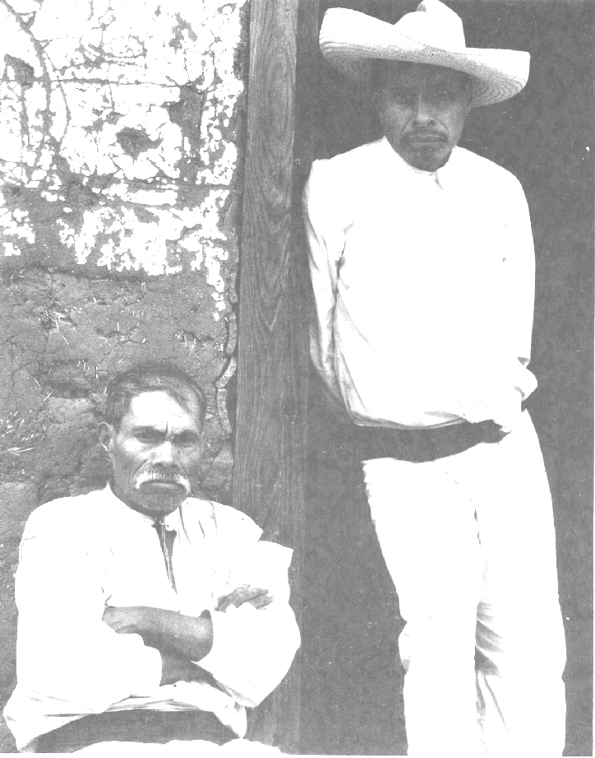

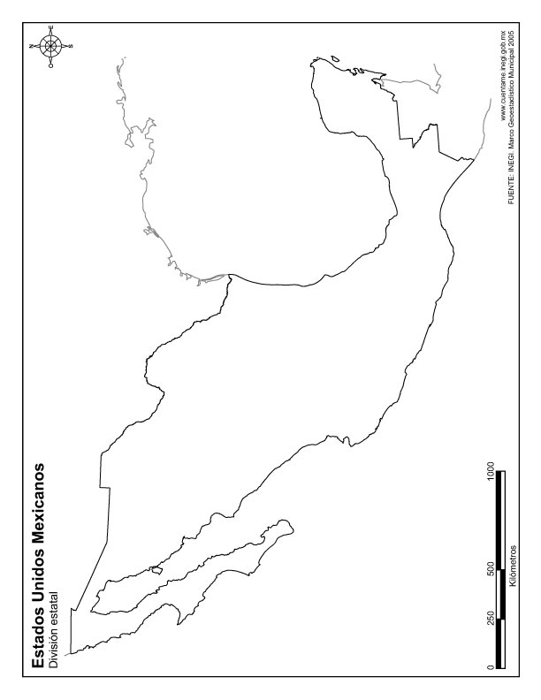

Written responses to additional outside lectures can be used to help boost your grade.
A Creole is someone of European heritage born in the Americas.
A mestizo is someone of mixed European and Indian heritage, often with hints of African, Asian, Sephardic, and Gypsy.
Under colonial rule the population had been divided into repúblicas, or estates, each governed by a distinct set of royal laws. Castas were disentailed [that is, no longer attached to particular parcels of communal land] individuals who, due to ethnic intermixture and migration no longer corresponded to any particular república Castas generally lived in towns and cities, or worked as semi-proletarian agricultural workers, and they came from a range of different ethnic backgrounds that included European, Indian, African, and Asian, and often were interethnic.

