Name ____ANSWERS_____________________________
Chemical Biology 03 Fall 2009
Quiz 1b
September 23, 2009
Biological Macromolecules

- a. Put an “x” in the table for each functional group you might find in a sugar (carbohydrate), fatty acid (fats), amino acid (not counting the side groups), or nucleic acid. 10 pts
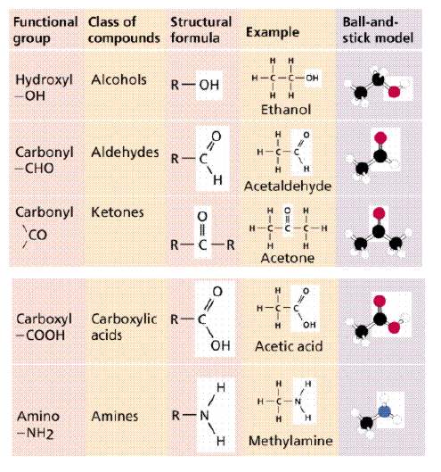
 | sugar | fatty acid | Amino acid | Nucleic acid
-OH | x |  |  | X
-CHO | x |  |  | X
CO | X |  |  | X
-COOH |  | x | X
-NH2 |  |  | X | X

b. Sugars have frequently shown up in our discussions of biological macromolecules. Use the space below to describe what a sugar is (empirical and molecular formula for say, glucose), to talk in general terms about its shape and structure, and to identify two ways in which simple or complex sugars have been incorporated into a biological macromolecule. 15 pts
Simple sugars have an empirical formula of CH₂O (carbohydrate) and many of the sic carbon sugars we saw in Chem03 have the structure C₆H₁₂O₆. In solution, the sugar will exist in a straight chain form and two cyclic forms. Each of the cyclic forms will is formed by the oxygen on C5 attacking the C on C1 to form the ring. So each six membered ring has five crbons and one oxygen in the ring. The rings themselves can also twist between a chair and a boat form. The boat form is less stable.
We have seen complex sugars attached to proteins acting as antigens on the surface of red blood cells. Humans will have wither O, A, B, or AB type blood. Individuals with this blood type will have only a short sugar for O, and a longer sugar for A, and a different longer sugar for B. Individuals with type AB blood have both the A sugars and the B sugars on the proteins in their red blood cell membranes.
We have also seen sugar bound to nucleic acid bases in ribose, either with 2’ OH or without (deoxy)

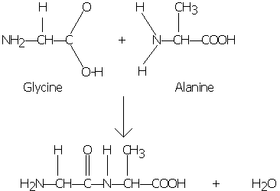
- Formation of Peptide Bonds: Shown below are the structures of two amino acids, glycine and alanine, and the reaction that causes the formation of peptide bond 25 points.

- The amino acids are shown in the top of the figure: Put a circle around each of the “R” groups, a triangle around each of the amino groups, a rectangle around each of the carboxylic acid groups, and underline the alpha carbon. 9 pts

- The arrow represents a reaction between the two amino acids to form a dipeptide. What type of reaction is this? Dehydration 4 pts

- The dipeptide is shown in the bottom of the figure. Put a square around the four atoms that make up the peptide bond. 4 pts

- What is unusual about the C-N bond in the middle of the molecule? 4 pts
Acts like a double bond, with no free rotation, and it is shorter than a regular single bonded C-H

- What is shown in the bottom of the figure is the dipeptide Gly-Ala. Draw the structure of the dipeptide Ala-Gly. 4 pts
(same as above but switch JUST the –R groups)

