Astronomy 11 Spring 2009
Third Problem set
Due at the beginning of class Friday, April 17

Throughout this problem set – and all the others -- let’s do calculations to only three figure accuracy: never write down a result with more than three significant figures.

(1) Melting Antarctica

Let us suppose that an asteroid collides with the earth, and that it lands in Antarctica. The kinetic energy of that asteroid will warm the ice, and melt some of it. If the asteroid is big enough, all the ice in Antarctica will melt, and sea level will rise to far as to cause worldwide catastrophic flooding: many coastal cities will be entirely submerged.

Our goal in this problem is to figure out how big an asteroid needs to be in order to produce this catastrophe.

Suppose the collision happens like so:

Earth: velocity = 30 km/sec asteroid: velocity = 42 km/sec
mass = ?

- What is the relative velocity between the earth and the asteroid? Give your answer in cm/sec but also convert it to miles per hour to get an intuitive feel for it.

According to one web site I checked, the total volume of the ice in Antarctica is 31 million cubic kilometers – i.e. 3.1 X 10 ⁷ (km)³.

- Convert this to cubic centimeters, and then find the mass of all the ice in Antarctica (the density of ice is nearly 1 gram/cm³).

The energy required to melt one gram of ice is 3.3 X 10 ⁹ ergs.

- How many ergs are required to melt all the ice in Antarctica?

- What mass must the asteroid have in order to carry this much kinetic energy?

- Suppose this asteroid has the same density that we guessed for Ida: 2 grams/cm³. Suppose further that it is spherical. What is its radius? Convert your answer to miles in order to get an intuitive feel for it.

[The answer you obtain will turn out to be really pretty small in astronomical terms. What this means is that even a small asteroid can pose a very serious threat. A number of scientists and politicians are pressing for a program to detect and destroy any such asteroids in earth-crossing orbits.]

(2) Searching for Planets Around Other Stars

In class I said that it is technically impossible for us to actually see through a telescope any planets that might be orbiting the distant stars. The object of this problem is to explore why.

There are two separate issues: (A) The planet lies very close to its star, as seen from the earth, and (B) The planet is a lot dimmer than the star.

Let’s start with (A). Here is a diagram.

Planet

Its star
Earth

θ

If the angle θ is too small, the star and planet will simply appear to be a single point of light through our telescopes, as opposed to a bright point and a dim one right beside it. Practically speaking, this means that θ must be bigger than about one second of arc (recall that there are 60 seconds of arc in a minute of arc, and 60 minutes of arc in a degree).

- Suppose that a planet were orbiting the (second) closest star, Alpha Centauri, at the same distance from it as we are from our sun. Find the angle θ for this case. (Alpha Centauri is 4 light years away from us: the endpaper of Bless tells you what a light year is. You might find Appendix A4 of Bless helpful.) Is this angle big enough for our telescopes to see the planet as a point of light separate from the star?

Now let’s move on to (B). We can use the inverse square law to find the flux we receive from the planet, and we can see if this flux is big enough for our telescopes to detect. Practically speaking, our best telescopes can detect anything whose flux is bigger than

Minimum detectable flux = f_{minimum} = 10 ^{– 15} ergs / cm² sec.

To be specific, let us suppose that the planet orbiting Alpha Centauri is just the same size as the earth.

To calculate the flux from such a planet, we need to know the luminosity of the planet – and a planet’s luminosity here means the amount of energy the planet reflects per second. But you already know how to calculate this! In the second problem set you calculated the total amount of sunlight falling on the earth: the answer you got was 1.74 X 10 ²⁴ erg / sec. This also is the amount of energy that would fall on our hypothetical planet (it turns our that Alpha Centauri is just as bright as the sun). Suppose the planet reflects half of the light falling on it: then the planet reflects

(1.74 X 10 ²⁴ erg / sec) / 2 = 8.7 X 10 ²³ erg / sec.

Unfortunately, however, this is not the luminosity that we should use in our inverse square law.

- Explain clearly why the planet in the above figure would be in its half phase as seen from the earth. (Make sure you draw a diagram!)

This means that we would only receive half the light reflected by the planet. Suppose we wanted to wait till the planet were in its full phase, so that we receive all the light. This would make it brighter. Unfortunately, though --

- Explain clearly why the angle θ in that case would be zero, so that there is no way we could see the planet as a point of light separate from the star. (Again, draw a diagram.)

The only thing we ca do is go back to the configuration illustrated above, in which case we can use

L_{planet} = 8.7 X 10 ²³ erg / sec

in the inverse square law.

- Explain clearly why the distance from us to the planet is essentially the same as the distance from us to Alpha Centauri.

- Calculate the flux we would receive from the planet. Is it bright enough for us to detect?

- Calculate the flux we get from Alpha Centauri (its luminosity equals that of the sun), and then calculate the ratio R

R = flux from Alpha Centauri / flux from its planet.

[Now you can see why finding such planets is so hard: they would be very much fainter than their stars, and they would lie very close to them as seen from here. Any planets that exist would be overwhelmed by the far brighter glare from their stars. NASA’s Terrestrial Planet Finder is a project to create the technology actually capable of doing this trick – you might enjoy looking it up.]

(3) A Planet About the Star HD #%*!@@*

The star HD #%*!@@* has the same mass and radius as our own sun. Astronomers who have been observing for a number of years the light from this star recently concluded that the spectral line which should have a wavelength of λ = 6,000 Angstroms actually has an observed wavelength that shifts by Δλ = 4.9 X 10 ^{– 4} Angstroms over a period of 3.7 years. They decide that this shift is due to HD #%*!@@*’s center-of-mass motion induced by a planet orbiting about it.

- What is the star’s velocity as it orbits about the center of mass (in cm/sec)?

- What is the radius of the orbit that the star moves in (in cm)?

- Is this radius of orbit greater or smaller than the radius of the star itself?

Now turn attention to the planet causing this motion.

- What is the radius of its orbit about the center of mass (first in A.U., then in cm)?

- Find the planet’s mass (in grams). Find the ratio between the mass of this planet and that of the earth.

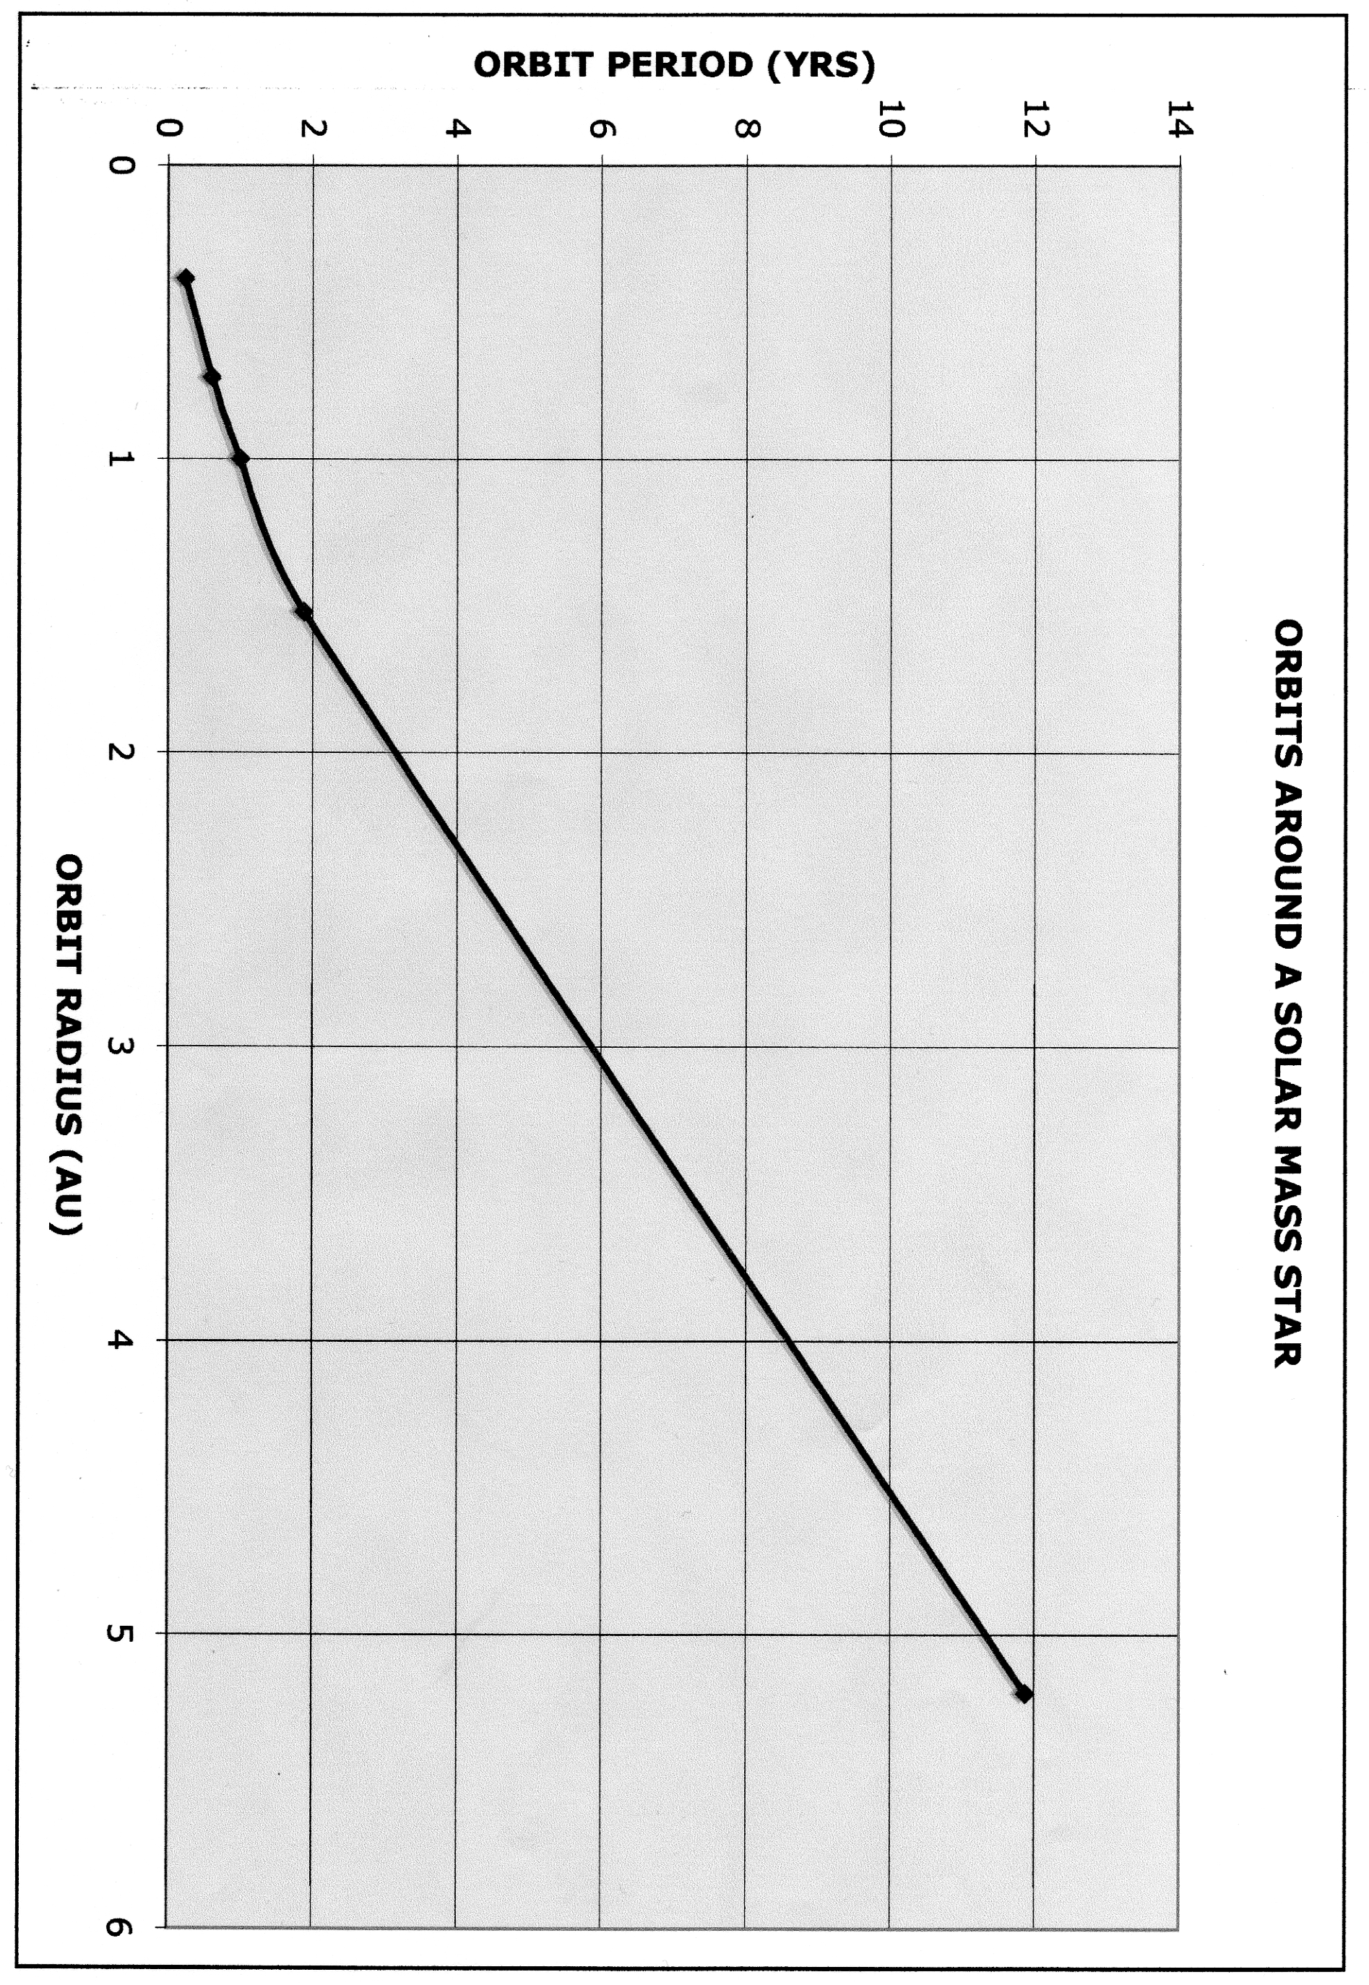
(4) “Alpha Centauri Calling”

Let us imagine that a an intelligent civilization exists on a planet orbiting Alpha Centauri, and that they want to send us a message by laser. They plan to blink their laser on and off in a kind of Morse Code, and they need it to be so bright (as seen by us) that we on Earth will be able distinguish it from the glare of Alpha Centauri itself. Suppose their laser sends light off in a beam of opening angle 1 second of arc.

- What does the luminosity of this laser have to be in order that the flux we receive from it be greater than the flux we receive from Alpha Centauri? [Alpha Centauri’s luminosity equals that of our sun.]

Recently I was looking at the website for the National Ignition Facility. This is a project attempting to produce controlled nuclear fusion by pointing ultra-bright lasers at a target. You should check out this website – it’s fascinating.

- The website mentions that their lasers produce a luminosity of 500 trillion Watts. Do the aliens on Alpha Centauri need a laser even more powerful than this? [A Watt is 10 ⁷ ergs/second.]

