Astronomy 11 Spring 2009
Second Problem set
Due at the beginning of class ??

Throughout this problem set – and all the others -- let’s do calculations to only three figure accuracy: never write down a result with more than three significant figures.

(1) Solar Power

Now that we know the amount of energy the sun emits per second – i.e. the sun’s luminosity – we can figure out how much of it falls on the earth.

The flux of sunlight we receive here at the earth

f_{from sun} = 1.36 X 10 ⁶ ergs / cm² sec

is the amount of energy falling on each square centimeter each second. If we want to find the total amount of solar energy falling on the entire earth, you might think that we should multiply f_{from sun} by the number of square centimeters on the earth – i.e. the earth’s surface area. But this would be wrong.

Here’s a picture that explains why.

sunlight

As you can see, half of the earth does not receive any sunlight at all, so we should not count the area of that half. Furthermore, even on the sunlit half, many of the square centimeters are oriented at slant angles to the incoming sunlight. All this makes it hard to decide what we should multiply f_{from sun} by. It turns out that we should multiply f_{from sun} by π r² (where r is the radius of the earth) to find the total number of ergs falling on the earth each second.

- Carry this out to find the total number of ergs falling on the earth each second.

Remember that the human race uses about 10 ²⁰ ergs of energy each second.

- How many ergs has the human race used in the last 10 years?

- Suppose we covered the entire earth with solar panels, and that they captured the sunlight with perfect efficiency – i.e. that they turned each erg of solar power into an erg of electricity. For how much time would we have to operate them in order to collect this much energy? Convert your answer to hours to get an intuitive feel for it.

(2) Centripetal acceleration

Recall the formula for centripetal acceleration:

a_{cent} = v² / R

where v is the object’s velocity and R the radius of the circle it is moving in. We also know from Newton’s second law that, in order to be accelerated like this, there must be a force

F = m a_{cent}

acting on the object, where m is the object’s mass.

Suppose the object is you, and that your mass is 70 kilograms. Suppose you are on one of those terrifying rides in an amusement park, in which you are whirled around in a circle -- you sit strapped in a chair, which is at the end of a long arm which whirls about. Suppose the thing whirls you in a circle once every 4 seconds, and that the length of its arm is 4 meters.

• What is your velocity?
• What force does the arm exert on you? Calculate your answer in dynes but then convert it to pounds.

(3) Asteroid Ida

Below is an image I recently saw of the asteroid 243 Ida.

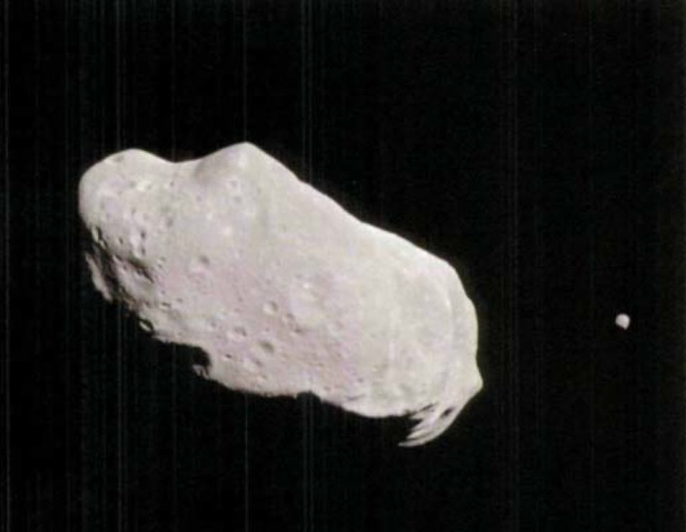

The goal of this problem is to estimate Ida’s mass.

- The caption on the image says that Ida “is about 35 miles long.” Carefully measure the asteroid’s width.

Now we want to find the asteroid’s volume. Let’s imagine that it has the shape of a cylinder:

R

H

The formula for the volume of such a cylinder is V=π R² H

- Convert the length and width of Ida to centimeters, and then calculate the asteroid’s volume in cubic centimeters.

- As we look at the picture of Ida, it obviously isn’t really a cylinder. Would you say that our assumption that it is cylindrical is leading you to overestimate or underestimate its volume? Explain your answer

- Assuming that it is made of rock, and that rock has a density of about 2 grams/cm³, calculate Ida’s mass.

(4) Weight

Let’s get some practice using Newton’s formula for the force of gravitation.

- Use it to calculate the weight of a 70-kilogram astronaut on Pluto. Give your answer in pounds to get an intuitive feel for it. [Note Appendix F contains the data you will need, but be careful: it contains an error. The Earth’s mass is
5.974 X 10 ²⁷ grams, not 5.974 X 10 ²⁴ grams.]

- In designing a mission to an asteroid, it is important to know how much a space probe would weigh on the asteroid. You have just estimated Ida’s mass. Use your result to estimate the weight of a 200-kilogram space probe on Ida. Give your answer in ounces to get an intuitive feel for it.

- Based on your answer, speculate on how a robotic spacecraft might move from place to place across Ida.

(5) Ida’s moon

Notice in the above image that Ida has a moon. The goal of this problem is to use our orbit formula to predict how rapidly this moon should be orbiting Ida, and then to see if it will be possible to test this prediction.

- Measure the distance from the center of Ida to its moon.

- Predict the velocity with which the moon should be orbiting Ida. To get an intuitive feeling for your result, convert it to miles per hour.

Now we want to see if it will be possible to test this prediction.

- Use the Doppler effect formula Δ λ / λ = v/c to calculate the Δ λ produced by this motion. Assume we are observing a spectral line with a true wavelength(what Bless calls the ‘lab wavelength’) of λ = 6,000 Angstroms (one Angstrom is 10 ⁻⁸ cm).

- Based on your earlier thoughts about the true volume of Ida, as opposed to the volume you have calculated: would you say that the actual value of Δ λ / λ is greater or less than your prediction? Explain your reasoning.

The spacecraft which went by Ida had instruments which are not able to measure the observed wavelength of light to a perfect accuracy. Let us suppose that the shift in wavelength Δ λ needs to be greater than 1/10 of an Angstrom in order for the spacecraft to measure it.

- Is it possible for the spacecraft to test your prediction for the orbital velocity of Ida’s moon by observing its Doppler shift?

