Amherst College
Candle Policy

The use of lit wick and flame candles, incense and other open flame paraphernalia is prohibited at Amherst College, with the following exceptions, and required guidelines;
- Birthdays
- Religious Events
- Special Dining Events
  - Amherst College Dining Services only
- Weddings

For those events listed above, approval must be obtained during the week,
at least 24 hours in advance from the event from either;
- Environmental Health and Safety Manager
- Amherst College Police Chief, or

If approved, the following guidelines shall be incorporated;
- Before the event, contact Amherst College Police Department at (413) 542-2291
  - Provide the dispatcher with your name and exact location of the event.
    - This notification is required, even though approval of the event was already granted
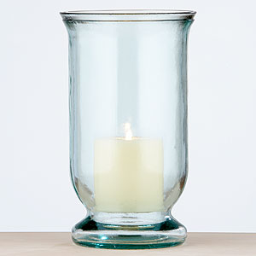
      - This notification alerts the Police Department that the event is taking place, and that they are aware of possible smoke detector activation from the area, to which they will still respond.
- Verify that a fire extinguisher is in close proximity, and that someone (i.e. Residence Counselor - RC) has been trained to use it, and knows the proper procedures for reporting a fire.
- All candles, including actual flame must be fully contained in a substantial glass or metal container which will not tip over.
  - Candles in the above containers must be placed on a non-combustible surface, away from flammable decorations and other combustible materials
    - Non-combustible surface includes a sound, sturdy, non-collapsible solid wood table
- Lit candles cannot be transferred from person to person, or carried from place to place
- Candles cannot be left unattended at any time.
- When the event has come to its conclusion, the responsible person must again contact the Amherst College Police Department
  - This will allow for inspection of the site to verify safe conditions, and to make sure that the police department knows that all future alarms from this area warrant fire department response.

The following are alternatives which are permitted, provided manufacturers guidelines are followed and that the electrical fixtures are FM (Factory Mutual) or UL (Underwriters Laboratory) approved.
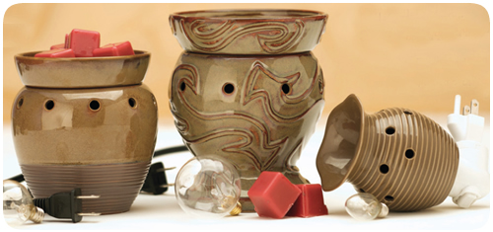
- Battery operated candles
- Electrically operated candles
- Ceramic (flameless) UL approved electric wax melting systems, which uses a 25 watt (maximum) bulb

